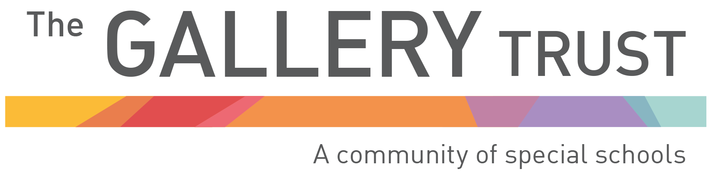

20 March 2020

Dear Parents and Carers

On Wednesday 18th March, Gavin Williamson, Secretary of State for Education, announced the closure of all schools in England as a response to the coronavirus pandemic. At the same time the government have asked schools across the country to provide care for children of key workers and vulnerable children, including those with Education, Health and Care Plans.

The most recent scientific advice on how to further limit the spread of coronavirus is clear. If children can stay safely at home, they should, in order to limit the spread of coronavirus and to reduce their chances of catching the virus.

However, schools have been requested by the Department for Education to provide care for pupils whose parents are identified as key workers and who are critical to the Covid-19 response, and who cannot make alternative childcare arrangements.

We are committed to supporting the national response to coronavirus and will be providing a limited care package for some pupils. The provision we are aiming to provide across our schools is designed to support those pupils who cannot be kept safely at home and to help key workers who are unable to make alternative arrangements for their children so they can continue their vital work. A separate communication will be sent to you to identify those parents/carers who are key workers, and I would be grateful for your early response to this.

The offer provided by schools will be a very different type of provision than our schools usually provide. There is no expectation that children who attend will have access to the full curriculum. Your child is not required to wear school uniform and should wear clothing suitable for outdoor activities.

I confirm that Orion Academy will remain open on Monday 23 March. We will risk assess this situation on a daily basis. This is because we have to assess many factors in order to ensure that pupils are safe in our care. This includes staff attendance, the availability of core services and access to vital infrastructure and resources, such as catering and cleaning.

We also need to consider the needs of individual pupils, and our ability to meet these needs. Pupils who require specific behaviour management plans or interventions which require the use of physical management from staff may not be able to attend school. All staff and pupils in school will be required to socially distance from one another to reduce the spread of coronavirus. Each pupil will be assessed on a case by case basis.

Your school will contact you to confirm if the school has enough staff and sufficient services to provide some care for your child.

Decisions about the provision on offer for your child will be made on a weekly basis based on the school’s risk assessment of the situation and the ability to ensure all pupils are safe. We will keep you updated through the school website, texts and ‘phone calls.

The government has also confirmed that families of children who are entitled to free school meals but not attending the provision will receive support in the form of supermarket vouchers. Again, your child’s school will be in touch regarding how to access these vouchers.

We encourage you to access online learning and education packs provided by your child’s school – these will soon be available on the school’s website. In the meantime, each pupil will be sent home with a work pack or will receive one through the post.

Your support and understanding at this difficult time, when we all face unprecedented challenges, is greatly appreciated. I know that we are all under considerable strain, but I do ask that school staff are treated in a respectful way in all of our communications.

We will keep you updated at every opportunity as this situation continues to evolve. Thank you for your support.

Yours sincerely

Mrs K Willett
Chief Executive Officer

