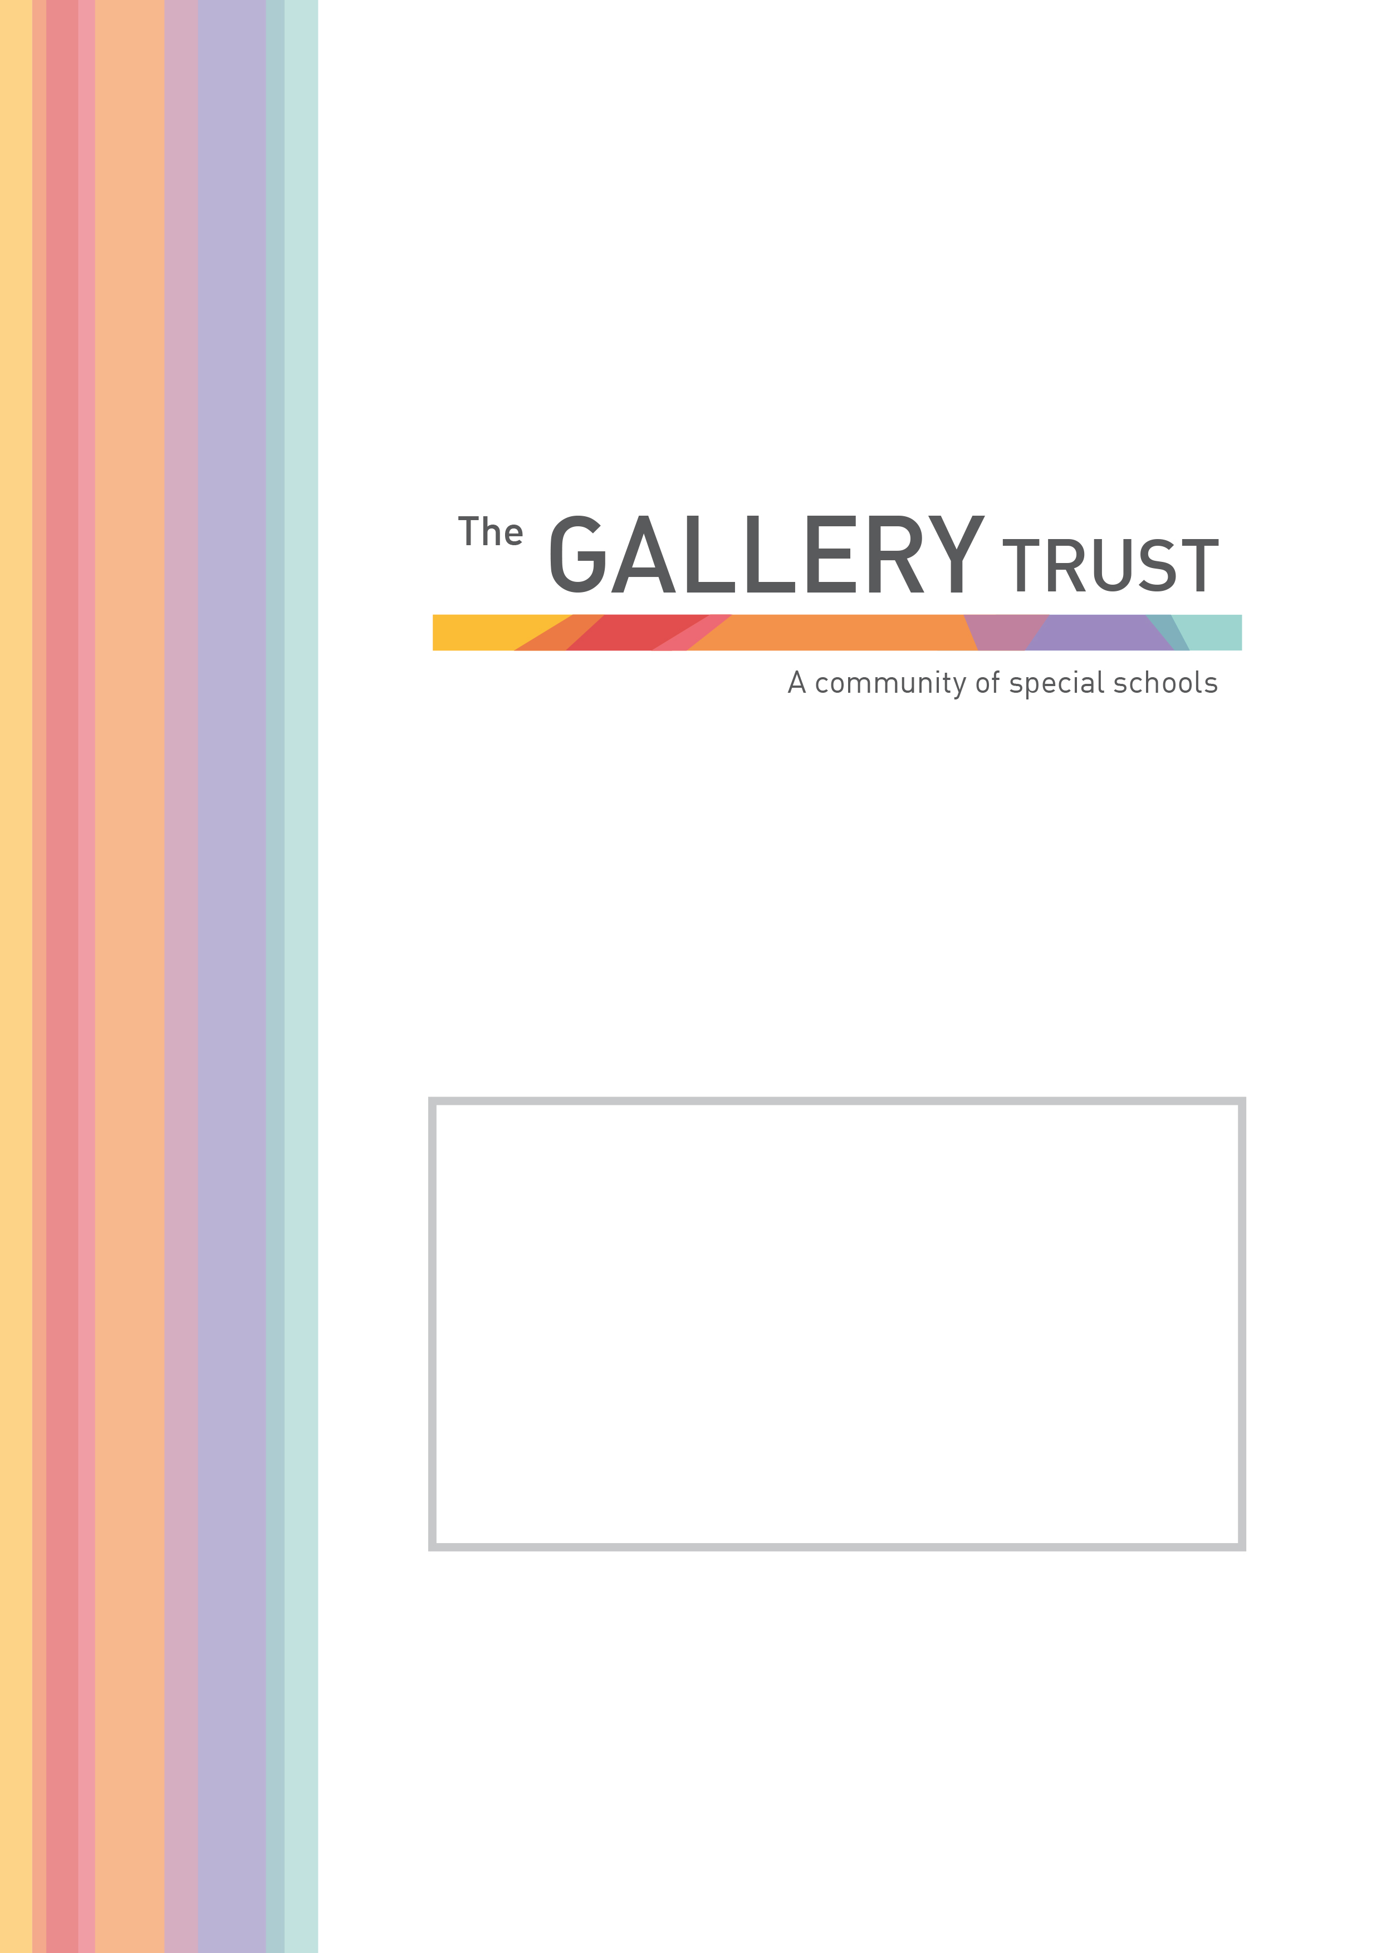
Consultant Executive
Head Teacher

Candidate Information Pack
June 2020
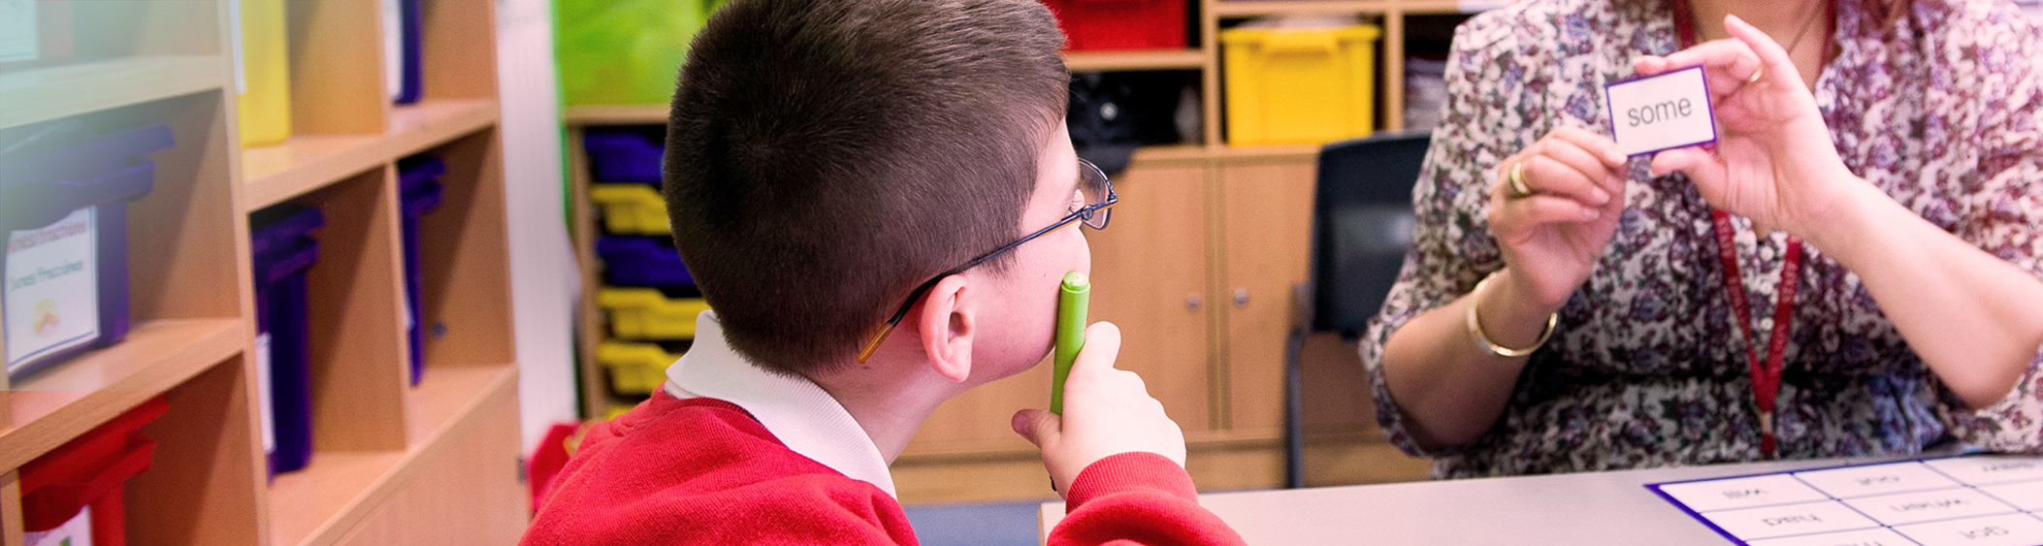
Consultant Executive Head Teacher
Northern House Academy and Bloxham Grove Academy
Leadership L25 to 31

The Gallery Trust, a special Multi Academy Trust, is seeking to recruit a Consultant Executive Head Teacher to work across two schools in the Trust, Northern House Academy, in Summertown, Oxford, and in Bloxham Grove Academy, a new free special academy scheduled to open in Bloxham in 2022.

This new post offers an exciting opportunity to join an expanding and successful Trust. We currently have 5 special schools in our Trust, with a further school converting to join us shortly, and we are in the preliminary stages of opening 2 special free schools.

The Executive Head Teacher will lead and inspire excellence throughout the two schools, working with and supporting school leaders at all levels to deliver success for all children, in each school, at every stage of their education and provide them with the skills and confidence in their future life.

The role will ensure leadership at all levels has a direct impact on strategic school improvement, pupil outcomes and effective business operation. As a senior leader within The Gallery Trust, the Executive Head Teacher will be responsible for establishing and implementing the vision and direction for the two schools. In leading the academies, the Executive Head Teacher will ensure that The Gallery Trust’s ethos and values are deeply embedded and visible amongst pupils and staff, and that the schools collectively and individually bring out ‘the best in everyone’. The Executive Head Teacher will provide full and effective collaboration across the two schools, and locally, translating into real benefits for pupil outcomes, professional development and efficiency savings. The role will bring a framework for excellence to life across the schools and ensure it is embedded in the school improvement plans for each academy.

The Executive Head Teacher will be a key member of the Trust’s central team, will work closely with colleagues in the Trust’s School Improvement Team and will take a flexible approach in supporting further schools as the Trust continues to expand.

This post is subject to satisfactory references which will be requested prior to interview, an Enhanced DBS check, health check, evidence of qualifications and verification of the right to work in the UK.

The Gallery Trust, Iffley Turn, Oxford OX4 4DU • Tel: 01865 747606
The Gallery Trust is an exempt charity. Company registration No. 08334718 Registered in England and Wales

About Northern House Academy

Northern House Academy provides education for students with a range of Special Educational Needs and Disabilities, including Autistic Spectrum Disorder, Social, Emotional and Mental Health Needs and Cognition and Learning Needs on its site in Summertown, Oxford.

Northern House Academy joined The Gallery Trust on 1 February 2020 and is part of our growing community of special schools alongside Iffley Academy, Bardwell School, Springfield School, Orion Academy and Bloxham Grove Academy. Bloxham Grove is currently in the pre-opening stage and will open in January 2022.

All students have an Education, Health and Care Plan, which drives their educational provision.

Northern House Academy currently offers places to 86 students aged from 5 to 11 years. Students attend from throughout the county.

Students are taught through a differentiated and bespoke curriculum designed to enhance academic and social development, with a strong emphasis on independence skills. The curriculum delivers a thematic, cyclical approach to provide a meaningful and interesting context for the development of basic skills, knowledge and understanding while providing the relevant National Curriculum requirements. Classes are grouped into stage, not age, allowing innovative and creative approaches to teaching and learning, and are taught predominantly by one class teacher, supported by additional class adults. The Academy provides support for the social and emotional needs of students through a qualified and skilled therapeutic team, underpinned by a Trust pastoral support term. The offer to students is enhanced by additional specialist therapies and interventions.

The Ofsted report of 2019 found all categories considered by inspectors (Leadership and Management, Behaviour and Safety of students, Quality of Teaching, Achievement of students,
Sixth Form provision) to be “inadequate”. The interim leadership at the school are working successfully to make rapid improvements across all areas of the school.

Aims and Values

We are committed to guiding and encouraging our children and young people towards reaching their full potential. We believe that each and every one of our unique learners has their own contribution to make to the life of the Academy, their family and their community, through:

- Engaging with a stimulating and challenging education of the highest quality within which they know that their achievements are valued
- Developing the ability to be independent and successful in adult life and the wider community
- Developing the ability to embrace change and the challenges this can bring
- Developing positive relationships and respect for one another
- Developing tolerance and understanding of individual needs
- Embarking on a journey of self-discovery
- Engaging with the Academy’s high expectations, positive attitudes and staff that have a passion for working with young people
- Supporting the Academy’s safe and secure structure
- Embracing the exciting and innovative challenges and opportunities on offer

About Bloxham Grove Academy

The Gallery Trust is opening a new free special school in North Oxfordshire for pupils with complex Special Educational Needs and Disabilities. Bloxham Grove Academy will offer special education to pupils with Autistic Spectrum Disorder, Social, Emotional and Mental Health Needs and Cognition and Learning Needs.
The academy will be located on a self-contained site adjoining The Warriner School, Bloxham and will complement and extend the excellent SEND already provided by the state funded special schools in the area.
Bloxham Grove Academy aims to achieve the very best outcomes for all learners ensuring that students with ASD, SEMH, and/or C&L achieve better outcomes than their peers with similar needs, in mainstream schools, alternative provision and independent special schools. We will ensure that we provide the most appropriate education for the special educational needs and disabilities of the students and promote high standards and fulfillment of potential.

We have high aspirations for every learner with a curriculum designed to enhance their academic and social development, and to focus on key areas which will have a real impact on their lives. Our core curriculum will provide daily opportunities for individual and group learning in English (Sound Reading System advanced synthetic phonics programme), Mathematics (Thematic approaches linked to problem solving or vocational contexts), and social communication (non-verbal communication, paralinguistic skills, conversational skills, assertive behaviour) with students working towards outcomes from their Education, Health and Care Plans.

Our pastoral model focuses on every student having a lead practitioner acting as their mentor throughout their school career and taking responsibility for promoting their emotional wellbeing and development. A range of additional interventions and therapies (e.g. art and music therapy, reflexology and massage, dogs as therapy sessions) supports students to ensure that they are emotionally ready to learn, and that individual barriers to learning are removed. All students will be supported by restorative approaches, a philosophy for making, maintaining and repairing relationships, and fostering a sense of social responsibility and shared accountability. Our whole school approach to relationship building and conflict management creates a caring community and a sense of shared responsibility.

We are aspirational for our learners and expect them to:
- achieve their best
- become confident individuals living fulfilling lives
- make a successful transition into adulthood

We are aspirational for our families and expect them to:
- work in partnership with the academy to make informed choices for their children
- support academy staff in setting aspirational targets for their children

About The Gallery Trust

The Gallery Trust is a successful Multi Academy Trust based in Oxfordshire dedicated to providing outstanding education and support for young people with special needs and disabilities, enabled through:
- Commitment to special education – striving to provide the best specialist learning experience for all students
- Opportunities for all to learn – ensuring that students and staff have access to learning pathways which enhance their lives
- Genuine respect and value – creating relationships which promote trust, confidence and respect within environments which are safe and secure
The Trust has 6 special schools:
- Iffley Academy, Oxford
- Bardwell School, Bicester
- Orion Academy, Oxford
- Northern House Academy, Oxford
- Springfield School, Witney
- Bloxham Grove Academy, Bloxham (in pre-opening stage)
Our application to open a second new free special school in Didcot has been successful and Mabel Prichard School, Oxford, will join the Trust in November 2020.
By pooling knowledge and resources, working collaboratively and providing appropriate CPD, the Trust meets the needs of all cohorts of SEND pupils, and by providing structured support services, school leaders can focus on enhancing standards of teaching and learning in their schools. Schools maintain their own distinct vision, ethos, and character while subscribing to the values of the Trust.
The Trust is an established voice of SEND in Oxfordshire and works closely with Oxfordshire County Council, the Department for Education and the Regional Schools Commissioner.
The Trust has two central teams, Business Services and School Improvement, which work closely together to provide strategic direction, school improvement and business services for our schools. The teams are responsible through the Chief Executive Officer to the Board of Trustees.

The

JOB DESCRIPTION

Consultant Executive Head Teacher
Northern House Academy and Bloxham Grove Academy

Reports to: Chief Executive Officer, The Gallery Trust

The Executive Head Teacher will lead and inspire excellence throughout the two schools, working with and supporting school leaders at all levels to deliver success for all children, in each school, at every stage of their education and provide them with the skills and confidence in their future life.

The Executive Head Teacher will ensure leadership at all levels has a direct impact on strategic school improvement, pupil outcomes and effective business operation. As a senior leader within The Gallery Trust, the Executive Head Teacher will be responsible for establishing and implementing the vision and direction for the two schools. In
leading the academies, the Executive Head Teacher will ensure that The Gallery Trust’s ethos and values are deeply embedded and visible amongst pupils and staff, and that the schools collectively and individually bring out ‘the best in everyone’. The Executive Head Teacher is responsible for ensuring there is full and effective collaboration across the two schools, and locally, and that this translates into real benefits for pupil outcomes, professional development and efficiency savings. They are expected to bring a framework for excellence to life across the schools and ensure it is embedded in the school improvement plans for each academy.

Broadly, the responsibilities of the role are as detailed below:

Educational Leadership and Management

- Accountable for performance, pupil progress, standards and the academic results across the schools
- Ensure the Trust’s principles are highly visible and are embedded in each academy’s school improvement plans
- Develop a shared expectation of outstanding teaching and learning and ensure collaborative learning and CPD across the schools
- Ensure that each academy has a robust school improvement plan and work with the Director of Schools to ensure appropriate school improvement support is in place and evaluated
The Gallery Trust, Iffley Turn, Oxford OX4 4DU • Tel: 01865 747606
The Gallery Trust is an exempt charity. Company registration No. 08334718 Registered in England and Wales

- Create and support an aspirational and innovative culture of learning across both schools
- Create a climate for learning and a system of monitoring and intervention that enables all pupils to thrive
- Set high educational standards in the academies
- Design and implement the curriculum and the broader pupil experience and share expertise and experiences across the schools
- Set and monitor against targets for pupil achievement
- Ensure the welfare and safety of all pupils from all groups, including their safeguarding
- Ensure each academy has effective behaviour management strategies in place and monitoring, with the Heads of School, attendance, exclusions and behaviour
- Ensure external relationships with DfE, Ofsted, local authorities, and other bodies are well managed and that the schools are all at least ‘Good’ in all future Ofsted inspections

Strategic Leadership and Management

- Define and deliver the vision and objectives of the two schools and the strategic plan as agreed with the Rapid Improvement Board and the Director of Schools
- Work with the school’s governance structures as the responsibilities of the Rapid Improvement Board are transferred to a future governance body, e.g. Local Governing Body
- Embed collaboration, learning and joint working across the two schools, ensuring that all learn from the very best each has to offer and that the schools work in partnership
- Agree, communicate and deliver aspirational short and medium term aims within the context of the longer-term vision
- Develop and maintain the values of The Gallery Trust in the academies
- Contribute to the on-going development of the Trust, actively seeking and sharing outstanding practice within and beyond the schools, playing a key role in Trust wide school improvement
- Play an active role in growth of the Trust, leading on due diligence of joiner schools in conjunction with the Director of Schools and in collaboration with the Central team, and making recommendations for appropriate schools to join
- Taking a flexible approach to supporting schools within the Trust as the Trust continues to grow
- Contribute professionally to the broader Gallery Trust agenda including taking the lead on specific areas as directed by the Director of Schools and the CEO

People Leadership and Management

- Ensure a culture of working together to achieve high standards throughout the academies
- Manage performance of each Head of School, supported by the chair of the Rapid
- Improvement Board and the CEO
- Ensure that each school has a rigorous and effective performance management system and that pay progression decisions are made in line with policy
- Undertake effective planning with each Heads of School to ensure that the staffing needs for the academies are proactively identified and that plans are in place to ensure appropriate succession

- Where appropriate pool resources and skills across the schools using shared posts and recruitment drives to benefit all
- Create a climate of reflective practice and professional development that enables all members of staff to flourish and achieve their very best. Drive collaborative CPD practice across the locality so that all staff have access to the very best CPD
- Take an active role in middle and senior leadership development across the schools, engaging with Trust Leadership and ensure effective succession and talent management strategies are in place
- Promote equality and fairness for all staff
- Support individual Heads of School in leading any staffing changes in the academy
- Take responsibility for your own professional development as the Executive Head Teacher

Financial and Business Management

- Work closely with the Heads of School and Schools Leaders to ensure budgets are set and managed within guidelines agreed with the Director of Schools and the Trust Finance Director
- Ensure each academy delivers an efficient staffing structure
- Monitor actual spending against budget for each school
- Develop a shared resources strategy across the schools and actively pursue opportunities to share back office services and thus streamline costs including areas such as Business Management, HR, Finance and Technology
- Ensure each academy implements key Trust policies and strategies (e.g. in relation to compliance, finance, HR and IT)
- Manage and utilise the sites and facilities to maximise their value to the academies, the Trust and the community and where appropriate ensure shared use of facilities across the locality
- Ensure that health and safety policies are fully implemented and managed

Links with Community and Business

- Provide visible leadership at Trust level and actively engage with relevant business, community and public bodies to benefit the pupils and academies
- Ensure each Head of School is developing strong and effective partnerships with parents Ensure each Head of School is developing a thriving sense of school community to include present and past pupils and parents
- Create proactive, entrepreneurial and effective links with the community including, for example, with business, other local schools and with local churches

Reporting

The Executive Head Teacher reports to the Director of Schools, who is responsible to the Trustees and the Chief Executive. The Rapid Improvement Boards, particularly the Chairs of Board, will also work closely with the Executive Head Teacher in relation to their responsibilities to act as a ‘critical friend’ to the academies. This relationship with the Chairs and Rapid Improvement Boards will be key to driving the schools forward and further developing local partnerships. The Executive Head Teacher will keep the Director of Schools fully informed on the progress of each school and will submit reports for consideration as appropriate. The Executive Head Teacher will participate in an annual review as part of the agreed appraisal process.

Other

Carry out any other reasonable request of the Chief Executive Officer.

As Executive Head Teacher, you will be required to meet the general requirements of this post as specified in the School Teachers’ Pay and Conditions Document. In addition, you will be required to fulfil any reasonable expectations from the Chief Executive Officer.

The Executive Head Teacher is accountable to the Trustees and Rapid Improvement Board for the standards achieved and the conduct, management and administration of the school, subject to any policies which the DfE may make.

This job description is subject to annual review.

The Gallery Trust is committed to safeguarding and promoting the welfare of
children and young people. Head Teachers must ensure that the highest priority is given to safeguarding children and young people. The successful candidate will be required to undergo an Enhanced Disclosure from the Disclosure and Barring Service (DBS). Any offer of employment with The Gallery Trust is subject to verification of ID and qualifications, satisfactory evidence of the right to work in the UK, satisfactory references, health clearance and NCTL and police clearance (where appropriate).

The Executive Head Teacher works for The Gallery Trust based at Northern House Academy. However, the Trust reserves the right, in exceptional circumstances, to deploy staff to different locations depending on the needs of the overall Trust.

Selection Criteria
Consultant Executive Head Teacher
Northern House Academy and Bloxham Grove Academy

Qualifications
- Educational and professional qualifications appropriate for the role of Executive Head Teacher. Such qualifications would normally include a degree from a recognised university, professional qualifications (i.e. NPQH and PGCE) and ideally a further postgraduate qualification based on Executive Leadership;
- Evidence of professional development across career to date;
- Qualified to work and teach in the UK
Experience
- Demonstrable substantial success at Headteacher level through significant periods of development;
- A proven track record of securing excellence in an educational establishment;
- A proven track record in rapidly raising pupil achievements;
- Experience of supporting leaders and schools beyond your own school, including tangible contributions to system leadership;
- Evidence of the ability to develop excellent relationships with staff, members of the local community, parents and pupils aged 5 - 18 years of age;
- Experience in leading and developing colleagues and effective teams;
- Recent experience of SEND
Professional qualities
- An in-depth understanding of school leadership and improvements needed to achieve outstanding pupil progress and personal development;
- The ability to create and implement effective management systems in which roles, responsibilities and accountabilities are clearly articulated;
- The skills and personal qualities to coach senior and middle leaders to improve their practice;
- Passion for education that embraces the belief that every student can learn and succeed;
- A clear understanding of and commitment to the development of The Gallery Trust values and
- Belief in equality of opportunities for all students and staff regardless culture, gender, ethnicity, sexual orientation or religious identity;
- Clarity of vision with the ability to communicate it in a compelling and engaging way;
- An adaptable leadership style which encourages leadership from others and celebrates success;
- Determination and resilience;
- Sensitivity and wisdom in managing relationships with pupils, parents and staff;
- High level interpersonal and communication skills with the capacity to influence at all levels;
- High expectations of pupil achievement, conduct and behaviour;
- A commitment to collaborative working, both within the school and across the Trust;
- Openness, energy and enthusiasm;
- Demonstrate a drive towards the National Standards of Excellence for Headteachers;
- An understanding of the importance of research in developing approaches to learning and curriculum design and the ability to put this into practice;
- Commitment to equality of opportunities and a willingness to challenge barriers to achievement
Safeguarding
- Deep commitment to safeguarding and promoting the wellbeing and welfare of students

Application process

To obtain more information and to apply for this post, please email recruitment@thegallerytrust.co.uk or telephone 07572 235294 to request an application form and a job pack. You can also download an application form and job pack from our website:

https://thegallerytrust.co.uk/recruitment/current-vacancies/

Please submit your application form by 5pm on Monday 6th July to recruitment@thegallerytrust.co,uk. Please ensure you detail any gaps in employment, and use the selection criteria which is contained in the job pack when you prepare your application, as shortlisting for interview will be based on how closely you demonstrate your ability to fulfil the essential criteria. We do not accept CVs. If you are shortlisted, we will take up written references before your interview so please provide permission for this and provide accurate phone and email contact details for your referees. One of your referees must be your current or last employer, and if you are employed in a school, must include your current Head Teacher.

If shortlisted for interview this will take place on Monday 13th and Tuesday 14th July at Northern House school (socially distanced).

The Gallery Trust is committed to safeguarding and promoting the welfare of all children and expects all staff to share this commitment. The successful candidate will be subject to an Enhanced DBS check, Occupational Health check and a probationary period of 6 months. The Gallery Trust is an equal opportunities employer and we welcome applications from a range of ethnic backgrounds to represent diversity in line with our school community.

