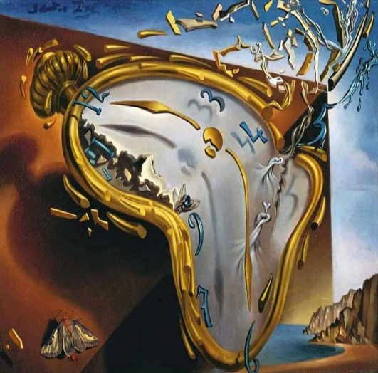
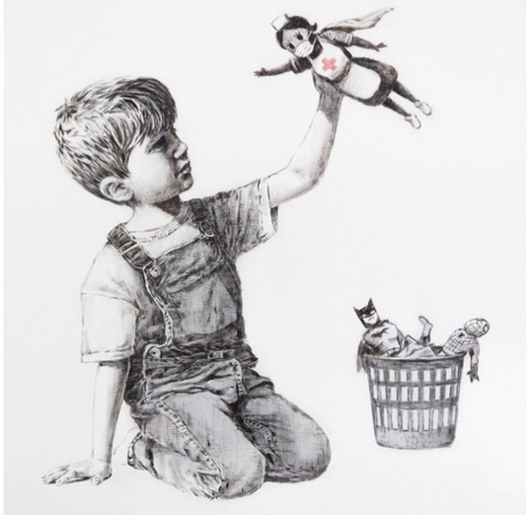

Lesson Plan 17/11/2020
Good morning Dali and Banksy class,
We hope you are all well and had a brilliant start to your week. Please see below todays lessons for you to complete. Please take lots of photos of all the wonderful work you do and send them to Miss. Kingston if you are in Dali class or Miss. Davies if you are in Banksy class.
Please do not worry if you don’t have access to a printer at home. Just do what you can and try your best. Please remember there is no pressure to complete all of these tasks. Short 10-15minute sessions will be enough for you and make sure you take regular breaks and continue learning through play.
All the best,
Miss. Kingston and Miss. Davies
Maths: Counting to 20
Link to lesson 6:
https://classroom.thenational.academy/lessons/finding-one-less-than-a-given-number-6wwp2d
Learning Objective:
I can find one less than a number to 20
Equipment:
- Number grid to 20
- 20 small objects
Lesson overview for parents:
- Introduction and welcome to guests for the teddy tea party
- Counting how many spoons we need for the teddy tea party
- Getting your equipment ready
- Looking at star words: numbers 1-20
- Counting to 20 using a number grid: counting out 20 sweets for the guests of the teddy tea party
- Exploring one less than a number to 20
- Independent work: working with an adult practice taking objects away from your number grid and counting how many are left
- Close: answer question: what is one less than 12
__________________________________________________________________________________
Literacy: Little Red Hen
Link to lesson 6:
https://classroom.thenational.academy/lessons/to-recycle-the-story-of-the-little-red-hen-and-change-the-ending-6tk3ae
Learning Objective:
I am able to recycle the story, developing character and changing the ending.
Equipment:
- Pencils
- Paper
Lesson overview for Parents:
- Introduction with Adam and Panda
- Review of today’s agenda
- Warm up with nursey rhyme: Humpty Dumpty
- Adam reminds us what happens in the story of Little Red Hen
- Adam and Panda reimagine Little Red Hen story and draws a new story map
- Independent work: draw your favourite animal from the new story
- Close: remember to share your work
__________________________________________________________________________________
PSHCE: A New Normal
Link to lesson 6:
https://classroom.thenational.academy/lessons/super-juice-crtk6d
Learning Objective:
I will learn what benefits different fruit have on my body
Equipment:
- Favourite teddy
- Paper
- Colouring pencils
- Fruit (and a blender if you have one)
Lesson overview for Parents:
- Introduction with Miss. Vali, Maximus, Percy, Billy, and Rosie
- Getting your equipment ready
- What’s wrong with Percy?
- Dr. Wade helps Percy
- Miss. Vali tells a story called I Will Never Not Eat A Tomato
- Making super juice
- Close: Draw a picture to share all the fruit that you used to create your super juice
__________________________________________________________________________________
Phonics:
These are the sounds we have previously covered in class –
Set 1: s, a, t, p
Set 2: i, n, m, d
Set 3: g, o, c, k
Set 4: ck, e, u

Please note your child may not be able to recall all these sounds and that's okay, the best thing for them is to consolidate them through the sets. (for example, if they are confident with s, a, t focus on practicing ‘p’ and there so on).
For todays lesson please click on the following link and watch Alphablocks ‘o’ video:
https://www.youtube.com/watch?v=GSF5bFTs45Y
Alphablocks is a great way to practice phonics and home. It is important that the children join in with the clip and practice repeating the sounds discussed. It would be great to pause the clip along the way and question your child on the sounds that are displayed on screen.
And
Phonics play:
Username: nhouse
Password: phonics
- Log into phonics play
- Click resources
- Click on Grab a Giggling Grapheme
- Click phase 2
- Click on block that has + g,o,c,k
Children also enjoy the interactive sound games in phase one. You could try Sound Starters or Welcome to the Zoo. These games are great fun and help develop listening skills, ability to describe sounds and talking about the difference between the sounds they hear and widens their vocabulary, so please give them a go.
Additional:
Books for your children will be uploaded onto Active Learn for them to work through. Teachers will send out login details for your child.
Please listen to your child read the books and help them break words into smaller sounds where they struggle. Please ask your child regular questions about what is happening throughout the book for example:
- What do you think is going to happen next? Why?
- How do you think the character is feeling at that moment? Why?
- Can they recall events throughout the story and tell you what has happened in the book – encourage them to use full sentences.

