Good morning Kandinsky
I am soooooo impressed with the amount of work you are doing! Also thank you for your emails, I have enjoyed reading them
It’s FAB FUN FRIDAY……Whoo!! Nearly the weekend!
English – The Boy in the Girl’s Bathroom – Lesson 4
https://classroom.thenational.academy/lessons/to-explore-a-theme-c8vkgt
Grammar- look at word groups
https://classroom.thenational.academy/lessons/to-explore-word-class-6cu3je
Maths- subtraction
https://classroom.thenational.academy/lessons/choosing-appropriate-subtraction-strategies-6nh3gc
Science- Heating and cooling
https://classroom.thenational.academy/lessons/what-happens-when-you-heat-or-cool-each-state-of-matter-68w3at

A fun activity: Build a tower (as it is FAB FUN FRIDAY).
Using marshmallows and spaghetti, you could also use tape.
Can you build a spaghetti tower alone or work with others (parents, siblings)? Spaghetti towers are made using dry spaghetti strands and marshmallows.
One way of making a tower is to make squares with the spaghetti and marshmallows first, before forming these into pyramids. Use these existing pyramids to form new ones, and watch as your tower grows higher! There are more ideas below.
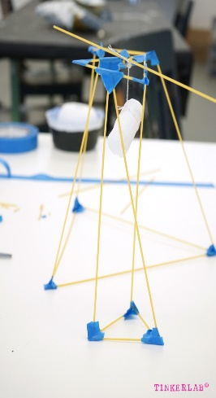
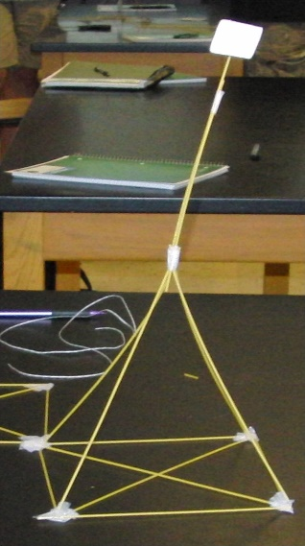
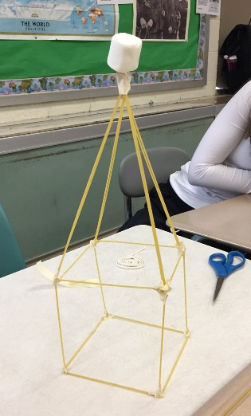

Please email me pictures of your towers.
Happy weekend
Mrs Waine

