Building bridges project

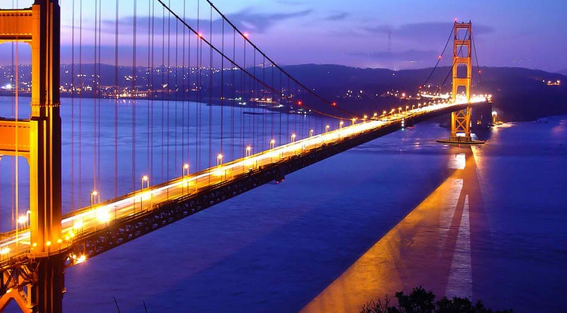
This Photo by Unknown Author is licensed under CC BY

Over the next week we would like you to research, design, build and test some different bridges. You can present your project however you like; it could be in a book, poster, powerpoint, video or any other way you want.

Your project could include;
Research – find pictures of different famous bridges and print them or draw them.
https://content.twinkl.co.uk/resource/d0/a1/cfe2-g-139-bridges-around-the-world-display-photos-english_ver_1.pdf?__token__=exp=1605095294~acl=%2Fresource%2Fd0%2Fa1%2Fcfe2-g-139-bridges-around-the-world-display-photos-english_ver_1.pdf%2A~hmac=8ff337dd42a1f25884d4eb7d4d1d73284408292ff69e548590bf7669e5ac77bc

Find out about different bridge designs. Arch, truss, suspension, cantilever, beam. Can you find examples of different types of bridges?

What makes bridges strong? Watch the videos below and have a go at some of these ideas yourself. You only need paper!
Idea! Draw and label diagrams or video yourself explaining how to build a bridge.

https://www.youtube.com/watch?v=WQfbzWkqoFY&safe=true
https://www.youtube.com/watch?v=YJuD6g-DZp4&safe=true
https://www.youtube.com/watch?v=NwvTldy2_1U&safe=true
https://www.youtube.com/watch?v=CqYGVW2Eu6Y&safe=true

Design - Come up with your own design for any type of bridge. How creative can you be? How will you make it strong? How will you record your design and build?

Record - You can use this sheet below to record your design or you can do it your own way.
- Poster
- Powerpoint
- Video
- Book including pictures, diagrams, photos, writing..
- Any other idea I haven’t thought of!
https://content.twinkl.co.uk/resource/8a/96/t-tp-6851-build-a-bridge-activity-sheet-english_ver_2.pdf?__token__=exp=1605096036~acl=%2Fresource%2F8a%2F96%2Ft-tp-6851-build-a-bridge-activity-sheet-english_ver_2.pdf%2A~hmac=5dbbb5390c455d5c26e3e655f2cb11573662984e50040a6600c12953d47fc368
Get creating and have fun!
We can’t wait to see what you come up with.

