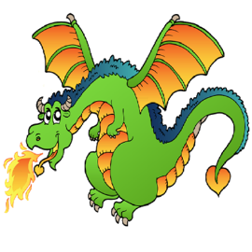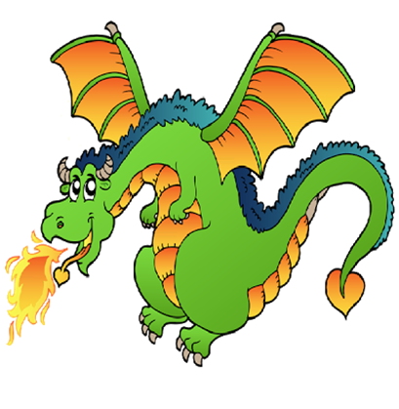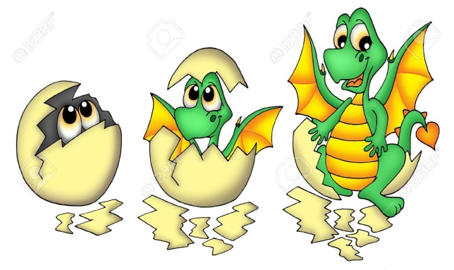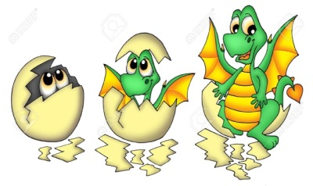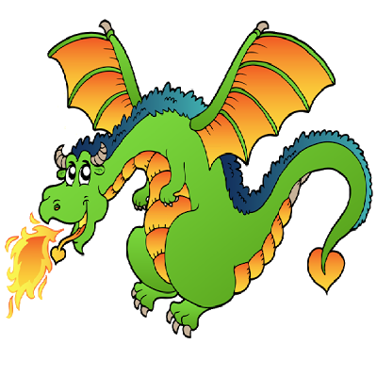

**exciting**

**apprehensively**

**slowly**

**evil**

**popped**

**hatched**

**colossal**

**dragon**

**frown**

**head**

**slumped**

**shiver**

**bigger than a…**

**floppy**

**rescue**

**glossy**

**scales**

**nervous**

**heavy**

**skin**

**looks**

**feels**

**flying**

**flared**

**caring**

**eyes**

**worried**

**T**

**anxious**

**hunched**

**bigger**

**nostrils**

**quivering**

**Adventure Word Mat**