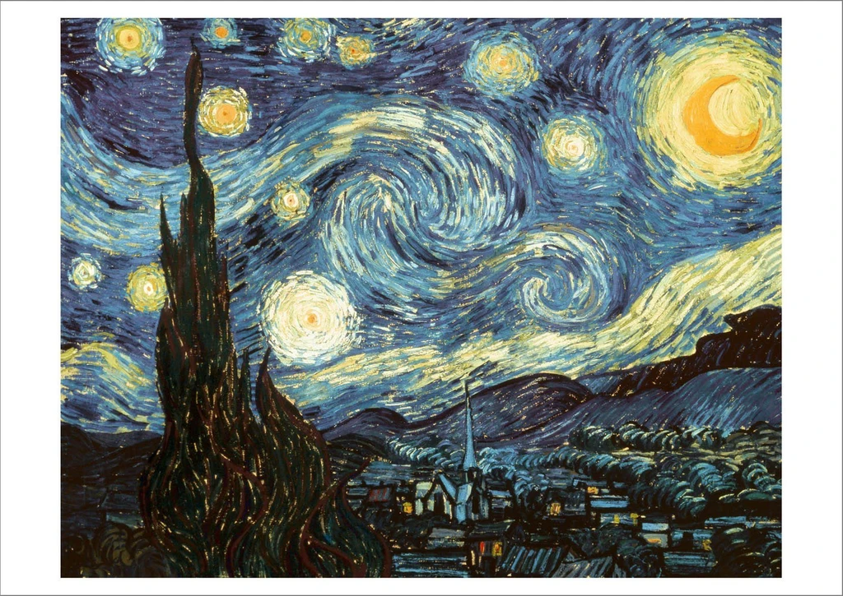 Van Gogh 10/11/2020 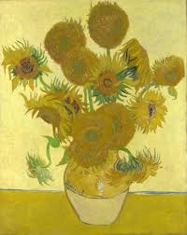
Dear Van Gogh Class and Parents,
As discussed during our phones calls please find below a range of activities for today. We will be sending out details of a River and Bridge project in the coming days.
I look forward to receiving any pictures of work or of activities that you complete; including some have mentioned cooking!
I will continue to be in touch over the coming days.
Thank you for all your support.
Lindsay McClimont

English

In class we have been developing our descriptive writing skills; with our focus on using adjectives to add detail.
Using the link below you choose one of the following:
- Write, type or tell an adult three sentences to describe the picture. Remember to add in the descriptive detail by using adjectives.

e.g The fiery yellow flames burst from the open mouth of the dragon.

- Write or type a short paragraph describing the picture.
- Write or type a short story about the picture. How did the children have a dragon as a pet? Do the children go on an adventure with the dragon?

https://www.pobble365.com/a-dangerous-pet/

There is two word banks to help you with some ideas.
I look forward to reading or hearing your amazing descriptions.

Maths
Over the past few weeks we have been focussing on place value.

Thames group:
Please look again at place value using dienes. Numbers up to 1000
https://www.topmarks.co.uk/learning-to-count/place-value-basketball

Then review ordering numbers to 1000
https://www.topmarks.co.uk/ordering-and-sequencing/coconut-ordering
There is an ordering numbers worksheet attached – ordering numbers to 1000 Thames. If you cannot print then you can copy the numbers in the correct order on a piece of paper.

Trent group:
Please look at how to partition 4 digit numbers
https://www.topmarks.co.uk/place-value/place-value-charts

Consolidate place value with dienes
http://www.ictgames.com/sharkNumbers/mobile/index.html

There is an ordering numbers worksheet attached – ordering 4-digit number Trent. If you cannot print then you can copy the numbers in the correct order on a piece of paper.

Phonics
Phonics play' will help with interactive activities and guidance.
https://www.phonicsplay.co.uk/

User name: nhouse
Login: phonic
Group A
The children will remember which phoneme they were working on.
‘or’
https://www.phonicsplay.co.uk/resources/phase/3/dragons-den
Group B
Or Alternative ‘a’ phoneme – ay / ai / a_e/ ea/ ey
https://www.phonicsplay.co.uk/resources/phase/5/alt-spellings-ai

Topic and DT (From 11.11.20 - ongoing).
2 on-going projects, which focus on ‘Rivers’ and ‘Bridges’ respectively:
1) River Research Project; Children to choose a river which they would like to research and then report back to the class about on the 20th.
2) Bridge… Design and Build Project;
Full details and links to follow!

