Autumn Falls
We are now in the Autumn Season and are surrounded by beautiful scenery. It is a perfect opportunity for you to capture this from the comfort of your own home.
You need to create your own Autumn art work using different items that can be found around the home or garden.
This project will give you a chance to be as creative and imaginative as possible. We are looking forward to seeing what you can come up with. Have fun and stay safe.
Here are some ideas you could explore:

Toilet rolls:
You could use old toilet rolls to make them into pieces of art. You could make your toilet roll into tree stumps and paint or stick leaves around it to look like this (see image below). Alternatively try turning an empty toilet roll into a woodland creature.
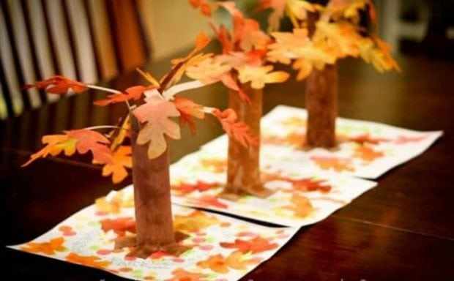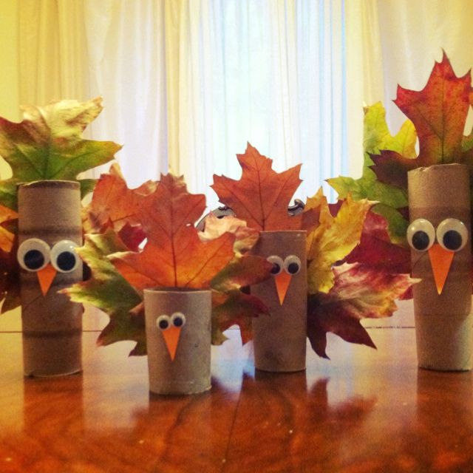

Painting:
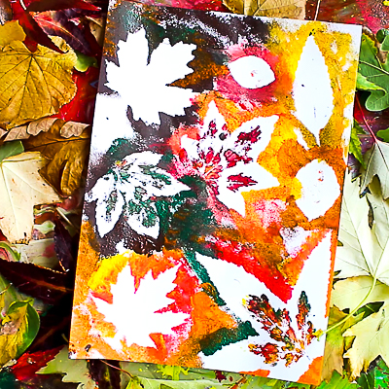
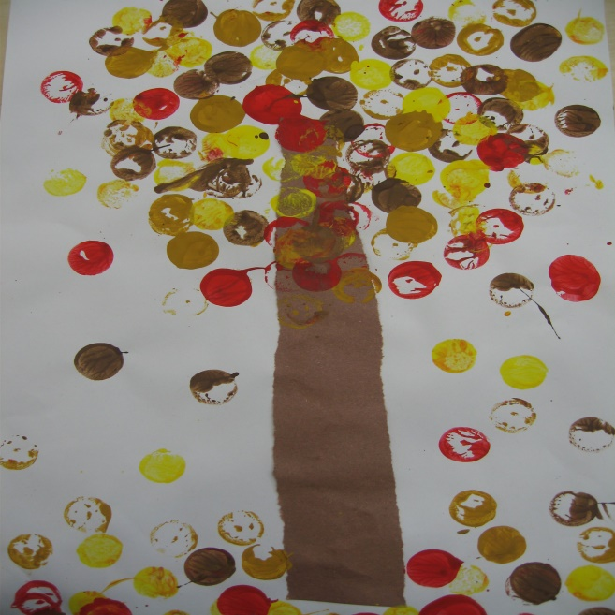
You could paint an Autumn themed picture from your imagination or you could use leaf stencils and cut them out, either from the internet or draw your own. If you have access to a garden go out and collect leaves / twigs / sticks for your picture.
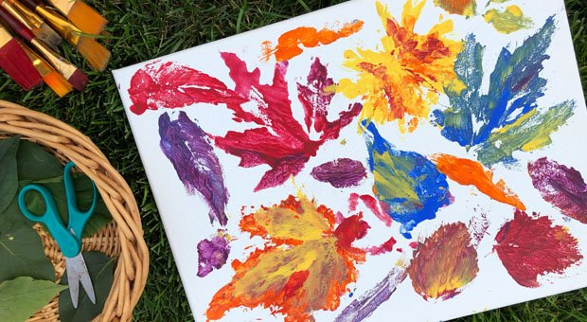
Leaf characters:
Another option would be to create your own animal out of leaves or items from the garden like these.

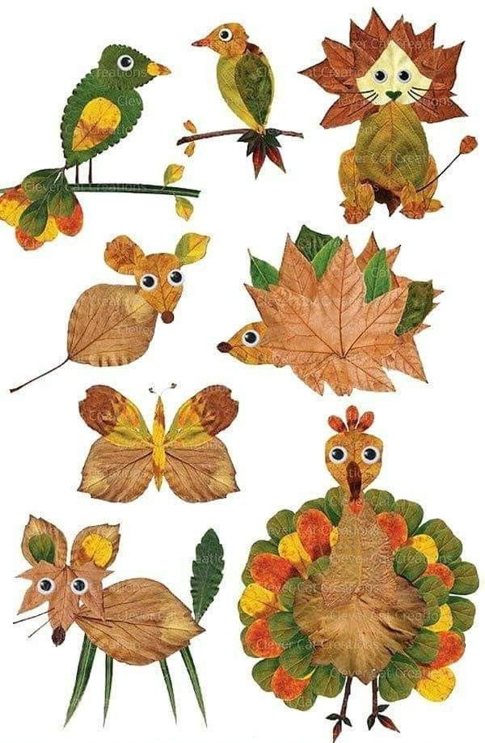

Collage:
Create your own collage from shredded magazines / old newspapers / cards.
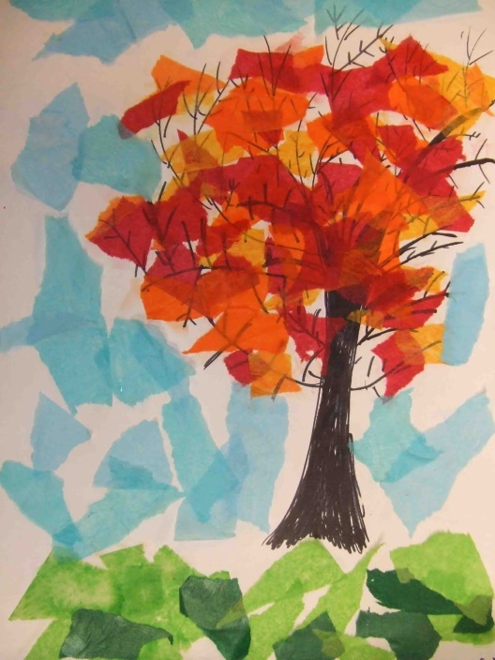
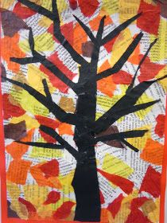
Tree Template:
Here is a template of a tree you may use to paint, colour, collage or stick items onto:
