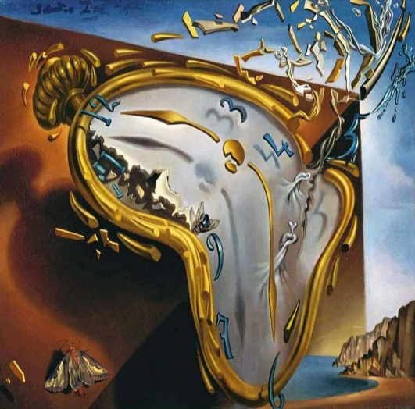
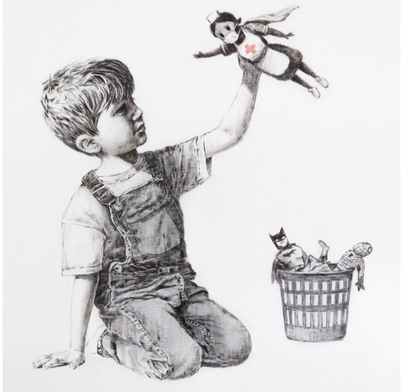

Lesson Plan 13/11/2020
Good morning Dali and Banksy class,
We hope you are all well. Please see below todays lessons for you to complete. Please take lots of photos of all the wonderful work you do and send them to Miss. Kingston if you are in Dali class or Miss. Davies if you are in Banksy class.
Please do not worry if you don’t have access to a printer at home. Just do what you can and try your best. Please remember there is no pressure to complete all of these tasks. Short 10-15minute sessions will be enough for you and make sure you take regular breaks and continue learning through play.
All the best,
Miss. Kingston and Miss. Davies
Maths: Counting to 20
Link to lesson 4:
https://classroom.thenational.academy/lessons/exploring-place-value-68tpcd
Learning Objective:
Exploring Place Value
Equipment:
- X2 tens frame
- 20 objects for counting (1 set of 10 objects need to be the same thing or colour and so does the other set of 10)
- Number cards to 10
Example of a 10s frame. There is an attached document which you can print off the frame to use. If you do not have a printer, that is no problem. You can copy the frames onto a piece of paper.

Lesson overview for parents:
- Introduction: Playing counting game with Reggie
- Counting pencils: 1-20 and putting them into groups of 10
- Looking at star words: 1-20, groups
- Use 10 frames to count your groups of 10 objects – place them on the frames
- Answering questions
- Independent work: counting objects on the 10s frame – adding more or taking away
__________________________________________________________________________________
Literacy: Little Red Hen
Link to lesson 4:
https://classroom.thenational.academy/lessons/to-reenact-a-story-focusing-on-character-6gu32t
Learning Objective:
To re-enact the story focusing on character
Equipment:
- None
Lesson overview for Parents:
- Introduction with Adam and Panda
- Reviewing the lesson agenda
- Learn the new nursery rhyme: Patty Cake
- Recap story of Little Red Hen
- Having a go at acting/ role play
- Recap what you have learnt today
__________________________________________________________________________________

PSHCE:
Link to lesson 4:
https://classroom.thenational.academy/lessons/games-apart-ccvkje
Learning Objective:
How can I play games safely?
Equipment:
- Favourite teddy
- Wide space
Lesson overview for Parents:
- Introduction with Miss Vali and her friends
- Learning new games to play with friends
- Talk about the rules to Splat and looking at how the game is played
- Looking at what happens when someone breaks the rules
- You choose your own game to play – describe to a parent or family member
- The rules of the game
- How many players are needed
- Aim of the game
- How to keep safe in your game
Have a go at playing your game and please remember to send your teacher lots of photos.
__________________________________________________________________________________

Phonics:
These are the sounds we have previously covered in class –
Set 1: s, a, t, p
Set 2: i, n, m, d
Set 3: g, o, c, k
Set 4: ck, e, u

Please note your child may not be able to recall all these sounds and that's okay, the best thing for them is to consolidate them through the sets. (for example, if they are confident with s, a, t focus on practicing ‘p’ and there so on).

For todays lesson please click on the following link and watch set 1 and set 2 videos
BBC Bitesize link for Phonic clips -https://www.bbc.co.uk/bitesize/topics/zf2yf4j
Next have a go at practicing how to write the letters. It is important for children to practice the letter formation for each sound from set 1 and 2. Encourage them to have a go at writing – correct letter formation modelling can be found here - https://www.doorwayonline.org.uk/activities/letterformation/

How to access letter formation sight:
- Press control and click on the link
- It will open to the Doorway number and letter formation page – click enter
- Choose your exercise (I would first click press and follow so your children can watch how letters are formed. Once they have watched how to form the letters go back to that page and click free draw)
- You can also choose your letter size and writing speed
- Click next
- You will now find a box where you can choose what letters you want your child to practice – please choose letters from set 1 and 2. There may also be letters and numbers that have been pre-selected. There will be a button that says clear to remove those letters/numbers.
And/ Or
Phonics play:
Username: nhouse
Password: phonics
- Log into phonics play
- Click resources
- Click on Flash cards speed trial (the one with the car)
- Click start
- Click phase 2 at the top
- You can select your car colour, race track and design and then click go.
- Try improve your speed and accuracy by doing this game a few time over

Children also enjoy the interactive sound games in phase one. You could try Sound Starters or Welcome to the Zoo. These games are great fun and help develop listening skills, ability to describe sounds and talking about the difference between the sounds they hear and widens their vocabulary, so please give them a go.

Additional:
Books for your children will be uploaded onto Active Learn for them to work through. Teachers will send out login details for your child.
Please listen to your child read the books and help them break words into smaller sounds where they struggle. Please ask your child regular questions about what is happening throughout the book for example:
- What do you think is going to happen next? Why?
- How do you think the character is feeling at that moment? Why?
- Can they recall events throughout the story and tell you what has happened in the book – encourage them to use full sentences.

