Draw your own Chibi Character

The aim of this project is to draw your own Chibi Character.
What’s a Chibi?
A chibi is a form of character drawing that originates in Japan. Chibi characters are usually between two and four heads tall.
Use the following steps as a guide.
Let’s go ahead and draw your personal chibi character.
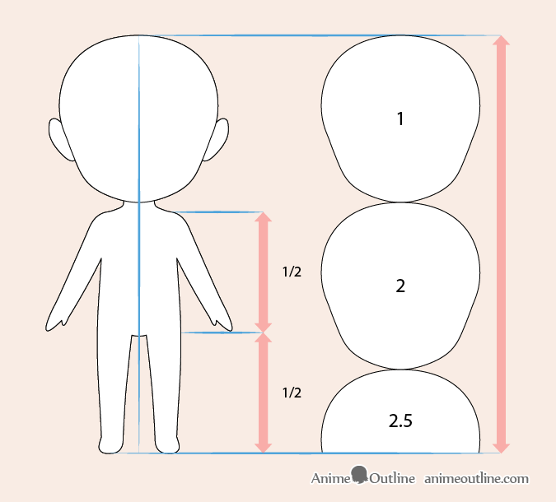
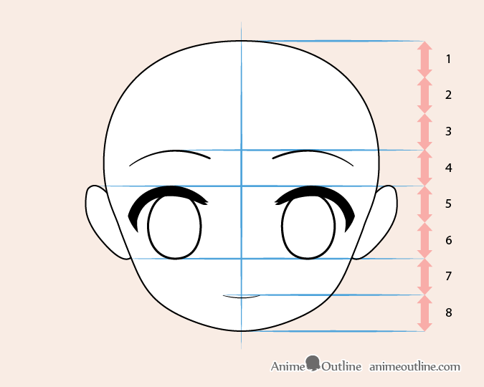
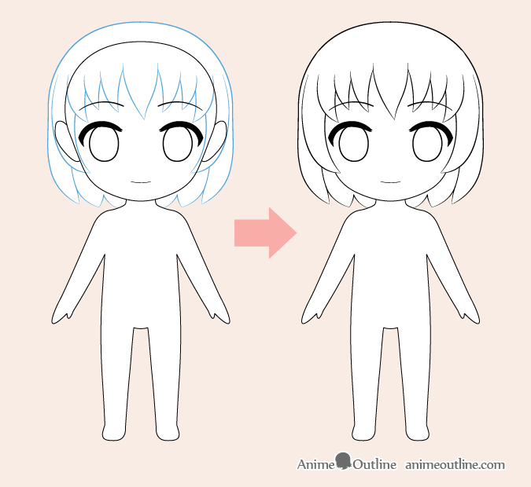

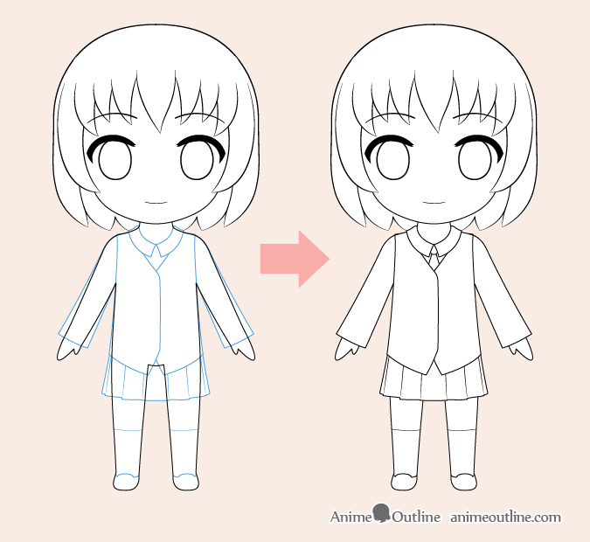
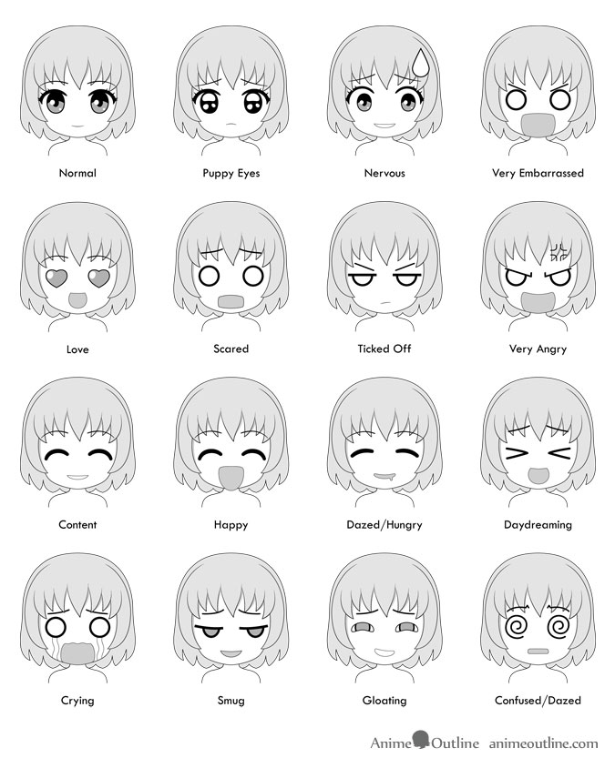
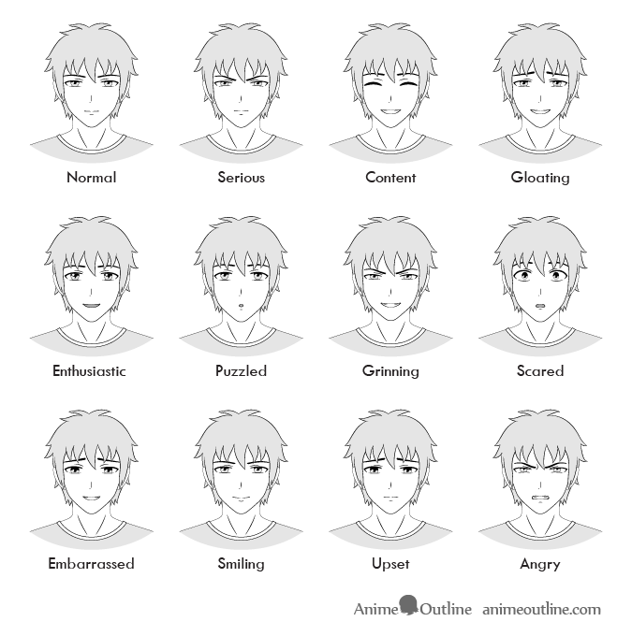
Here’s some I drew to inspire you

