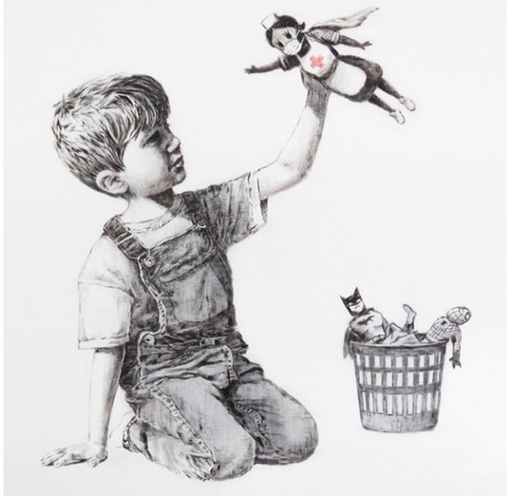

Lesson Plan 12/11/2020
Good morning Dali and Banksy class,
We hope you are all well. Please see below todays lessons for you to complete. Please take lots of photos of all the wonderful work you do and send them to Miss. Kingston if you are in Dali class or Miss. Davies if you are in Banksy class.
Please do not worry if you don’t have access to a printer at home. Just do what you can and try your best. Please remember there is no pressure to complete all of these tasks. Short 10-15minute sessions will be enough for you and make sure you take regular breaks and continue learning through play.
All the best,
Miss. Kingston and Miss. Davies
Maths: Developing a sense of 10
Link to lesson 3
https://classroom.thenational.academy/lessons/developing-a-sense-of-10-cmvkjt
Learning Objective:
I will be able to sort and compare groups of 10
Equipment:
- 10 objects – for example: buttons, pencils, bottle caps etc (try find objects that can be grouped, for example 5 red pencils and 5 blue pencils)
- X2 containers
Lesson overview for parents:
- Introduction: counting pencils
- Getting your objects ready
- Looking at star words/ key vocab – 1-10, more, less, fewer, how many, the most
- Counting your objects
- Sorting out objects with Reggie
- Discuss with a family member which containers have more or less and repeat
__________________________________________________________________________________
Literacy: Little Red Hen
Link to lesson 3:
https://classroom.thenational.academy/lessons/to-focus-on-character-cnk3jr
Learning Objective:
To step the story focusing on character
Equipment:
- Something to make a path way out of – you could use cushions for example or you could put squares of paper on the floor to make a trail
Lesson overview for Parents:
- Introduction: say hello to Adam and Panda and look at today’s agenda
- Warm up: practice singing song of Little Red Hen
- Learn how to step a story with actions (it would be useful here to place your items around the room to create a pathway)
- Close: what have we learnt today
__________________________________________________________________________________

PSHCE: A New Normal: Glitter Germs
Link to lesson 3:
https://classroom.thenational.academy/lessons/glitter-germs-c9j3at
Learning Objective:
I know how to keep myself and my clothes clean
Equipment:
- Your favourite teddy
- Piece of paper
- Coloured pencils
Lesson overview for Parents:
- Introduction: Welcome back and get your equipment ready
- Say hello to Billy, Maximus, Rosie and Percy
- Discuss how germs have spread over our friends’ bodies at school
- Discussing ways (with teddy) which we can keep ourselves and our clothes clean
- Looking at what germs are
- Drawing a picture to show the difference between dirty and clean clothes (challenge yourself by adding key words to your picture to describe your washing. Ask a family member to help you write them down)
- Say hello to Dr. Wade and her healthy helpers who will show you how to keep your body clean
__________________________________________________________________________________

Phonics games:
Practice reading SATPIN CVC words:
https://www.youtube.com/watch?v=MQpw77ll6M&list=PLDFqXo8hEdBH7WarYB9Xw7xQK-LUC8r3h

And/ Or
Phonics play:
Username: nhouse
Password: phonics
- Log into phonics play
- Click resources
- Click on Flash cards speed trial (the one with the car)
- Click start
- Click phase 2 at the top
- You can select your car colour, race track and design and then click go.
- Try improve your speed and accuracy by doing this game a few time over

Children also enjoy the interactive sound games in phase one. You could try Sound Starters or Welcome to the Zoo. These games are great fun and help develop listening skills, ability to describe sounds and talking about the difference between the sounds they hear and widens their vocabulary, so please give them a go.

Additional:
Books for your children will be uploaded onto Active Learn for them to work through. Teachers will send out login details for your child.
Please listen to your child read the books and help them break words into smaller sounds where they struggle. Please ask your child regular questions about what is happening throughout the book for example:
- What do you think is going to happen next? Why?
- How do you think the character is feeling at that moment? Why?
- Can they recall events throughout the story and tell you what has happened in the book – encourage them to use full sentences.

