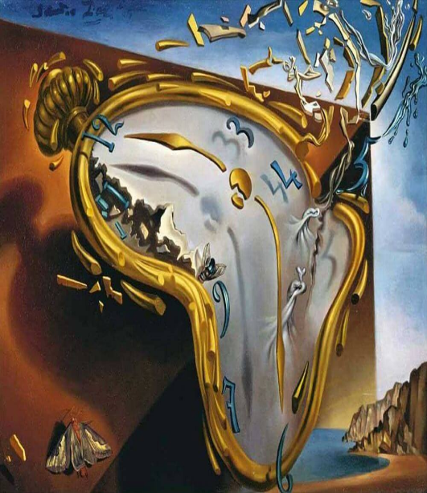
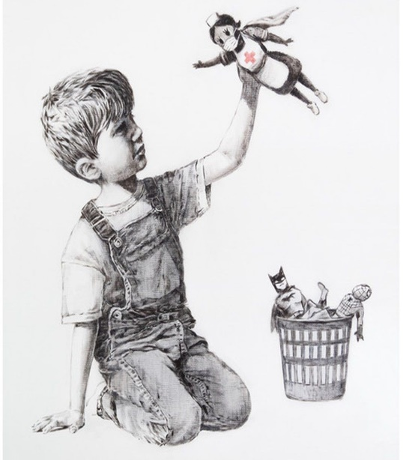

Lesson Plan 11/11/2020
Good morning Dali and Banksy class,
We hope you are all well. Please see below todays lessons for you to complete. Please take lots of photos of all the wonderful work you do.
We can’t wait to see all your smiling faces when we come back to school. Until then please make sure you keep safe and stay inside.
All the best,
Miss. Kingston and Miss. Davies

Maths: Ordering numbers to 20
Link to lesson 2
https://classroom.thenational.academy/lessons/ordering-numbers-up-to-20-6rt3ad
Learning Objective:
I can order numbers to 20.
Equipment:
- 20 objects for counting -i.e. pencils, buttons, bottle caps etc
- Number cards to 20 (please see attachment)
- Pencil/pen
- Paper
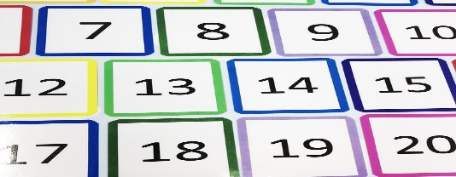
Example of number cards you’ll find in the attachment. Please print and cut out if you can. If not, you can write the numbers on a piece of paper.

Lesson overview for parents:
- Introduction: jumping with Reggie
- Exploring how to count to 11 using objects
- Jumping with Reggie to 16 and answering more or less questions
- Looking a star words/ key vocabulary: 1-20, more, greater, fewer, less
- Using number cards order one group of numbers to 10
- Answer questions about pictures shown on screen
- Use number cards, place numbers in the correct order
__________________________________________________________________________________
Literacy: Little Red Hen
Link to lesson 1:
https://classroom.thenational.academy/lessons/to-sing-and-map-a-story-6wukgd
Learning Objective:
I can create a story map of Little Red Hen.
Equipment:
- Paper and pencils to draw with.
Lesson overview for Parents:
- Introduction: Say hello to Adam and Panda
- Learn Little Red Hen song and actions
- Adam explains how to draw a story map
- Adam rereads Little Red Hen and draws pictures to help him remember key events
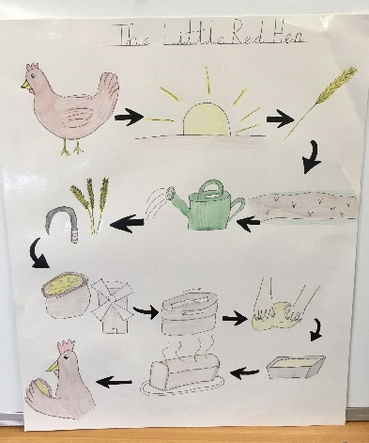
- Using your story map, tell a member of your family what happens in Little Red Hen

Example of a story map

(Please take pictures of your child creating their story maps and please send the story maps to school when we return. Thank you)
__________________________________________________________________________________

PSHCE: A New Normal
Link to lesson 2:
https://classroom.thenational.academy/lessons/were-part-of-the-same-pond-68t6ad
Learning Objective:
I understand what social distancing means and why it is important
Equipment:
- A favourite teddy
- Paper
- Colouring pencils
Lesson overview for Parents:
- Introducing our friends – Miss. Vali, Rosie, Billy, Maximus and Percy
- Find your favourite teddy
- Listen to a story
- Answer questions with your teddy
- Creative time – create a lily pad to sit on at school to keep safe
__________________________________________________________________________________

Phonics games:
Phonics bucket sorting sounds:
- Print off and cut out phonic bucket with s,a,t,p,i,n on them (pages 1-6).
- Print off pages 24,25,26 and cut out raindrops
- Please help children read each word on the raindrop and sort each raindrop into the buckets based on their different letter sounds
And/ Or

Phonics play:
Username: nhouse
Password: phonic
- Log into phonics play
- Click resources
- Click on Buried Treasure
- Click start
- Click phase 2 at the top
- Chose set 1 +i +n or you can choose to enter in your own words.
Additional:
- Pudsy colour by number

