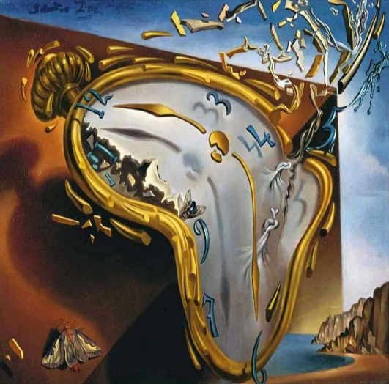
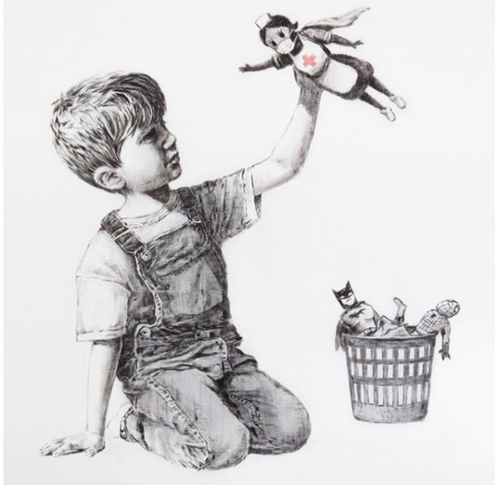

Lesson Plan 16/11/2020
Good morning Dali and Banksy class,
We hope you are all well and had a lovely weekend. Please see below todays lessons for you to complete. Please take lots of photos of all the wonderful work you do and send them to Miss. Kingston if you are in Dali class or Miss. Davies if you are in Banksy class.
Please do not worry if you don’t have access to a printer at home. Just do what you can and try your best. Please remember there is no pressure to complete all of these tasks. Short 10-15minute sessions will be enough for you and make sure you take regular breaks and continue learning through play.
All the best,
Miss. Kingston and Miss. Davies
Maths: Counting to 20
Link to lesson 5:
https://classroom.thenational.academy/lessons/finding-one-more-than-a-number-to-20-6mw38c
Learning Objective:
I can find one more than a number to 20
Equipment:
- Number grid to 20
- 1 small object
Lesson overview for parents:
- Introduction and welcome to today’s maths lesson
- Using number line to work out how old Susan will be on her next birthday
- Get your equipment ready
- Exploring star words: 1-20
- Say hello to Reggie and play ‘Park the Car’ using your number grid and small object
- Play park the car with a family member
- Closing – play closing game with number cards
__________________________________________________________________________________
Literacy: Little Red Hen
Link to lesson 5:
https://classroom.thenational.academy/lessons/to-tell-the-story-independently-focusing-on-character-crtpac
Learning Objective:
I can tell the story of Little Red Hen independently focusing on character
Equipment:
- Your story map
- Favourite teddy
Lesson overview for Parents:
- Introduction with Adam and Panda
- Review of today’s agenda
- Warm up with nursey rhyme
- Adam sings Little Red Hen using actions
- Look at the story map you drew
- Adam re-tells the story – join him saying some of the words
- Tell a family member or your favourite teddy the story of Little Red Hen
__________________________________________________________________________________

PSHCE: A New Normal
Link to lesson 5:
https://classroom.thenational.academy/lessons/lockdown-heroes-c4rk2c
Learning Objective:
I will learn who our lockdown heroes are.
Equipment:
- Favourite teddy
- Basket or box
- Treats
- Coloured paper or card
- Colouring pencils
Lesson overview for Parents:
- Introduction with Miss. Vali, Maximus, Percy, Billy, and Rosie
- Looking at wonderful work that has been created in previous PSHCE lessons
- Getting your equipment ready
- Say hello to Miss. Vali’s friends
- Exploring who our lockdown heroes are
- Create and hamper and card to say thank you to a lockdown hero
__________________________________________________________________________________

Phonics:
These are the sounds we have previously covered in class –
Set 1: s, a, t, p
Set 2: i, n, m, d
Set 3: g, o, c, k
Set 4: ck, e, u

Please note your child may not be able to recall all these sounds and that's okay, the best thing for them is to consolidate them through the sets. (for example, if they are confident with s, a, t focus on practicing ‘p’ and there so on).
For todays lesson please click on the following link and watch Alphablocks ‘g’ video:
https://www.youtube.com/watch?v=7TLBk0OxOqc
Alphablocks is a great way to practice phonics and home. It is important that the children join in with the clip and practice repeating the sounds discussed. It would be great to pause the clip along the way and question your child on the sounds that are displayed on screen.

And/ Or
Phonics play:
Username: nhouse
Password: phonics
- Log into phonics play
- Click resources
- Click on Dragons Den
- Click start
- Click phase 2
- Choose set 1&2 +g
Children also enjoy the interactive sound games in phase one. You could try Sound Starters or Welcome to the Zoo. These games are great fun and help develop listening skills, ability to describe sounds and talking about the difference between the sounds they hear and widens their vocabulary, so please give them a go.
Additional:
Books for your children will be uploaded onto Active Learn for them to work through. Teachers will send out login details for your child.
Please listen to your child read the books and help them break words into smaller sounds where they struggle. Please ask your child regular questions about what is happening throughout the book for example:
- What do you think is going to happen next? Why?
- How do you think the character is feeling at that moment? Why?
- Can they recall events throughout the story and tell you what has happened in the book – encourage them to use full sentences.

