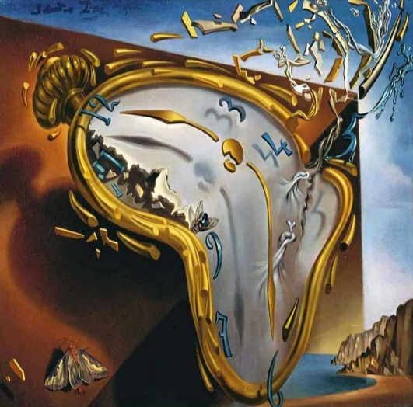
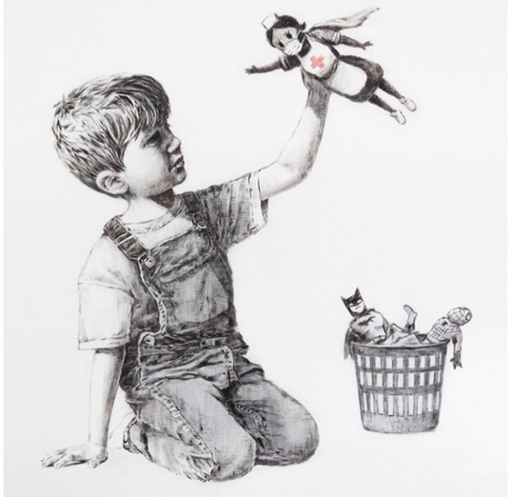

Lesson Plan 19/11/2020
Good morning Dali and Banksy class,
It’s our last day of isolation, YAY! WE can’t wait to see you tomorrow, but until then please see below todays lessons for you to complete. Please take lots of photos of all the wonderful work you do and send them to Miss. Kingston if you are in Dali class or Miss. Davies if you are in Banksy class.
We look forward to welcoming you back to school very soon, but until then please remember to stay safe.
All the best,
Miss. Kingston and Miss. Davies
Maths: Counting to 20
Link to lesson 8:
https://classroom.thenational.academy/lessons/investigating-number-combinations-within-20-64tp8d
Learning Objective:
Investigating number combinations within 20
Equipment:
- 20 cubes or objects for counting
- Number line to 20
- Number cards to 20
- 4 bowls or containers
(Please don’t worry if you do not have a printer at home. All of the material can be written on a piece of paper )

Lesson overview for parents:
- Introduction with Reggie – counting eggs
- Get your equipment ready -number line from 0 -20, number cards 0-20, 20 small objects for counting, 4 small bowls or containers
- Exploring star words: 1-20 and groups
- Sharing your objects between 4 containers
- Independent practice - sharing objects into equal groups
__________________________________________________________________________________
Literacy: Little Red Hen
Link to lesson 8:
https://classroom.thenational.academy/lessons/to-step-a-recycled-story-and-develop-character-c4t6ad
Learning Objective:
I am able to step a recycled story and develop character
Equipment:
- Something to make a pathway
Lesson overview for Parents:
- Introduction with Adam and Panda
- Looking at what is on today’s agenda
- Warm up: role playing games and learning special words: Tell me more
- Recapping the story map
- Stepping out the new story
- Close: recap what we have learnt in the story
__________________________________________________________________________________
Phonics:
These are the sounds we have previously covered in class –
Set 1: s, a, t, p
Set 2: i, n, m, d
Set 3: g, o, c, k
Set 4: ck, e, u

Please note your child may not be able to recall all these sounds and that's okay, the best thing for them is to consolidate them through the sets. (for example, if they are confident with s, a, t focus on practicing ‘p’ and there so on).
For todays lesson please click on the following link and watch Alphablocks ‘k’ video:
https://www.youtube.com/watch?v=Ot0QjqxbKtE
Alphablocks is a great way to practice phonics and home. It is important that the children join in with the clip and practice repeating the sounds discussed. It would be great to pause the clip along the way and question your child on the sounds that are displayed on screen.
And
Phonics play:
Username: nhouse
Password: phonics
- Log into phonics play
- Click resources
- Click on Flash cards time challenge
- Click on start
- Click phase 2
- Choose 1- or 2-minute challenge
Children also enjoy the interactive sound games in phase one. You could try Sound Starters or Welcome to the Zoo. These games are great fun and help develop listening skills, ability to describe sounds and talking about the difference between the sounds they hear and widens their vocabulary, so please give them a go.
Additional:
Books for your children will be uploaded onto Active Learn for them to work through. Teachers will send out login details for your child.
Please listen to your child read the books and help them break words into smaller sounds where they struggle. Please ask your child regular questions about what is happening throughout the book for example:
- What do you think is going to happen next? Why?
- How do you think the character is feeling at that moment? Why?
- Can they recall events throughout the story and tell you what has happened in the book – encourage them to use full sentences.

CHRISTMAS COMPETITION

Please see below information regarding the Christmas Card competition.

