Michelangelo Class Monday 11th – Friday 16th September

Good morning, I hope you have all had a lovely weekend and are all keeping safe and well.
The links for this week’s lessons begin on the page below.

I have also included the broadcast schedule for BBCs Lockdown Learning, this is a new service so I am not too sure about the content but it may be good especially if children are feeling overwhelmed with the formal lessons.
https://www.bbc.co.uk/bitesize/articles/zvryp4j
Starting on Monday 11 January, CBBC will broadcast three hours of primary school programmes from 9am every weekday. They will include BBC Bitesize Daily, as well as other much-loved shows with an educational twist, such as Our School, Celebrity Supply Teacher, Horrible Histories and more.

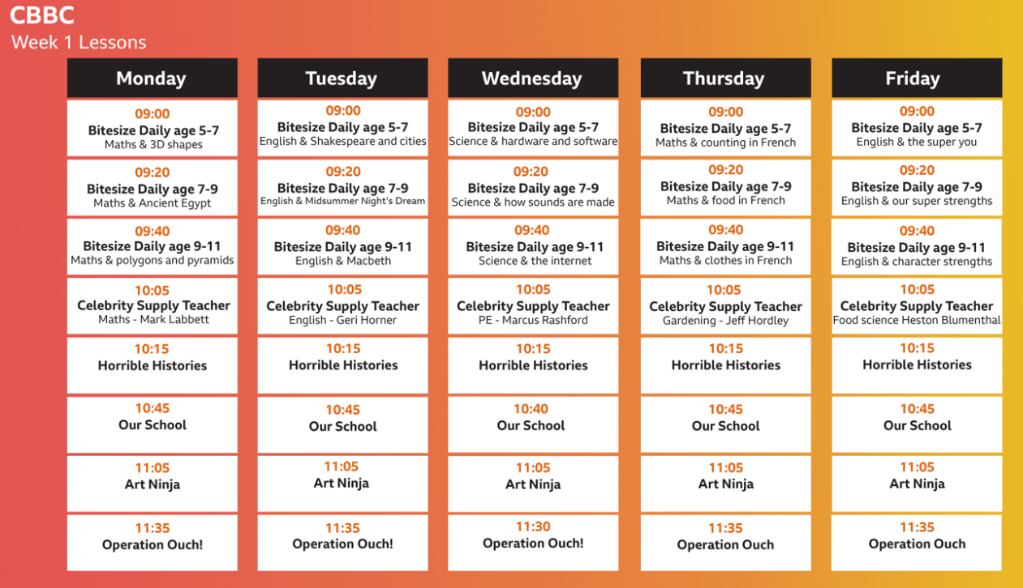

Continue to play these fun phonics and maths games:
Log onto Phonics Play for Phonics Games.
https://www.phonicsplay.co.uk/ username: nhouse password: password

Go to Hit the button for quickfire Maths games
https://www.topmarks.co.uk/maths-games/hit-the-button

Keep logging on to access Active Learn, Times Table Rockstars and Easimaths. I have emailed you the login details. Joe Wicks is also restarting his PE lessons next week.

Feel free to mix and match and find what best works for you and your child. Carry on reading daily, cooking with your children and playing games.
Remember to get in touch if you have any questions at all and continue to email in with pictures of work or fun activities that you are completing. I will be in touch during the week.

Keep safe,

Mr Horsley
Michelangelo Class Monday 11th January 2021

The links below take you to online lessons. For most of the lesson’s children will need a pencil and paper.

English. The BFG, Lesson 5:
In this lesson, we will introduce new vocabulary, identify word pairs and synonyms and apply the vocabulary in sentences.
https://classroom.thenational.academy/lessons/to-develop-a-rich-understanding-of-words-associated-with-night-time-60r3gc

English. The BFG, Lesson 6:
In this lesson, we will think about different ways of referring to the characters introduced in the opening scene of The BFG.
https://classroom.thenational.academy/lessons/to-generate-vocabulary-for-character-description-6rtkct

Maths. Fractions, Lesson 1:
In this lesson we will be exploring what equal and unequal mean and finding half of a shape by dividing it into two parts.
https://classroom.thenational.academy/lessons/to-identify-one-half-of-a-shape-60up2c

PSHE. All around me, Lesson 1:

Community care
In today’s lesson, you will understand what a community is and explore the different types of communities.
https://classroom.thenational.academy/lessons/community-care-cctp8c

Geography: Mountains, Volcanoes and Earthquakes, Lesson 1:

What is the Earth made of?
In this lesson, we are going to be learning about the structure of the Earth.
https://classroom.thenational.academy/lessons/what-is-the-earth-made-of-6hk3ec

Michelangelo Class Tuesday 12th January 2021

The links below take you to online lessons. For most of the lesson’s children will need a pencil and paper.

English. The BFG Lesson 7:
In this lesson, we will practise the rules associated with adding the suffix -ed.
https://classroom.thenational.academy/lessons/to-practise-and-apply-knowledge-of-suffixes-past-and-present-tense-including-a-test-61h3ce

English The BFG Lesson 8:
In this lesson, we will analyse the opening scene of The BFG and generate vocabulary to describe the setting, what we can hear and what we can see. We will then think about how we feel when we watch the opening and how we can reflect this in our writing.
https://classroom.thenational.academy/lessons/to-analyse-the-opening-scene-70u36t

Maths. Fractions Lesson 2:
In this lesson we will be finding one half of a quantity by splitting the whole into two equal parts.
https://classroom.thenational.academy/lessons/to-find-half-of-a-quantity-6nhpct

Music. Lesson 1:
This lesson will include a fun warm-up and learning a song from Brazil through performing rhythm and pulse simultaneously, with an added challenge at the end!
https://classroom.thenational.academy/lessons/to-understand-how-to-maintain-the-pulse-using-the-voice-and-body-60up2d

Science: Light and Dark, Lesson 1:
In this lesson we are going to learn about light and dark.
https://classroom.thenational.academy/lessons/what-is-light-c4w30d

Michelangelo Class Wednesday 13th January 2021

The links below take you to online lessons. For most of the lesson’s children will need a pencil and paper.

English. The BFG Lesson 9:
In this lesson, we will learn about fronted adverbials and recap the purpose of an opening.
https://classroom.thenational.academy/lessons/to-write-the-first-part-of-the-opening-part-1-6ctp6c

Maths. Fractions Lesson 3:
In this lesson we will be finding one quarter by dividing the whole into four equal parts.
https://classroom.thenational.academy/lessons/to-find-one-quarter-of-a-shape-c8r66c

PSHE. All around me, Lesson 2:

Community care
In this lesson, you will explore the roles and responsibilities that you, as a citizen, have in your community.
https://classroom.thenational.academy/lessons/i-roll-with-my-role-65h3gr

Geography: Mountains, Volcanoes and Earthquakes, Lesson 2:

What are fold mountains?
In this lesson, we are going to be learning about mountain ranges across the world and how they are formed.
https://classroom.thenational.academy/lessons/what-are-fold-mountains-61hp2r

Science: Light and Dark, Lesson 2:
In this lesson, we will be learning how our eyes are able to see different objects.
https://classroom.thenational.academy/lessons/how-can-we-see-objects-6ct6ct

Michelangelo Class Thursday 14th January 2021

The links below take you to online lessons. For most of the lesson’s children will need a pencil and paper.

English. The BFG Lesson 10:
In this lesson, we will practise extending sentences using joining words. Following shared writing, we will carry on writing the first part of the opening.
https://classroom.thenational.academy/lessons/to-write-the-first-part-of-the-opening-part-2-ccr36t

Maths. Lesson 4:
In this lesson we will be finding a quarter of a given quantity and applying this to a part-whole model.
https://classroom.thenational.academy/lessons/to-find-one-quarter-of-a-quantity-6xjkad

Music. Lesson 2:
This lesson will include: a warm-up; learning a body percussion pattern; exploring graphic notation to help us perform on and off beat rhythms, and a challenge at the end!
https://classroom.thenational.academy/lessons/to-understand-the-difference-between-on-and-off-beats-crr3gd

Science: Light and Dark, Lesson 3:
In this lesson, we will be learning about the difference between night and day.
https://classroom.thenational.academy/lessons/what-is-the-difference-between-night-and-day-60wp2c

Buddhism Lesson 2:
In this lesson, we are going to be learning about Buddhism as a religious tradition that was originally passed on by word of mouth.
https://classroom.thenational.academy/lessons/what-are-the-four-noble-truths-of-buddhism-74tp6d

Michelangelo Class Friday 15th January 2021

The links below take you to online lessons. For most of the lesson’s children will need a pencil and paper.

English. The BFG Lesson 11
In this lesson, we will watch and order the second part of the opening. We will also look at ways to show not tell.
https://classroom.thenational.academy/lessons/to-write-the-second-part-of-the-opening-part-1-crtk4c

Maths. Fractions Lesson 5:
In this lesson we will be exploring half, quarter and three-quarter turns.
https://classroom.thenational.academy/lessons/to-identify-half-quarter-and-three-quarter-turns-6dgkjc

PSHE. All around me, Lesson 3:

Community care
In today’s lesson, you will be able to recognise the different groups that make up and contribute to a community.
https://classroom.thenational.academy/lessons/we-are-a-jigsaw-6cv3ed

Geography: Mountains, Volcanoes and Earthquakes, Lesson 3:
In this lesson, we are going to be learning about how volcanoes are formed.
https://classroom.thenational.academy/lessons/how-are-volcanoes-made-71h3cd

Music, Lesson 3:

This lesson will consolidate some of the learning from lesson 2, as well as exploring how off beats can be found in different musical styles.
https://classroom.thenational.academy/lessons/to-explore-on-and-off-beats-in-different-musical-styles-chj32c

