Banksy home learning timetable
Today I will….

Make my bed | 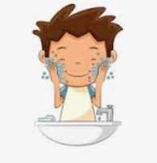  Wipe my face after eating breakfast | Brush my teeth | Feelings check in  Talk to an adult about how you are feeling today  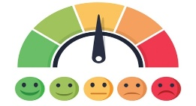 | Get active  PE with Joe Wicks on his YouTube channel  BBC Super Movers  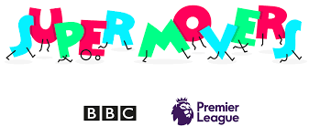 | Complete my phonics activity
Have a mid-morning snack.  Remember to drink lots of water. | Feelings check in  Talk to an adult about how you are feeling now | Complete my maths activity | Read a book on Bug Club | Play! | 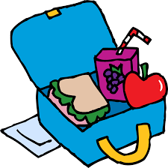  Help to make / set out lunch
Get active  Cosmic yoga  Go Noodle | Play a game  I spy  Noughts and Crosses  Guess Who  Connect 4  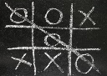 | Feelings check in  Talk to an adult about how you are feeling now | Go out for your 1 hour daily exercise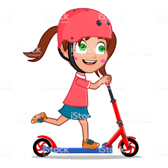 | Share some books with an adult | Creative time  Painting  Baking  Junk modelling  Colouring in  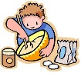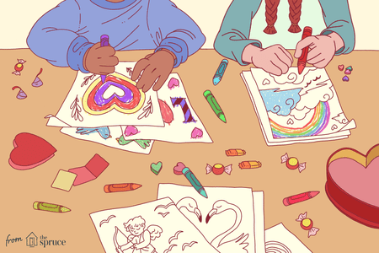
Feelings check in  Talk to an adult about how you are feeling now | Help to make dinner or set the table | Send my teacher a picture of my home learning | Take a bath, wash or shower before bed | Brush my teeth | Listen to a bedtime story

