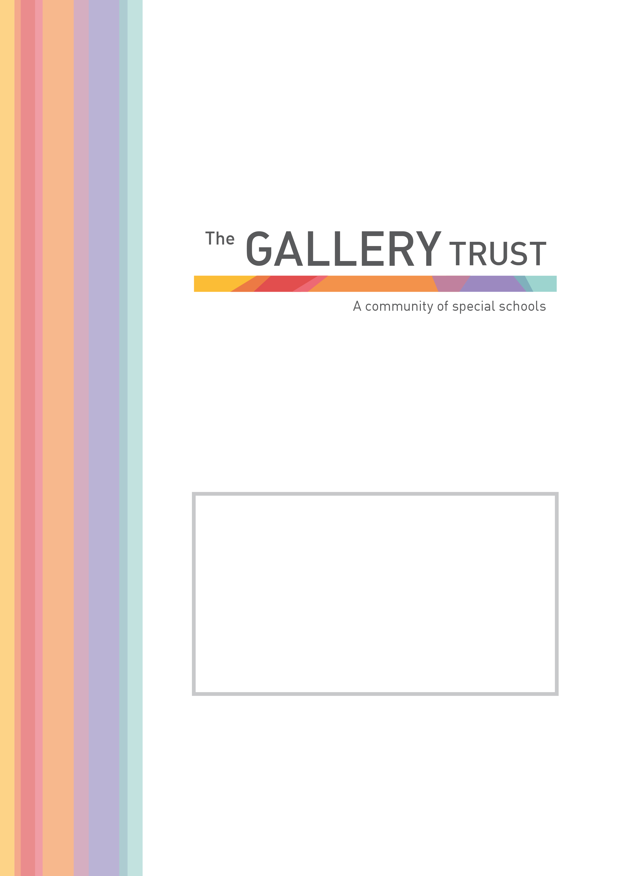
Lunchtime supervisor
Bardwell School

Candidate Information Pack
September 2021

Contents

About The Gallery Trust

About Bardwell School

Job Description

Application Process

Selection criteria

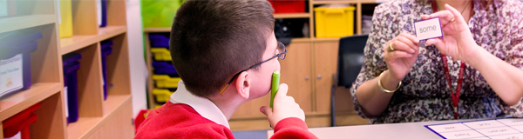

About The Gallery Trust

The Gallery Trust is a successful Multi Academy Trust based in Oxfordshire, and is an exempt charity and a limited company. The Trust’s charitable objectives are focused on providing outstanding education and support for young people with special needs and disabilities. The Trust has a strong vision and values and is dedicated to:

- Commitment to special education – striving to provide the best specialist learning experience for all students
- Opportunities for all to learn – ensuring that students and staff have access to learning pathways which enhance their lives
- Genuine respect and value – creating relationships which promote trust, confidence and respect within environments which are safe and secure

The largest SEND Trust in the county, there are 430 staff working for the MAT within 8 establishments:
- Iffley Academy, Oxford
- Bardwell School, Bicester
- Orion Academy, Oxford
- Northern House Academy, Oxford
- Springfield School, Witney
- Mabel Prichard School, Oxford
- Bloxham Grove Academy, Bloxham (in pre-opening phase, to open 2022)
- Didcot School (in pre-opening phase, to open 2023/2024)
- The Gallery@Longford Park
- The Grove@Longford Park

Further expansion is anticipated over the next 3 years.

The Trust is an established voice of SEND in Oxfordshire, and works strategically with Oxfordshire County Council, the Department for Education and the Regional Schools Commissioner to meet the demand for special school places in Oxfordshire. The Trust is funded by the Department for Education, with additional SEND funding provided by Oxfordshire County Council.

The Trust has an executive team which comprises of Director of Schools, Chief Operating Officer and Director of Development reporting to the Chief Executive Officer. The Chief Operating Officer manages the Business Services team which provides the full range of back office services to schools, including Finance, Audit, Risk management, Estates, ICT, and Health and Safety. The School Improvement team is managed by the Director of Schools. The Chief Executive Officer performs the role of Accounting Officer and reports to the Board of Trustees

About Bardwell School

Bardwell School is a successful school and has grown in recent years with a current number
on roll of 103 students.

Bardwell School is a community special school for children aged 2 – 19 with severe learning
difficulties and profound and multiple learning difficulties. We are passionate about children at Bardwell having their abilities recognised and celebrated, whilst receiving an excellent education. The whole staff team is committed to very high standards both professionally and in relation to every aspect of our pupils’ education.

Bardwell School is seeking inspirational and dynamic Lunchtime Supervisor, gifted practitioners who can meet the needs of this vibrant and diverse community.

Bardwell School is a member of The Gallery Trust, an expanding Special School Trust which
is dedicated to improving outcomes for SEND learners in Oxfordshire. The Trust has a national reputation for excellence and is influential in the development of SEND strategy in the county. With six academies currently in the Trust, two special academies in pre- opening and with two special schools currently in negotiation to join our MAT, the Trust’s aim is to build a community of special schools.

Please visit our website to find out more about the school, and if you would like to visit the school to find out more about this exceptional opportunity and inform your application, you will be most welcome. Our staff and students will be delighted to meet you!

On behalf of the Board of Trustees, thank you again for your interest and we look forward to hearing from you.

Matthew Selsdon
Interim Headteacher

Lunch-Time Supervisor

Grade 4: £18,933 pro rata per annum
Actual annual salary £3,196.41 per annum
7.5 hours a week, term time only (38 weeks a year)
To start April 2020 (or as soon as possible)

Bardwell School is the community special school in Bicester, we serve the Bicester and Kidlington areas, but also have children from across Oxfordshire. We are seeking enthusiastic and motivated staff to join our thriving and vibrant community at an exciting time in our development.

Judged as Good by Ofsted in July 2018, we recognise ourselves as a very strong school, that is on a continuous journey of school improvement. We make respectful relationships with our students through our understanding of their special educational needs, thorough assessment of their skills and abilities and carefully planning next steps for them. We are a warm and caring community, dedicated to equipping pupils with the skills and knowledge they need to succeed.

The role of the Lunchtime Supervisor involves setting appropriate boundaries for children, supporting with their education and care and liaising with families to get the best possible outcomes. You will have the attributes to work across the whole school, and will have, or be willing to quickly develop, skills to create a climate for success to support pupils with special educational needs and disabilities to learn and develop. You will also demonstrate a resilient and instinctive approach in meeting our pupils’ needs.

If you share our passion for making a real difference to the lives of children and young people with special needs, this could be the opportunity you are looking for. In return for your contribution to our team, you will work in an environment, which is innovative and in a role which is rewarding and fulfilling. We will provide you with induction and training, and the opportunity to join the Local Government Pension Scheme, one of the largest public sector pension schemes in the UK. This is an exciting time to join our team, having recently joined The Gallery Trust, we are further developing our curriculum and assessments and will soon be having a new hall and classrooms built to support further expansion.

JOB DESCRIPTION

Lunch-Time Supervisor

Job and Person Summary
Bardwell School is a Special School that educates children and young adults who have a wide range of Learning Difficulties. We are looking to employ lunchtime staff to support our pupils and young adults when eating their lunch and throughout their break-time.
The successful applicants will join class teams consisting of a class teacher, and teaching assistants. If you have the right attitude and ethos to work at Bardwell School we will support you by providing induction and training to ensure you have the skills and knowledge to support our pupils effectively.
To be considered for this role you must have:
- High expectations of all children and a commitment to ensuring they can develop and reach their potential.
- The ability to develop fair, respectful, supportive and constructive relationships with young people.
Personal Qualities you have will include:
- A fun, can do approach
- The ability to communicate effectively with children, young adults and colleagues.
- Being able to act on feedback and be open to mentoring.
- Patience.
- The ability to celebrate positive behaviour and achievements.
We will provide induction and training to ensure you:
- Have the skills to support pupils with their eating, drinking and personal care needs.
- Understand the importance of effective positioning and the principles that underpin this.
- Have knowledge on how to establish a stimulating play environment and positively influence our pupils’ play opportunities.
- Know how to make professional judgments to prioritise and manage a range of tasks.
- Carry out your duties in line with our School Policies, including Safeguarding and Child Protection and Health and Safety Policy.
At Bardwell School we take safeguarding seriously. All staff have a responsibility to keep our pupils and staff safe. You will receive training in line with this crucial responsibility.

A typical day will include:
11.45: Arrive in class and discretely complete any preparation tasks before lunch (this could include washing items used during morning lessons and supporting pupils with personal care).
11.55 – 12.30: Supporting pupils to develop independence with their eating skills. This may also include administering medication and supporting pupils who are fed by gastronomy tube.
12.30 – 13.00: Supervising play activities and having a positive influence while encouraging an inclusive play atmosphere.
13.05: Ensuring pupils are back in class to start their afternoon lessons. Discretely support any preparation for the afternoon (including washing items used at lunch time and supporting with personal care).
13.05 – 13.15: Completing any tasks in class following lunch (this could include washing items and supporting pupils with personal care).
This role will also include completing personal care tasks with pupils, supporting children who may express their feelings and frustrations who behaviours. It will suit a positive, dynamic person with a can do, flexible approach.
The above activities are only an indication of the advertised role. You will have a flexible attitude and will work under the direction of the class teacher and headteacher.

Application Process

To apply for this post, please email jobs@bardwell.oxon.sch.uk or telephone 01869 242182 to request an application form and a job pack. You can also download an application form and job pack from our website: www.bardwell.oxon.sch.uk

Please submit your application form by Monday 4th October 2021 at 5pm to jobs@bardwell.oxon.sch.uk or by post. Please ensure you detail any gaps in employment and use the selection criteria which is contained in the job pack when you prepare your application, as shortlisting for interview will be based on how closely you demonstrate your ability to fulfil the essential criteria. We do not accept CVs. If you are shortlisted, we will take up written references before your interview so please provide permission for this and provide accurate phone and email contact details for your referees. One of your referees must be your current or last employer, and if you are employed in a school, must include your current Head Teacher.

The Gallery Trust is committed to safeguarding and promoting the welfare of all children and expects all staff to share this commitment. The successful candidate will be subject to an Enhanced DBS check, Occupational Health check and a probationary period of 6 months. The Gallery Trust is an equal opportunities employer and we welcome applications from a range of ethnic backgrounds to represent diversity in line with our school community.

SELECTION CRITERIA

Lunch-Time Supervisor

Essential:

- Understanding of child development and learning
- Ability to relate well to children and adults
- Ability to work flexibly, throughout the whole school, meeting the needs of pupils in a range of contexts
- Good organisational and interpersonal skills
- Willingness and ability to undertake physical management of pupils, following appropriate training

Desirable:

- Experience of working with or caring for children of relevant age
- Team Teach trained
- First aid trained
- Understanding of relevant policies/codes of practice and awareness of relevant legislation

