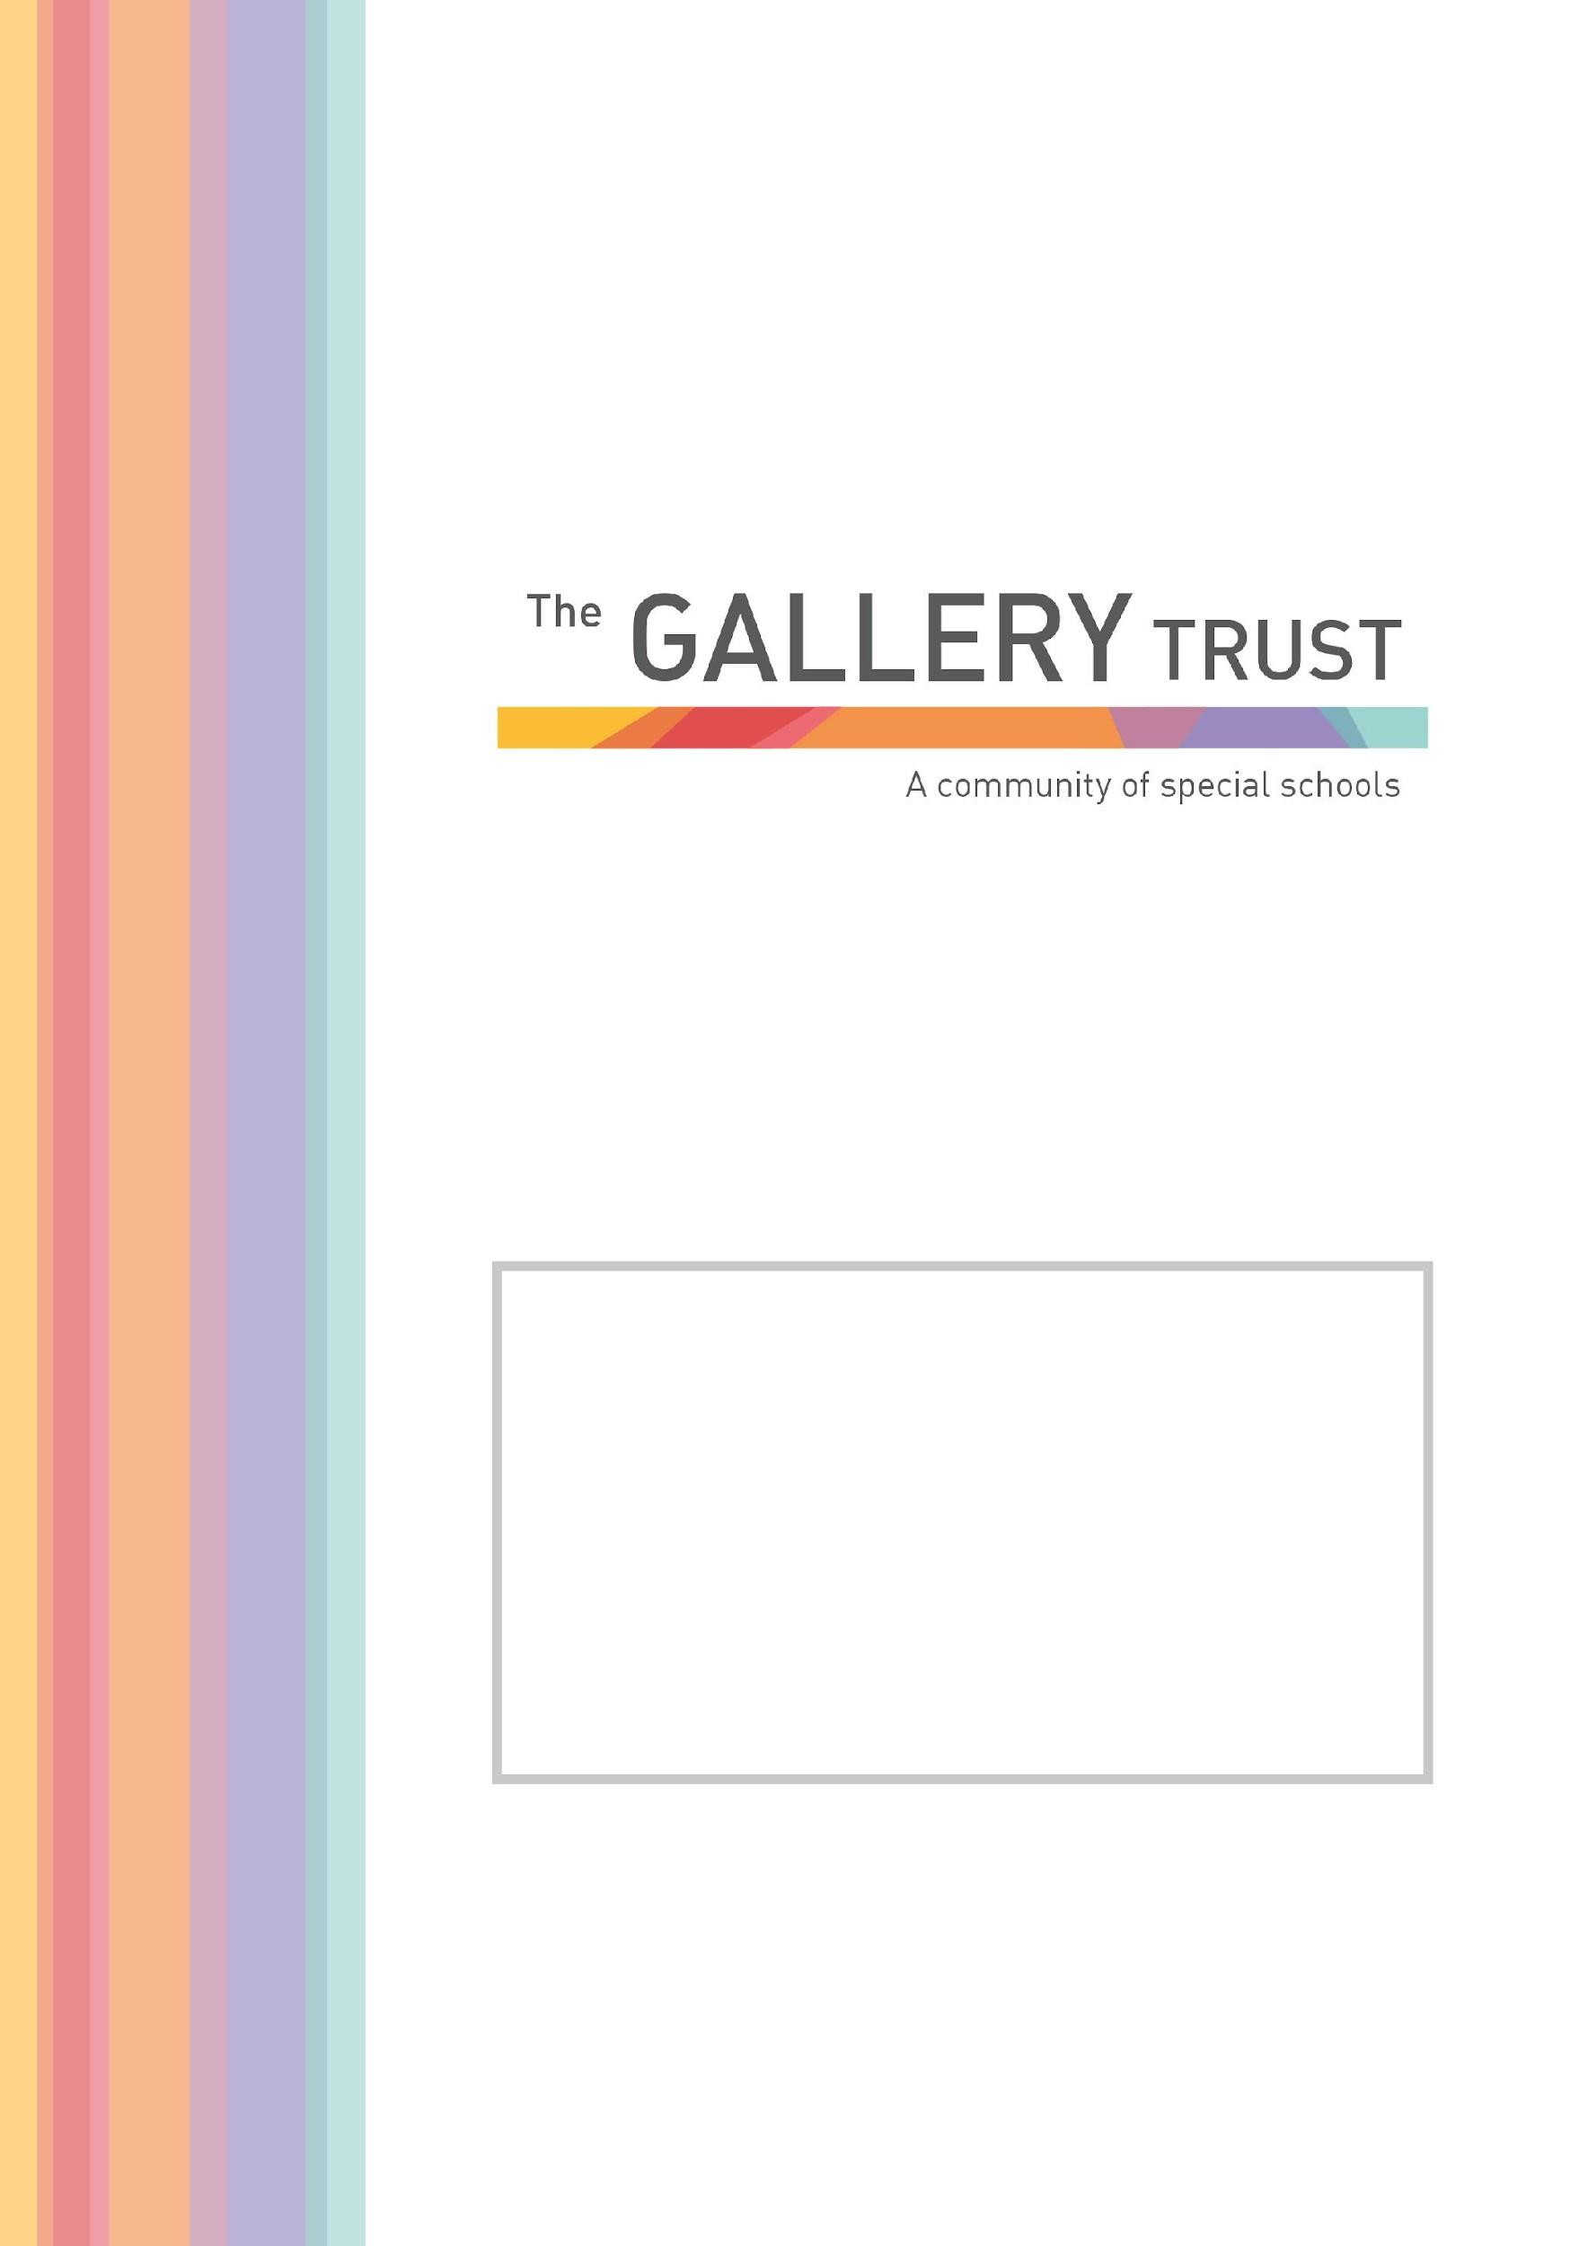

Administrative Assistant
Candidate Information Pack
September 2021

[insert message from Head with image. Example below is for Bardwell]

Thank you for your interest in the post of Administrative Assistant at Mabel Prichard School.

We are a community special school for children and young people with complex needs from the ages of 2 to 19.
At Mabel Prichard School, we believe in enabling every student to discover who they are and to realise their full potential. Our curriculum offers a broad range of opportunities to face challenge; develop independence; prepare for adulthood; discover the world around them; be safe and develop the skills and knowledge to lead a happy, positive and fulfilled life.
Through our strong caring ethos, we support students to respect their whole community, regardless of background, race, gender, faith and disability and to celebrate diversity, so they are able to develop skills of empathy and tolerance in their life ahead.
We believe education plays a pivotal role in developing as individuals, alongside the vital input from families and other professionals whom we enjoy working closely with. The purpose of the school is to create opportunities through education for each student to value themselves and each other; develop confidence; communicate their thoughts and ideas and to enjoy discovering their strengths to take forward in their life ahead.
Mabel Prichard School is a member of The Gallery Trust, an expanding Special Needs Multi Academy Trust which is dedicated to improving outcomes for SEND learners in Oxfordshire. The Trust has a national reputation for excellence and is influential in the development of SEND strategy in the county. With six academies currently in the Trust, our aim is to build a community of eight to ten special schools over the next five years.

Please visit our website to find out more about the school. If you would like to visit the school to find out more about this exceptional opportunity before you submit your application, you will be most welcome. Our staff and students will be delighted to meet you.

Thank you again for your interest and we look forward to hearing from you.

Lucy Wawrzyniak
Executive Headteacher

Administrative Assistant
Grade 5
Actual Salary £13041.62 - £13568.37 per annum
(FTE Salary £19312 - £20092 per annum)
30 hours per week, 38 weeks per year, term time only
Monday to Friday 8:30am – 3:00pm
To start as soon as possible

We are seeking to appoint an enthusiastic and dynamic Administrative Assistant to join our existing administration team, working on both our primary and secondary sites.

You will:

- Have numeracy and literacy GCSE’s (or equivalent), at Grade C or above
- Experience of working in a school or educational setting
- Confident in the use of internet, email and database programs
- Be committed to ongoing self-development and training
- A good team player with the ability to work on their own initiative

Application Process

To apply for this post, please email recruitment@mabelprichard.org. You can also download an application form and job pack from our website www.mabelprichard.org or from The Gallery Trust website www.thegallerytrust.co.uk

Please submit your application form by Friday 5th November at 12 noon to recruitment@mabelprichard.org or by post. Please ensure you detail any gaps in employment and use the selection criteria which is contained in the job pack when you prepare your application, as shortlisting for interview will be based on how closely you demonstrate your ability to fulfil the essential criteria.

We do not accept CVs. If you are shortlisted, we will take up written references before your interview so please provide permission for this and provide accurate phone and email contact details for your referees. One of your referees must be your current or last employer, and if you are employed in a school, must include your current Head Teacher.

The Gallery Trust is committed to safeguarding and promoting the welfare of all children and expects all staff to share this commitment. Any offer of employment with The Gallery Trust is subject to verification of ID and qualifications, satisfactory evidence of the right to work in the UK, health clearance, NCTL and Enhanced Disclosure and Barring Check. The Gallery Trust is an equal opportunities employer, and we welcome applications from candidates from all ethnic and community backgrounds.

The Gallery Trust is a Multi Academy Trust which is dedicated to improving outcomes for SEND learners in Oxfordshire. The aim of the Trust is to provide outstanding education and support for young people with special needs and disabilities, enabled through:

- Commitment to special education – striving to provide the best specialist learning experience for all students
- Opportunities for all to learn – ensuring that students and staff have access to learning pathways which enhance their lives
- Genuine respect and value – creating relationships which promote trust, confidence and respect within environments which are safe and secure

The Trust is on a continuing journey of expansion, growing from a Multi Academy Trust based on a single academy in 2013, to its position as the largest Special Trust in Oxfordshire.

The schools in the Trust are:

- Bardwell School, Bicester
- Bloxham Grove Academy, Bloxham, to open in 2022
- A Free Special School in South Oxfordshire, opening date to be confirmed
- Iffley Academy, Oxford
- Mabel Prichard School, Oxford
- Northern House Academy, Oxford
- Orion Academy, Oxford
- Springfield School, Witney
- The Grove (satellite provision of Orion Academy)
- The Gallery (resource base for mainstream students)

The Trust’s vision is to continue to expand over the next five years, supporting a community of converter academies, free schools and sponsored academies. All member academies have the opportunity to share SEND expertise and to work with peers who share common aims and goals.

The Trust is committed to investment in learning, developing system leadership, working in partnership and through a shared vision, enabling all students to reach their full potential.

At Mabel Prichard School students work in class groups where teachers differentiate learning for all students, ensuring lessons are inclusive for all.

The school has developed a comprehensive and broad skills-based curriculum, which can be found on the school’s website. This curriculum, which is underpinned by detailed assessment processes, guides the learning for all students. The school has excellent links with community partners and its strong focus on pathways to adulthood supports students onto further education and into employment.

The committed team at Mabel Prichard School includes class teachers, teaching assistants, lunchtime supervisors, care assistants, school business manager and admin team, caretaker and cleaning team and safeguarding leads.

The school recognises its success is based on successful partnerships. Most importantly, the school works closely with parents and understands that they know their child best. The wider multi-professional team at Mabel Prichard includes a Special School Nurse, Speech and Language Therapist, Occupational Therapist and Physiotherapist. The school also hosts health clinics through the special school nurse provision.

Administrative Assistant
Job Description

Introduction

This job description describes in general terms the normal duties which the postholder will be expected to undertake. However, the job or duties described may vary or be amended from time to time without changing the level of responsibility associated with the post.

The performance of all the duties and responsibilities shown below will be under the reasonable direction of the School Business Manager. The School Business Manager will be mindful of her/his duty to ensure that the employee has a reasonable workload and sufficient support to carry out the duties of the post.

The job description will be reviewed at least annually, and any changes will be subject to consultation. The academy’s grievance procedure will be used to resolve any disagreement arising out of the job description. Other relevant policies may be the Stress at work policy and Dignity at work policy.

Job Purpose

Organisation

- Undertake reception duties, answering general telephone and face to face enquiries and signing in visitors
- Assist with pupil first aid/welfare duties, liaising with parents/staff etc
- Assist in arrangements for school trips, events etc

Administration

- In line with LA procedures and working alongside a member of the senior leadership team, arrange annual reviews of Education, Health and Care Plans, co-ordinating all relevant stakeholders and providing all relevant paperwork

- Provide general clerical/admin. support e.g. photocopying, filing, complete standard forms, respond to routine correspondence

- Maintain manual and computerised records/management information systems

- Produce lists/information/data as required e.g. pupil data, attendance

- Take notes at meetings

- Sort and distribute mail and email correspondence

- Maintain pupil records

Resources

- Operate relevant equipment/ICT packages (e.g. Microsoft Office, RM Integris, ParentMail)
- Maintain stock and supplies, cataloguing and distributing as required
- Hold a charge card for Adhoc and emergency purposes
- Receipt and logging of income

Responsibilities

- Be aware of and comply with policies and procedures relating to safeguarding, health, safety and security, confidentiality and data protection, reporting all concerns to an appropriate person
- Be aware of and support difference and ensure equal opportunities for all
- Contribute to the overall ethos/work/aims of the school
- Appreciate and support the role of other professionals
- Attend and participate in relevant meetings as required
- Participate in training and other learning activities and performance development as required

Personal Skills
- Ability to work within a team
- A friendly welcoming disposition
- Ability to work under pressure
- Ability to manage time and workload well.
- An understanding of children with special needs
- Professional conduct
- To adhere to confidentiality

The above list of job duties is not exclusive or exhaustive and the post holder will be required to undertake such tasks as may reasonably be expected within the scope and grading of the post.

Selection Criteria
Person Specification Administrative Assistant Grade 5

 | Essential | Desirable
Experience | Previous experience of working in a school or similar environment
Qualifications/  Training | Good numeracy/literacy skills, equivalent to GCSE grade C or above. | Qualification or experience in relevant discipline
Knowledge/Skills | - Confident in the use of the internet, email and database programs  - Use of relevant equipment/resources  - Good keyboard skills  - Ability to relate well to children and adults  - Work constructively as part of a team, understanding school roles & responsibilities and your own position within these  - Communicate effectively (both verbally and in writing at all levels to a variety of audiences e.g. pupils, staff, parents, visitors  - Promote a positive working environment  - Be able to prioritise workloads; have excellent time management and organisational skills  - Be able to work under pressure and meet deadlines  - Be able to use initiative  - Produce accurate work | - Knowledge of the administration processes involved in Education, Health and Care Plans  - Use of RM Integris  - Use of GDrive  - Appropriate knowledge of first aid  - Understand the statutory requirements of legislation concerning Safeguarding, including Child Protection, Equal Opportunities, Health & Safety and inclusion

