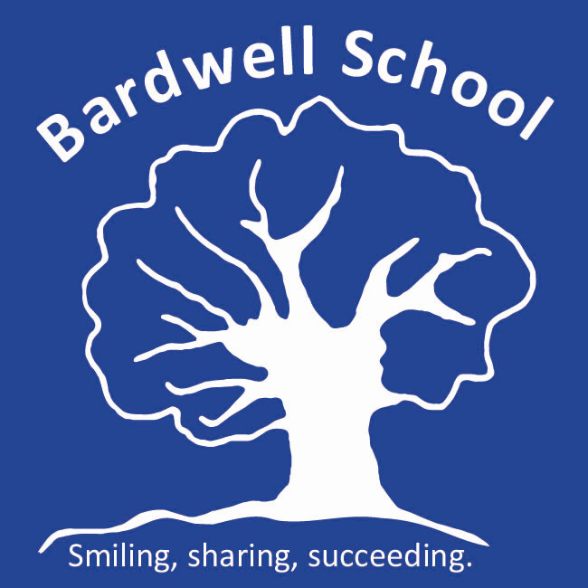

Experience in Work Policy

Written: November 2021
Date of review: September 2024
Bardwell Lead: Matthew Selsdon (Interim Headteacher)
Signed LAB:
Signed TGT:

1. Introduction

Experience in work or work experience, is defined by The Department for Education (DfE) as “a placement on an employer’s premises in which a student carries out a particular task or duty, or range of tasks and duties, more or less as would an employee, but with the emphasis on the learning aspects of the experience.” By law, pupils from year 9 upwards can access work experience.

Experience in work can be classified as either:
- Block - the placement takes place over 5 or 10 consecutive working days.
- Extended - the placement takes place on 1 or 2 days per week over a period of time. Schools must ensure that they comply with the criteria that are designed to safeguard students' entitlement to a broad and balanced curriculum. It is therefore unlikely that extended work experience of more than two days a week will meet this requirement.

For the purpose of this document, the term ‘employer’ has been adopted to refer to the company that is offering experience in work. The term ‘employee’ is used to refer to anyone that is employed by this company. The term ‘pupil’ or ‘student’ refers to the young people enrolled at Bardwell school. Support staff from Bardwell such as teaching assistances and teachers are referred to as ‘staff’.

2. Aims and benefits of Experience in Work

At Bardwell, the majority of our pupils are offered access to experience in work. This gives them the opportunity to develop their personal and social skills and to directly learn about the world of work. Pupils develop skills necessary to operate in a workplace e.g. appropriate dress, time keeping and social interactions at work. Each of our pupils have individual targets when taking part in experience in work, focused around developing their key skills and generalise these skills to a range of settings. At Bardwell, we aim to prepare our pupils for their lives beyond Bardwell and this is just one of the opportunities we provide our pupils to support them with this (additional information on the opportunities we offer pupils can be found in our post-16 curriculum document)..

3. Supporting Experience in Work

The level of support that we provide pupils when they are undertaking experience in work is decided on an individual basis and can change across a placement depending on progress and confidence in a placement. Largely, the support we provide falls into the following categories:
- Staff providing 1:1 support
- Staff providing small group support
- Staff closely shadowing a pupil
- Staff shadowing a pupil from a distance
- Staff facilitating travel to and from a place of work but then leaving them to complete the placement independently
- Completely independent placements

4. Organising Experience in work

To ensure that we are fulfilling our statutory requirements and appropriately safeguarding pupils that attend experience in work, we work alongside Oxfordshire Local Enterprise Partnership Ltd (OxLEP). OxLEP supports Bardwell by ensuring employers are offering a safe work environment for pupils, as well as making sure they are following all the legal requirements for a pupil to be placed. Additional information about OxLEP can be found on their website at:

https://www.oxfordshirelep.com/skills/our-programmes/work-experience.

For every placement that pupils attend, the following process is followed:
- Bardwell source a placement. As part of this, we explain to the employer when we would like our pupils to attend, what we’d like them to achieve, the hours of work and any support or adaptions that will need to be put in place to facilitate the placement. At this point in the process, Bardwell will explain to the employer that OxLEP will need to complete a health and safety inspection and see their liability insurance certificate before the placement can start. It should also be explained that the employer is responsible for conducting risk assessments for the students whilst on their premises.
- Bardwell will send home a consent form to parents (Appendix 1) to gain consent for the placement to go ahead.
- At Bardwell, we fill in a form to inform OxLEP of the placement we have arranged (Appendix 2).
- Completed forms are sent back to: Sophia.Sokolowski@oxfordshirelep.com
- OxLEP then check that the placement meets all of the statutory obligations. This includes checking the working hours and break entitlements are followed, ensuring appropriate risk assessments are in place, checking what DBS checks are already in place (they will inform the school if they feel a DBS should be in place, see ‘Safeguarding’ section below), ensuring that the company holds the relevant insurance, as well as completing a health and safety inspection on the premise (see the next section for additional information on this).
- Once OxLEP have approved a placement, they let Bardwell know that the placement has been approved.
- The first time a pupil attends a placement, they will be given a health and safety induction by the employer. Sometimes this will be conducted on their first shift but it could also be delivered on a pre-visit. This will be agreed with the employer prior to the placement starting.
- At this point, pupils are able to regularly attend the placement.
- Bardwell will keep an open dialogue with employers throughout the placement and will conduct appropriate reviews of the placements to ensure they continue to meet the needs of the students.

5. Health and safety

To ensure that pupils are safe within their placements, a number of checks take place. This includes OxLEP completing a health and safety check. This check is completed by their qualified health and safety inspectors and it ensures that the following are checked:
- That contact details such as their address, email and telephone information are all correct.
- Who is responsible for health & safety at the business and who will be supervising the student
- That there is a Health and Safety policy in place (if there is more than 5 employees)
- That the employer will complete a Health and Safety induction for the student on day one or before
- That a Health and Safety poster is displayed (if more than 5 employees)
- That there is a fire evacuation procedure in place, fire exits are clear, extinguishers provided and relevant signage is displayed (if applicable).
- That first aid arrangements are in place, accidents are recorded and investigated.
- That written risk assessments exist for the business (if more than 5 employees)
- What personal protective equipment is provided and what the student will need to provide themselves (Most employers provide all PPE unless there is a requirement for safety shoes/boots and then the student is usually expected to provide their own).
- That welfare facilities are available i.e. toilets, washing facilities, drinking water, rest areas/somewhere to eat.
- Identify with the employer what hazards the student may be exposed to and the control measures in place to reduce risk.
- That the employer is aware of child protection issues and that, to their knowledge, no one who will come into contact with the student has been disqualified from working with children. Although, it isn’t usually required that employers are DBS checked, they note if they already have a DBS in place.
- Collect any specific information relevant to the opportunity being provided i.e. job description, dress requirements, hours of work, meal times/breaks, transport (most employers require the student to get there under their own steam). They also ask if there are any other requirements i.e. medical conditions which might preclude the student from the placement.
- A physical check that they have current employer liability insurance in place which will cover the student. Also if the student is travelling in a company vehicle, OxLEP confirm that they have business use insurance covering the vehicles.

To further ensure safety of our pupils at these placement, we provide support from our school staff, based on their individual need (as described above).

6. Safeguarding

To ensure that our pupils are continually safeguarded from harm, we ensure that employers are fulfilling their legal duties prior to sending pupils to a placement (as detailed above). We also share information with employers about what to do if they have any concerns about the wellbeing of pupils. We provide employers a contact details sheet, which shares the details of the teacher that they are dealing with, alongside information about the safeguarding lead and how they can contact them (see appendix 3).

OxLEP ensures that employers are aware of child protection issues and collect information about the employees to make sure there is no risk to our students from those that have been barred from working with children. Although it is not standard practice to ask employers to be DBS checked, we recognise cases where a DBS is necessary, for example if a pupil that is under the age of 16 is attending without support from Bardwell staff or in placements that may require pupils to work in a secluded area on a 1:1, or for placements where a student will be attending long term, working closely with an employee there on a 1:1 basis. Bardwell and OxLEP will work together to decide when a DBS is necessary. It is Bardwell School’s responsibility to initiate the DBS checks if we feel that one is necessary for the placement.

APPENDIX 1 – Experience in work - Parental consent
Dear parents/carers,
We are delighted to inform you that (pupils name) has been offered the chance to participate in Experience in Work.
This will take place at (company’s name) *every/between (day of the week/period of time). (Pupils name) will start at (starting time) and finish at (finishing time).
*This experience will be supported by a member of staff who will accompany then throughout their time.
OR
*They will attend this placement independently and we have organised (describe travel arrangements to and from the placement).
Before the placement can be approved, a number of checks will be carried out to ensure that the company is fulfilling its statutory requirements e.g. health and safety checks, insurance checks, risk assessments etc. If there are any significant risks found, we will communicate these with you prior to the placement starting. Please note, if the risk is considered to be too high, the placement will not be approved.
We have enclosed a copy of our Experience in Work policy for your information. Please read through the document, and then complete the slip below.
If you have any further questions, please do not hesitate in contacting me.
*delete at appropriate
(teachers name and contact details)

I *consent/do not consent to (pupils name) participating in Experience in Work at (company’s name) and I have understood the schools Experience in Work Policy.
____________________________ ____________________________
(Parent/carer - Print name) (Parent/carer - signature)

APPENDIX 2 – OxLEP Skills – Extended Placement Form
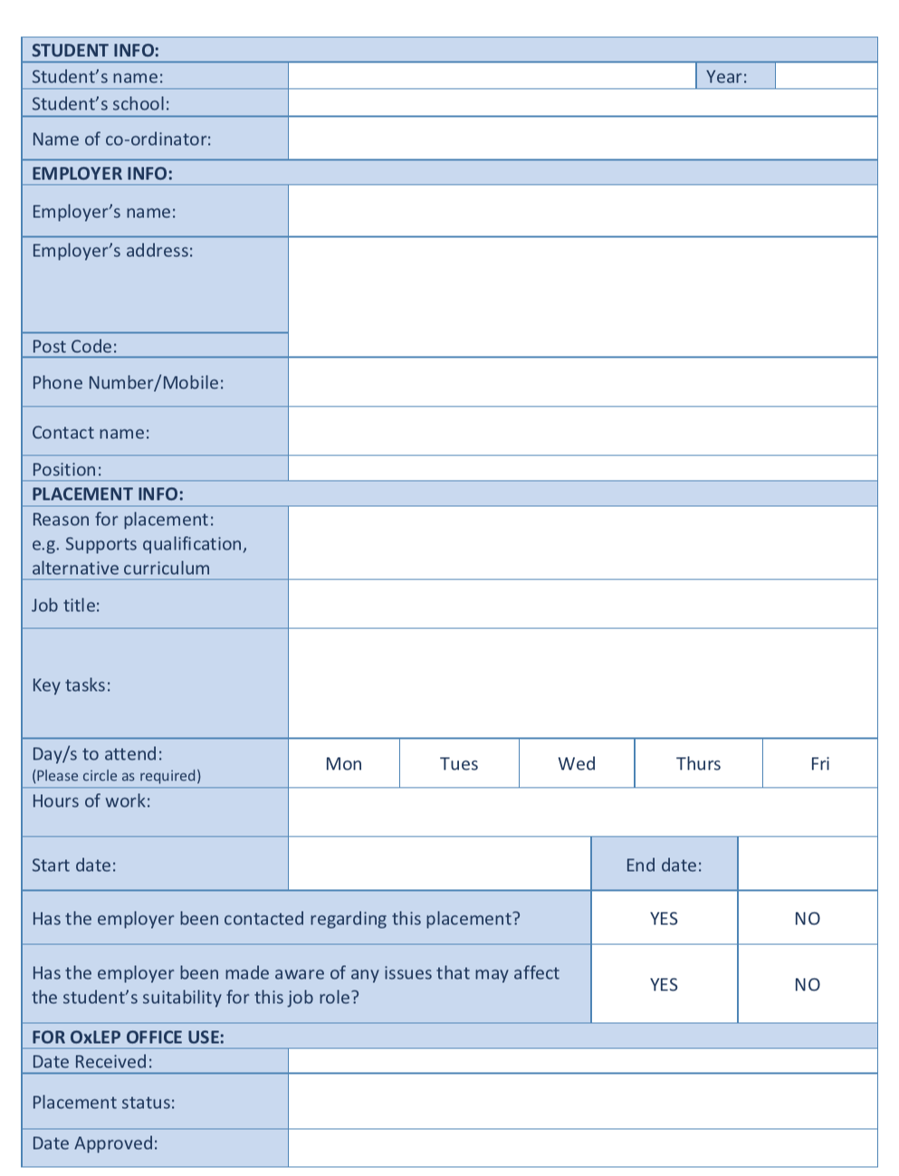

APPENDIX 3 – Experience in Work Information
Thank you for working alongside Bardwell School to provide Experience in Work. We look forward to working with you over the coming weeks.
Contact details
Should you need to contact us or have any questions or concerns over the course of the placement, please refer to contact details below:
Bardwell School  Hendon Place  Sunderland Drive  Bicester, OX26 4RZ | Contact telephone number  01869.242.182 | Name of contact:  Email address:
Safeguarding
When we use the term ‘safeguarding’, we are referring to the process of promoting the welfare of our pupils and protecting them from harm. OxLEP will have a discussion with you about child protection and will ensure you have understood this. If you have any concerns regarding the welfare of students that are placed with you, please let us know immediately. You can directly contact the teacher (detailed above) or if you have serious concerns and would like to speak to our safeguarding lead, please call the school office and ask to speak to one of the following:
Jade Levine | Pastoral and Safeguarding Manager  Designated Safeguarding Officer | jlev0231@bardwell.oxon.sch.uk
Matthew Selsdon | Interim Headteacher  Deputy Safeguarding Officer | head.7029@bardwell.oxon.sch.uk

