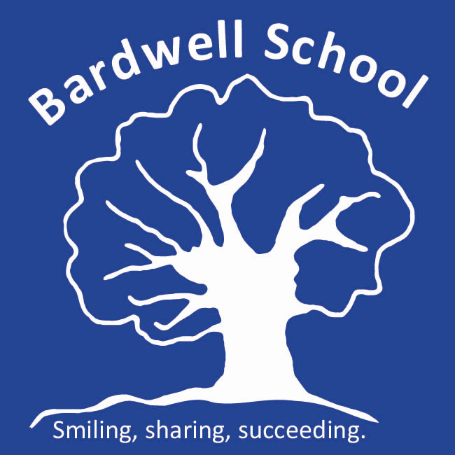

Behaviour Policy

Written: November 2021
Date of review: September 2023
Bardwell Lead: Matthew Selsdon (Interim Headteacher)
Signed LAB:
Signed TGT:

1. Introduction
One of the school’s aims is to nurture in all our pupils self-confidence combined with sensitivity and respect towards others, through an understanding of rights and responsibilities. We recognise that the school cannot do this in isolation but is pivotal in making a huge difference to the lives of its pupils. Therefore, we expect all members of the school community to celebrate pupils’ success and achievements and to recognise the importance of positive shared values about behaviour. In order to ensure that all staff working in the school adopt a common approach towards pupils’ behaviour whole school training communicating this policy, is delivered annually.
2. Philosophy
We believe that all children feel more secure and learn more successfully if clear boundaries, based on high expectations, have been set for their behaviour. This is particularly crucial when working with children with learning difficulties who need consistency and clear unambiguous messages in order to understand what is expected of them.
We believe in encouraging pupils to develop all their positive abilities and qualities, this includes helping pupils learn to behave in positive ways. Our pupils can learn to take responsibility for their behaviour and in this they are no different from children in any other school. Again, like all other children, they must learn to differentiate between how they might expect to be treated as an individual (social rights) and how they as an individual should treat others (social duties). Therefore, our children must learn that almost every social situation has its own rules, although this may need to be made explicit if the child does not have an implicit appreciation of social etiquette. Respect and consideration towards others and their property, politeness and acceptance of other people’s differences are qualities which we hope to develop in all our pupils.
By being positive, consistent and rewarding good behaviour, we can create an environment in which there is an incentive for behaving well. It is our belief that rewards are preferable to sanctions when working to modify challenging behaviour, but we recognise that sanctions may be a necessary element in many behavioural management programmes.
The staff of Bardwell School have a crucial role in fostering an atmosphere within which this philosophy can be put into practice and high expectations of childrens’ behaviour can be met. We expect all our staff to show a respect for pupils’ achievements and to raise their expectations accordingly as behaviour improves. Consistency of mood and approach is just as important as consistency of practice. We would wish our school to be a “haven of consistency” for pupils experiencing difficulties outside of school, a place of security where they know that boundaries will remain the same. The school will always challenge negative attitudes about behaviour and we are committed to effective staff development and training.
It is important that we maintain this philosophy and remain true to it when we go out into the community or to our inclusion link schools.

3. General Practice
Generally, the school’s policy on everyday management of pupils’ behaviour is based on rewarding and celebrating achievement. Some examples of this are:
- making the pupils aware of success throughout the lesson
- pointing out achievement and success to other members of the group, staff or visitors
- sharing achievements with parents and carers through notes in home-school diaries
- using assemblies to celebrate success
- displaying work and using photographs, videos, the school website, Multi-Me and other means to record success
As well as setting a climate of success, staff are also responsible for establishing appropriate classroom routines and rules which includes involving pupils whenever practical. We also believe in using lots of praise in our endeavours to create a school environment where every pupil is valued. However, it’s not just ‘what’ we say but ‘how’ we interact with the pupils that is equally important. Using suitable tone of voice, facial expression and body language are all prominent aspects of effective behavioural management. We are also very aware that staff can be powerful models of behaviour for many of our pupils, therefore, we adopt a ‘proactive’ response style to how we manage behaviour throughout Bardwell School. This approach can be summarised as follows:
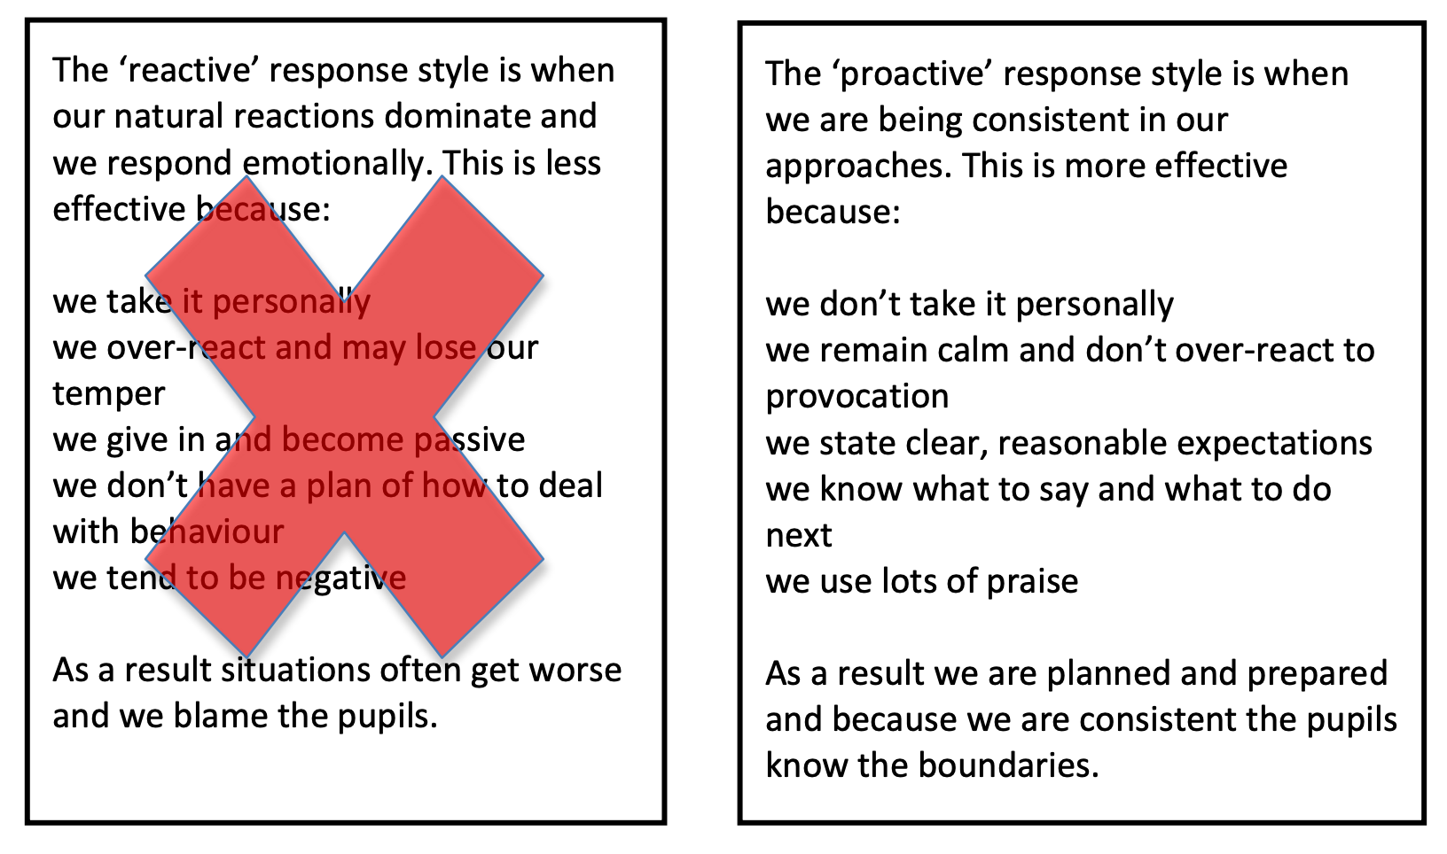
3. Specific Practice
As some of our children present inappropriate behaviour, we recognise the importance of working closely with parents in carrying out consistent strategies of behavioural management. Usually, a Behaviour Support Plan, will be written up and distributed to everyone coming into regular contact with the pupil at school so that maximum consistency can be achieved. Where at all possible, parents/carers will be kept informed and may be closely involved at every stage of planning and implementation. All Individual Support Plans are regularly monitored and revised accordingly. Occasionally, outside professionals (e.g. educational psychologist) may be called upon to give advice.
In deciding which challenging behaviours to target, we always give regard to the age- appropriateness of our expectations - some classroom rules in the nursery are quite rightly different from those in the senior school.
We always try to identify why a child is behaving in a certain way and use this as the basis for developing Individual Support Plans. Our practice must be well thought out and our responses based on principled reasons. In order to do this we pay just as much attention to how people around the child are reacting to the behaviour and what is happening prior to it, as we do to the behaviour itself.
We begin by observing* the pupil displaying challenging behaviour in a variety of different situations. When an undesirable behaviour occurs, we pay close attention to what seemed to precede it and to how the behaviour was dealt with or responded to by adults. Having completed this initial period of observation we draw up a strategy which will guarantee that, when the situation re-occurs, the behaviour will be dealt with appropriately and consistently (i.e. in a way which will not be rewarding to the child and will discourage the behaviour in the future). We are always aware that, for many children, a verbal telling-off or even eye contact can be very rewarding. Any policy of behavioural management can only be successful if people take every opportunity to praise the pupil when they are behaving well.
*Observation may be video recorded for the sole purpose of understanding behaviour patterns and implementing positive approaches to behaviour management. If video recording is to used, parents will be consulted and the footage will be disposed on completion of the process.
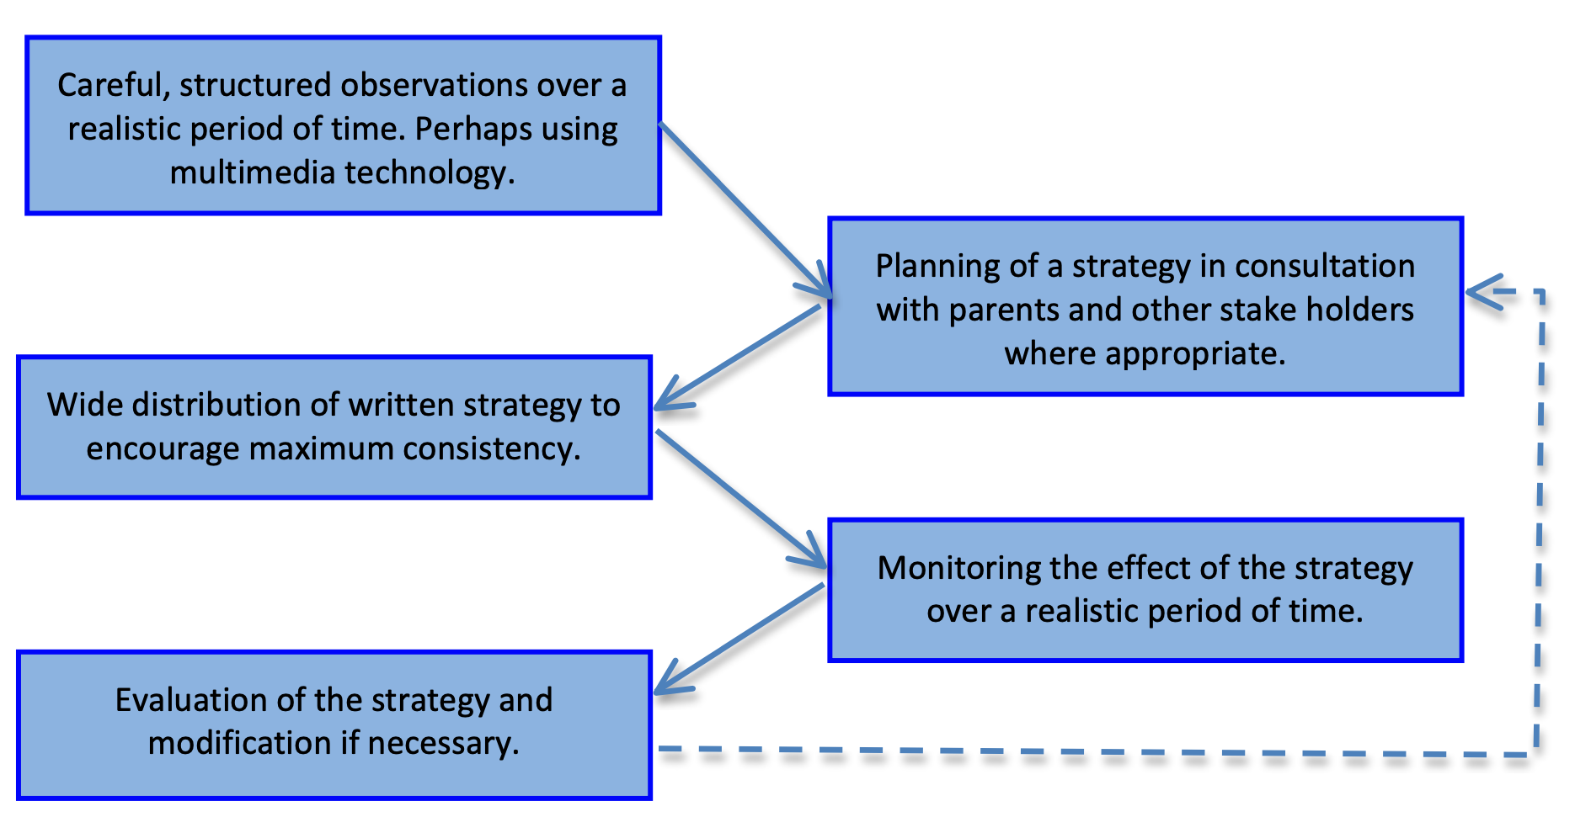

Individual Support Plans are underpinned by the following actions of good practice:
- responding calmly
- analysing what is happening
- anticipating what might happen next
- thinking about the short- and long-term implications of our response
- communicating clearly with others involved in the response
- debriefing afterwards - what have we learned (which may include recording our response)
It is not our policy to avoid situations in which challenging behaviour is likely to occur - we believe in helping the child to change their behaviour to suit the situation not changing the situation to suit the behaviour of the child. We think it is important that children learn that they cannot opt- out, manipulate, or take control of situations simply by misbehaving.
Our approach to helping children to modify their own challenging behaviour can only be effective within a caring, responsible, school community. There are some sanctions which are not used at Bardwell School:
- Denial of food at lunchtimes
- Persistent deprivation of a curriculum area (inc. swimming)
- Any sanction which humiliates a pupil or denies respect
Occasionally a pupil may present such challenging behaviour that some form of physical intervention may be necessary as part of their carefully considered Behaviour Support Plan. This is covered separately in the Positive Handling policy.
Confidentiality
As part of the annual staff review everyone in school is asked to sign a confidentiality agreement. In addition, work experience pupils and students and volunteers are also required to sign one.
Again, visiting professionals have their own code of practise which protects pupil and staff confidentiality. There are clear guidelines relating to Child Protection complaints procedures.
If a pupil has a behaviour support plan, then a copy will be available in the class. Discretion is required, the plan has to be accessible, but we need to be aware of the people coming in to the classroom and pupil’s right to privacy.
There are times when it would be helpful to share support plans e.g. respite care. Permission should be sought from parents to do this.
Complaints
We have a separate complaint policy which should be referred to relating to any consideration of a complaint regarding the implementation of this policy.

