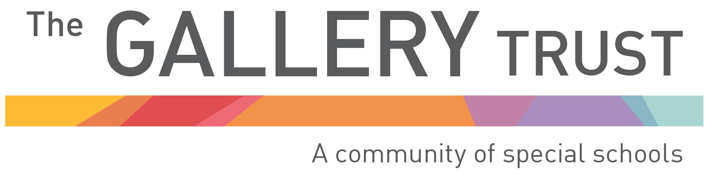

Anti-bullying Policy

Written: November 2021
Date of review: September 2024
Bardwell Lead: Matthew Selsdon (Interim Headteacher)
Signed LAB:
Signed TGT:

At Bardwell School we recognise that everyone has the right to feel welcome, secure and happy in school, and we work tirelessly to create a positive working atmosphere for pupils and staff alike.
Bullying of any sort prevents this from happening and impacts on our ability to provide an equality of opportunity. It is therefore everyone’s responsibility to be aware of the impact of bullying and to work actively to ensure that it does not occur within our school.
Bullying is defined as “behaviour by an individual or a group, repeated over
time that intentionally hurts another individual either physically or emotionally”. (DfE “Preventing and Tackling Bullying”, July 2017). This may take the form of name-calling, violence, threatening behaviour, isolation, ridicule or indirect actions such as gossiping.
The school recognises that within the context of a Special School environment, pupils may present bullying behaviours, without the conceptual awareness that what they are doing is bullying. However, bullying is recognised by the school as being a form of peer on peer abuse. It can be emotionally abusive and can cause severe and adverse effects. As such, we are aware that irrespective of the intention, the impact on others would be no less significant and therefore requires a structured and supportive approach.
We are aware that as a school we have a duty to be proactive in our actions to ensuring that bullying does not become an issue at Bardwell school. In order to achieve this, any bullying type behaviours from pupils will be dealt with within the context of the school’s structured Behaviour Policy. This will enable a consistent whole school approach to be taken in order to facilitate the effective management of all inappropriate behaviours, including those which may be deemed bullying type behaviours. We recognise that bullying can take place using digital technology and our approach to this is covered in the school’s ICT Acceptable Use Policy.
With regard to adult behaviour, all complaints, including those which may be deemed bullying type behaviours, would be dealt with through The Gallery Trust’s structured Complaints Procedure and/or with reference to the Trust’s Dignity at Work Policy. This will ensure that all negative situations are dealt with in a consistent manner.
Where developmentally appropriate, pupils will be actively involved in exploring bullying and its impact through the PSHE curriculum. This will involve a variety of educational opportunities, such as discussion and role-play, in order to provide a relevant and purposeful context.

