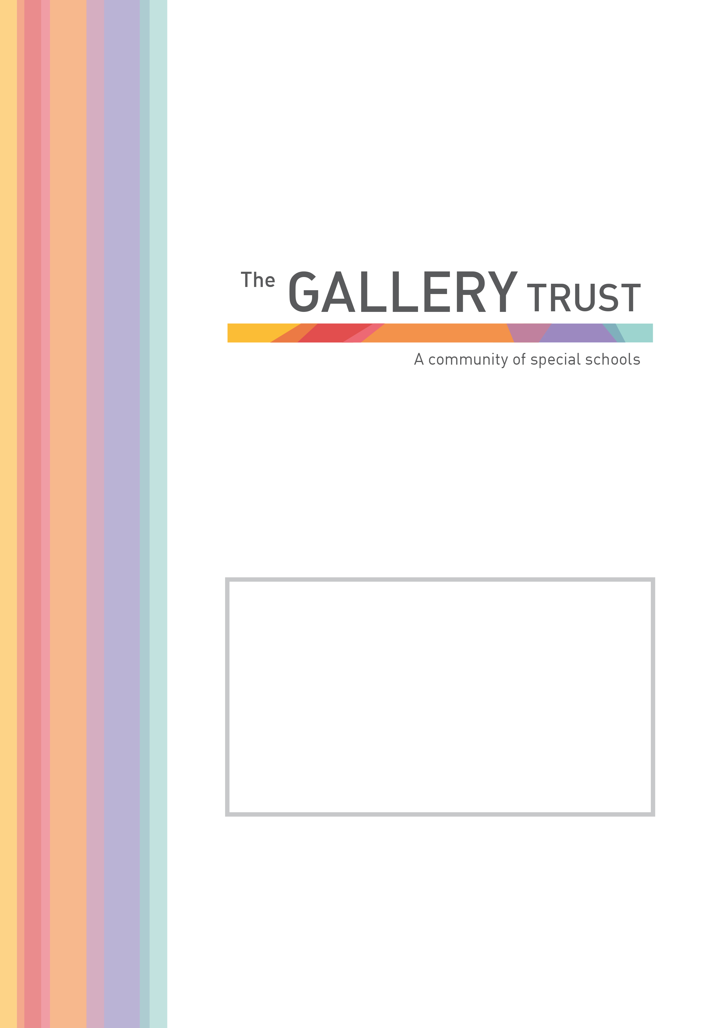
Lunchtime supervisor
Bardwell School

Candidate Information Pack
March 2022

Thank you for your interest in the post of Teaching Assistant at Bardwell School.

Bardwell School is a community special school for children aged 2 – 19 years with severe learning difficulties and profound and multiple learning difficulties. The school has 103 pupils on roll, following recent expansion of the school buildings.

We are passionate about students at Bardwell having their abilities recognised and celebrated, whilst receiving an excellent education. The staff team is committed to very high standards in relation to every aspect of our pupils’ education. The school is values led, with every decision underpinned by its principles and values. These values include a positive reinforcement approach to behaviour management and a non-label led individualised approach to planning and delivering learning for all students.

Bardwell School is a member of The Gallery Trust, an expanding Special Needs Multi Academy Trust which is dedicated to improving outcomes for SEND learners in Oxfordshire. The Trust has a national reputation for excellence, and is influential in the development of SEND strategy in the county. With six academies currently in the Trust, our aim is to build a community of eight to ten special schools over the next five years.

Thank you again for your interest and we look forward to hearing from you.

Matthew Selsdon
Interim Head Teacher

JOB DESCRIPTION
Lunch Time Supervisor

Grade 4: £18,933 pro rata per annum
Actual annual salary £3,196.41 per annum
7.5 hours a week, term time only (38 weeks a year)
To start April 2020 (or as soon as possible)

Bardwell School is the community special school in Bicester, we serve the Bicester and Kidlington areas, but also have children from across Oxfordshire. We are seeking enthusiastic and motivated staff to join our thriving and vibrant community at an exciting time in our development.

Judged as Good by Ofsted in July 2018, we recognise ourselves as a very strong school, that is on a continuous journey of school improvement. We make respectful relationships with our students through our understanding of their special educational needs, thorough assessment of their skills and abilities and carefully planning next steps for them. We are a warm and caring community, dedicated to equipping pupils with the skills and knowledge they need to succeed.

The role of the Lunchtime Supervisor involves setting appropriate boundaries for children, supporting with their education and care and liaising with families to get the best possible outcomes. You will have the attributes to work across the whole school, and will have, or be willing to quickly develop, skills to create a climate for success to support pupils with special educational needs and disabilities to learn and develop. You will also demonstrate a resilient and instinctive approach in meeting our pupils’ needs.

If you share our passion for making a real difference to the lives of children and young people with special needs, this could be the opportunity you are looking for. In return for your contribution to our team, you will work in an environment, which is innovative and in a role which is rewarding and fulfilling. We will provide you with induction and training, and the opportunity to join the Local Government Pension Scheme, one of the largest public sector pension schemes in the UK. This is an exciting time to join our team, having recently joined The Gallery Trust, we are further developing our curriculum and assessments and will soon be having a new hall and classrooms built to support further expansion.

Application Process

To apply for this post, please email jobs@bardwell.oxon.sch.uk or telephone 01869 242182 to request an application form and a job pack. You can also download an application form and job pack from our website: www.bardwell.oxon.sch.uk

Please submit your application form to jobs@bardwell.oxon.sch.uk or by post. Please ensure you detail any gaps in employment and use the selection criteria which is contained in the job pack when you prepare your application, as shortlisting for interview will be based on how closely you demonstrate your ability to fulfil the essential criteria. We do not accept CVs. If you are shortlisted, we will take up written references before your interview so please provide permission for this and provide accurate phone and email contact details for your referees. One of your referees must be your current or last employer, and if you are employed in a school, must include your current Head Teacher.

The Gallery Trust is committed to safeguarding and promoting the welfare of all children and expects all staff to share this commitment. The successful candidate will be subject to an Enhanced DBS check, Occupational Health check and a probationary period of 6 months. The Gallery Trust is an equal opportunities employer and we welcome applications from a range of ethnic backgrounds to represent diversity in line with our school community.

About The Gallery Trust

The Gallery Trust is a Multi Academy Trust which is dedicated to improving outcomes for SEND learners in Oxfordshire. The aim of the Trust is to provide outstanding education and support for young people with special needs and disabilities, enabled through:

- Commitment to special education – striving to provide the best specialist learning experience for all students
- Opportunities for all to learn – ensuring that students and staff have access to learning pathways which enhance their lives
- Genuine respect and value – creating relationships which promote trust, confidence and respect within environments which are safe and secure

The Trust is on a continuing journey of expansion, growing from a Multi Academy Trust based on a single academy in 2013, to its position as the largest Special Trust in Oxfordshire.

The schools in the Trust are:

- Bardwell School, Bicester
- Bloxham Grove Academy, Bloxham, to open in 2022
- A Free Special School in South Oxfordshire, opening date to be confirmed
- Iffley Academy, Oxford
- Mabel Prichard School, Oxford
- Northern House Academy, Oxford
- Orion Academy, Oxford
- Springfield School, Witney
- The Grove@Longford Park, Banbury (satellite provision of Orion Academy)
- The Gallery@Longford Park, Banbury (resource base for mainstream students)

The Trust’s vision is to continue to expand over the next five years, supporting a community of converter academies, free schools and sponsored academies. All member academies have the opportunity to share SEND expertise and to work with peers who share common aims and goals.

The Board of Trustees believes that by providing the support of highly experienced and specialised school improvement and business teams, the Head Teacher will be empowered to focus on the standards of teaching and learning and in meeting the operational and strategic demands of running Bardwell School.

The Trust is committed to investment in learning, developing system leadership, working in partnership and through a shared vision, enabling all students to reach their full potential.

About Bardwell School

Bardwell School is a community special school that caters for children aged 2 – 19 years.

Students work in class groups where teachers differentiate learning for all students ensuring lessons are inclusive for all.

The school has developed a comprehensive and broad skills-based curriculum, which can be found on the school’s website. This curriculum, which is underpinned by detailed assessment processes, guides the learning for all students. The school has excellent links with community partners and its strong focus on pathways to adulthood supports students onto further education and into employment.

Bardwell School benefits from a hydrotherapy pool that has recently been refurbished. All pupils access the pool for weekly swimming lessons, and pupils with physically disabilities and/or physiotherapy programmes attend additional weekly sessions as required.

The committed team at Bardwell School includes class teachers, teaching assistants, lunchtime supervisors, reception, finance and human resources staff, site manager and cleaning team, a pool manager and pool assistant, an ICT technician and pastoral and Safeguarding manager.

The school is also commissioned to deliver a Short Break service, Branch-Out. This provision is highly regarded by parents and professionals and lead by the Short Breaks Lead and Short Breaks Deputy and has a team of play workers. Branch-Out provide after school clubs, youth clubs and holiday provision.

The school recognises its success is based on successful partnerships. Most importantly, the school works closely with parents and understands that they know their child best. The wider multi-professional team at Bardwell includes a Special School Nurse, Speech and Language Therapist, Occupational Therapist and Physiotherapist. The school also hosts health clinics through the special school nurse provision.

JOB DESCRIPTION

Lunch-Time Supervisor

Job and Person Summary
Bardwell School is a Special School that educates children and young adults who have a wide range of Learning Difficulties. We are looking to employ lunchtime staff to support our pupils and young adults when eating their lunch and throughout their break-time.
The successful applicants will join class teams consisting of a class teacher, and teaching assistants. If you have the right attitude and ethos to work at Bardwell School we will support you by providing induction and training to ensure you have the skills and knowledge to support our pupils effectively.
To be considered for this role you must have:
- High expectations of all children and a commitment to ensuring they can develop and reach their potential.
- The ability to develop fair, respectful, supportive and constructive relationships with young people.
Personal Qualities you have will include:
- A fun, can do approach
- The ability to communicate effectively with children, young adults and colleagues.
- Being able to act on feedback and be open to mentoring.
- Patience.
- The ability to celebrate positive behaviour and achievements.
We will provide induction and training to ensure you:
- Have the skills to support pupils with their eating, drinking and personal care needs.
- Understand the importance of effective positioning and the principles that underpin this.
- Have knowledge on how to establish a stimulating play environment and positively influence our pupils’ play opportunities.
- Know how to make professional judgments to prioritise and manage a range of tasks.
- Carry out your duties in line with our School Policies, including Safeguarding and Child Protection and Health and Safety Policy.
At Bardwell School we take safeguarding seriously. All staff have a responsibility to keep our pupils and staff safe. You will receive training in line with this crucial responsibility.

A typical day will include:
11.45: Arrive in class and discretely complete any preparation tasks before lunch (this could include washing items used during morning lessons and supporting pupils with personal care).
11.55 – 12.30: Supporting pupils to develop independence with their eating skills. This may also include administering medication and supporting pupils who are fed by gastronomy tube.
12.30 – 13.00: Supervising play activities and having a positive influence while encouraging an inclusive play atmosphere.
13.05: Ensuring pupils are back in class to start their afternoon lessons. Discretely support any preparation for the afternoon (including washing items used at lunch time and supporting with personal care).
13.05 – 13.15: Completing any tasks in class following lunch (this could include washing items and supporting pupils with personal care).
This role will also include completing personal care tasks with pupils, supporting children who may express their feelings and frustrations who behaviours. It will suit a positive, dynamic person with a can do, flexible approach.
The above activities are only an indication of the advertised role. You will have a flexible attitude and will work under the direction of the class teacher and headteacher.

SELECTION CRITERIA
Lunch-Time Supervisor

 | Essential | Desirable
Professional Qualifications | Grade 4 at GCSE in Maths and English (C on old scaling) or equivalent  in mathematics and English, or suitable equivalent experience | NVQ 2 for Teaching Assistants or equivalent
Experience |  | Previous experience working in a school environment  Previous experience working with SEN  Experience of working with or caring for children of relevant age
Professional Knowledge & Skills | Understanding of child development and learning  Ability to self-evaluate learning needs and actively seek learning opportunities  Ability to work flexibly, throughout the whole school, meeting the needs of pupils in a range of contexts  Willingness and ability to undertake physical management of pupils, following appropriate training  Willingness to undertake First Aid training and to attend to the medical, first aid and personal needs of pupils.  Ability to take an active role in the support of PE lessons  Effective use of ICT to support learning | Team Teach trained  Understanding of relevant policies/codes of practice and awareness of relevant legislation  General understanding of National Curriculum  First aid trained
Personal Skills and Qualities | Ability to establish and maintain positive relationships with pupils, colleagues and parents  Good organisational skills Good communication skills  Ability to remain positive and enthusiastic, including when under pressure  Strong commitment to raising standards

