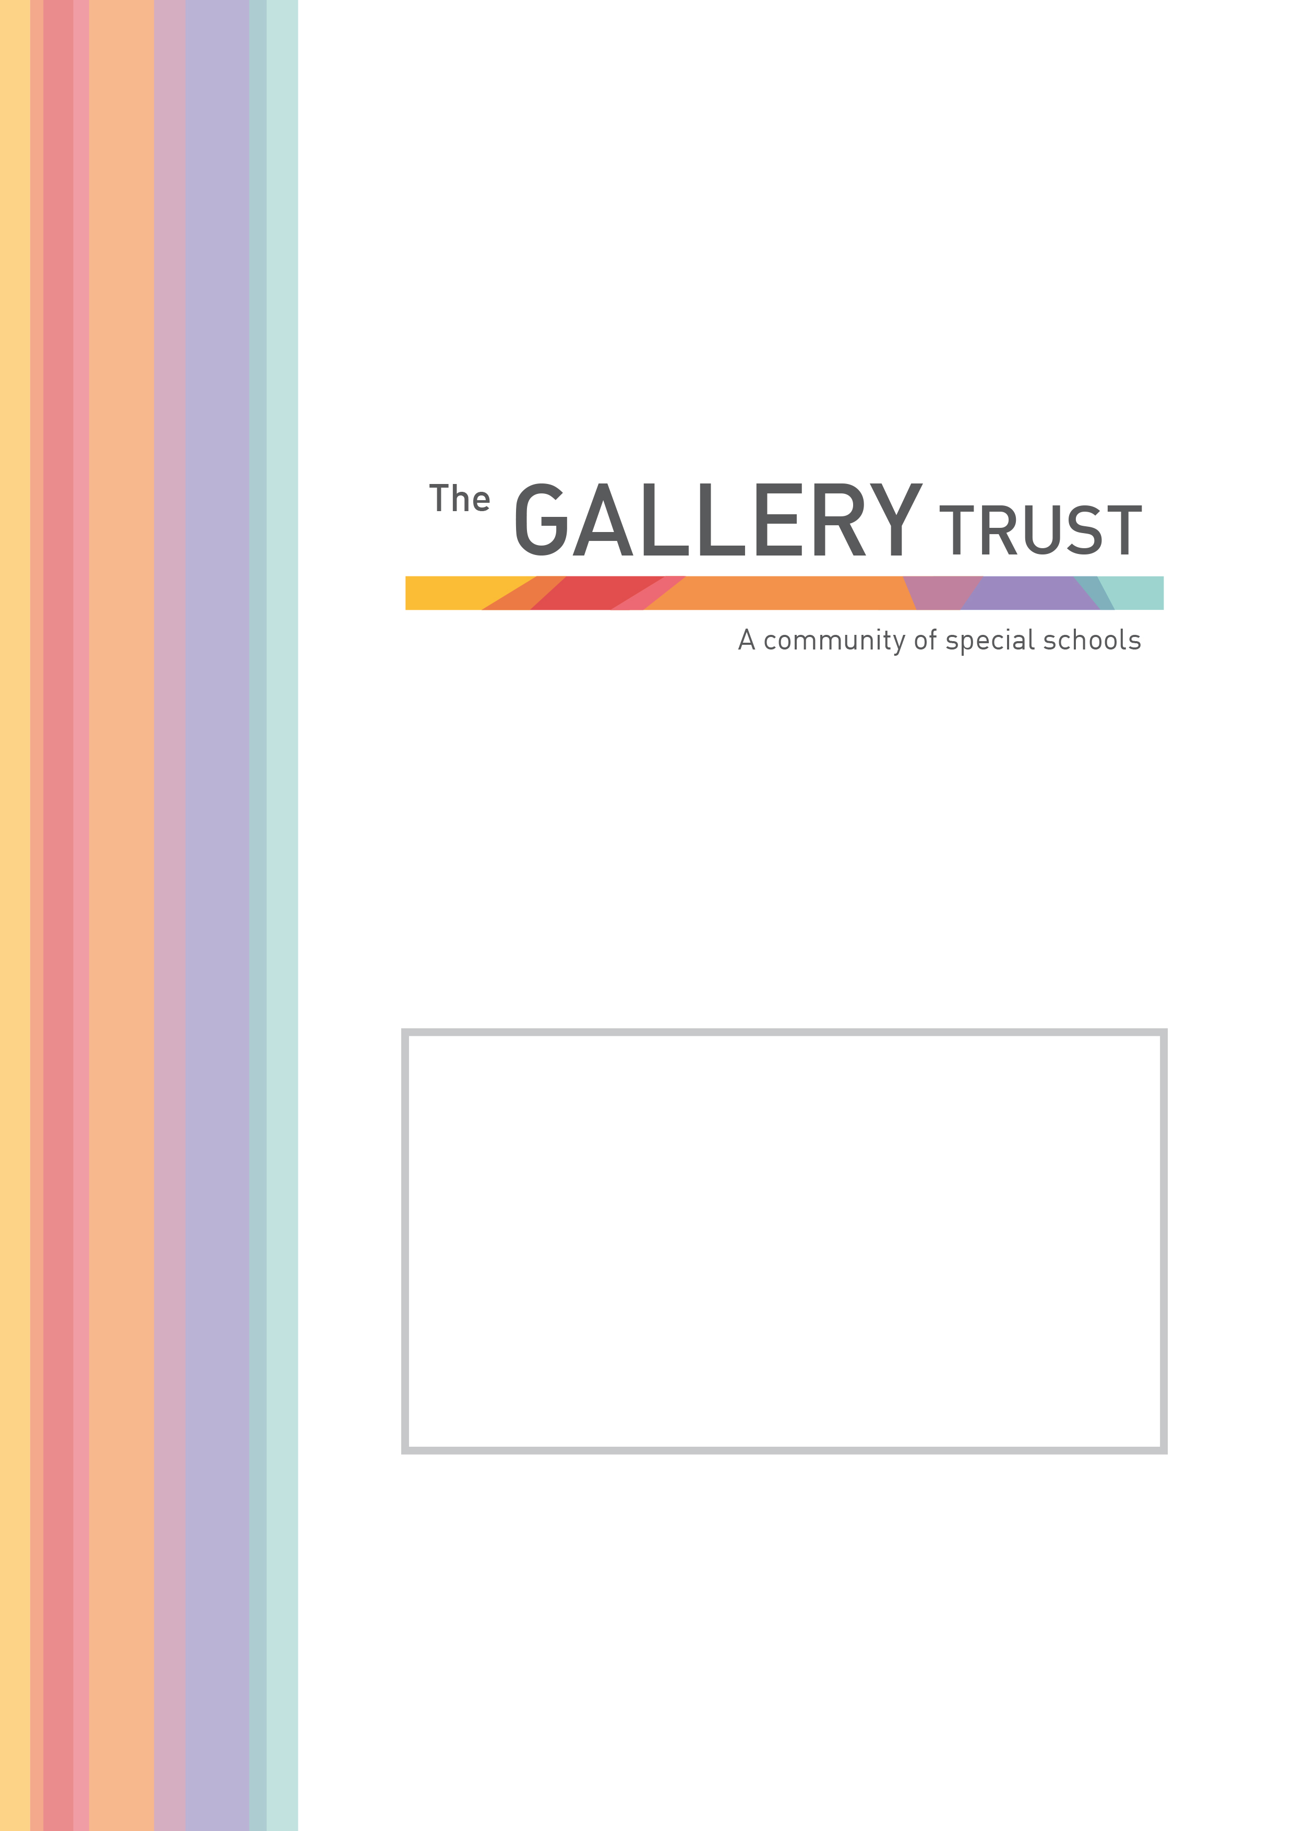

Teacher
Bardwell School

Candidate Information Pack
April 2022

Thank you for your interest in the post of Teacher at Bardwell School.

Bardwell School is a community special school for children aged 2 – 19 years with severe learning difficulties and profound and multiple learning difficulties. The school has 103 pupils on roll, following recent expansion of the school buildings.

We are passionate about students at Bardwell having their abilities recognised and celebrated, whilst receiving an excellent education. The staff team is committed to very high standards in relation to every aspect of our pupils’ education. The school is values led, with every decision underpinned by its principles and values. These values include a positive reinforcement approach to behaviour management and a non-label led individualised approach to planning and delivering learning for all students.

Bardwell School is a member of The Gallery Trust, an expanding Special Needs Multi Academy Trust which is dedicated to improving outcomes for SEND learners in Oxfordshire. The Trust has a national reputation for excellence and is influential in the development of SEND strategy in the county. With six academies currently in the Trust, our aim is to build a community of eight to ten special schools over the next five years.

Please visit our website to find out more about the school. If you would like to visit the school to find out more about this exceptional opportunity before you submit your application, you will be most welcome. Our staff and students will be delighted to meet you!

Thank you again for your interest and we look forward to hearing from you.

Matthew Selsdon
Interim Head Teacher

Teacher
Full Time Permanent

Salary: Class Teacher (TMS1– UPS3 + 1SEN point)

This is an exciting time to join the team at Bardwell School. We are recruiting for a permanent post from September 2022 or as soon as possible.

A teaching role at Bardwell is absorbing, thought provoking, exciting and challenging. We have high aspirations and expectations for all of our pupils and in turn this leads to high expectations of teachers. Teachers at Bardwell have a deep understanding of how all children learn and apply this knowledge in class to deliver creative, exciting learning that motivates our pupils and supports them to achieve.

Teachers at Bardwell School work hard, but all aspects of the role and workload are focused on having an impact on the children and young adults at our school. The teaching team actively informs developments and collectively identifies the best ways to improve the school further.

Some examples of our expectations include:
- Delivering highly personalised inclusive lessons
- Completing termly assessments that include multimedia evidence of achievements
- Working closely with other professionals and families
- Being a lead professional in the class, promoting and establishing high standards in your class team
- Supporting in the delivery of our residential trip programme
- Contributing to our continual journey of school improvement

If you have a proven track record of being an excellent teacher this could be a great role for you. However, previous special school experience is not necessary, and we also welcome applications from strong trainee teachers or those early in their career. It is essential you fully share our values, which can be found on our website.

Application Process

To apply for this post, please email jobs@bardwell.oxon.sch.uk or telephone 01869 242182 to request an application form and a job pack. You can also download an application form and job pack from our website www.bardwell.oxon.sch.uk or from The Gallery Trust website www.thegallerytrust.co.uk

Due to the Spring Break closure period for the school, the closing date for applications is a little longer than usual.

Please submit your application form by 5pm on Monday 2nd May 2022 to jobs@bardwell.oxon.sch.uk or by post. Please ensure you detail any gaps in employment and use the selection criteria which is contained in the job pack when you prepare your application, as shortlisting for interview will be based on how closely you demonstrate your ability to fulfil the essential criteria. We do not accept CVs. If you are shortlisted, we will take up written references before your interview so please provide permission for this and provide accurate phone and email contact details for your referees. One of your referees must be your current or last employer, and if you are employed in a school, must include your current Head Teacher.

The Gallery Trust is committed to safeguarding and promoting the welfare of all children and expects all staff to share this commitment. Any offer of employment with The Gallery Trust is subject to verification of ID and qualifications, satisfactory evidence of the right to work in the UK, health clearance, NCTL and Enhanced Disclosure and Barring Check. The Gallery Trust is an equal opportunities employer, and we welcome applications from candidates from all ethnic and community backgrounds.

The Gallery Trust is a Multi Academy Trust which is dedicated to improving outcomes for SEND learners in Oxfordshire. The aim of the Trust is to provide outstanding education and support for young people with special needs and disabilities, enabled through:

- Commitment to special education – striving to provide the best specialist learning experience for all students
- Opportunities for all to learn – ensuring that students and staff have access to learning pathways which enhance their lives
- Genuine respect and value – creating relationships which promote trust, confidence and respect within environments which are safe and secure

The Trust is on a continuing journey of expansion, growing from a Multi Academy Trust based on a single academy in 2013, to its position as the largest Specialist Trust in Oxfordshire.

The schools in the Trust are:

- Bardwell School, Bicester
- Bloxham Grove Academy, Bloxham, to open in 2024
- A Free Special School in South Oxfordshire, opening date to be confirmed
- Iffley Academy, Oxford
- Mabel Prichard School, Oxford
- Northern House Academy, Oxford
- Orion Academy, Oxford
- Springfield School, Witney
- The Grove (satellite provision of Orion Academy)

The Trust’s vision is to continue to consolidate our recent growth by securing effective systems that deliver school improvement through all academies whilst continuing to expand over the next five years, supporting a community of converter academies, free schools and sponsored academies. All member academies have the opportunity to share SEND expertise and to work with peers who share common aims and goals.

The Trust is committed to investment in learning, developing system leadership, working in partnership and through a shared vision, enabling all students to reach their full potential.

Bardwell School is a community special school that caters for children aged 2 – 19 years.

Students work in class groups where teachers differentiate learning for all students ensuring lessons are inclusive for all.

The school has developed a comprehensive and broad skills-based curriculum, which can be found on the school’s website. This curriculum, which is underpinned by detailed assessment processes, guides the learning for all students. The school has excellent links with community partners and its strong focus on pathways to adulthood supports students onto further education and into employment.

Bardwell School benefits from a hydrotherapy pool that has recently been refurbished. All pupils access the pool for weekly swimming lessons, and pupils with physically disabilities and/or physiotherapy programmes attend additional weekly sessions as required.

The committed team at Bardwell School includes class teachers, teaching assistants, lunchtime supervisors, reception, finance and human resources staff, site manager and cleaning team, a pool manager and pool assistant, an ICT technician and pastoral and Safeguarding manager.

The school is also commissioned to deliver a Short Break service, Branch-Out. This provision is highly regarded by parents and professionals and lead by the Short Breaks Lead and Short Breaks Deputy and has a team of play workers. Branch-Out provide after school clubs, youth clubs and holiday provision.

The school recognises its success is based on successful partnerships. Most importantly, the school works closely with parents and understands that they know their child best. The wider multi-professional team at Bardwell includes a Special School Nurse, Speech and Language Therapist, Occupational Therapist and Physiotherapist. The school also hosts health clinics through the special school nurse provision.

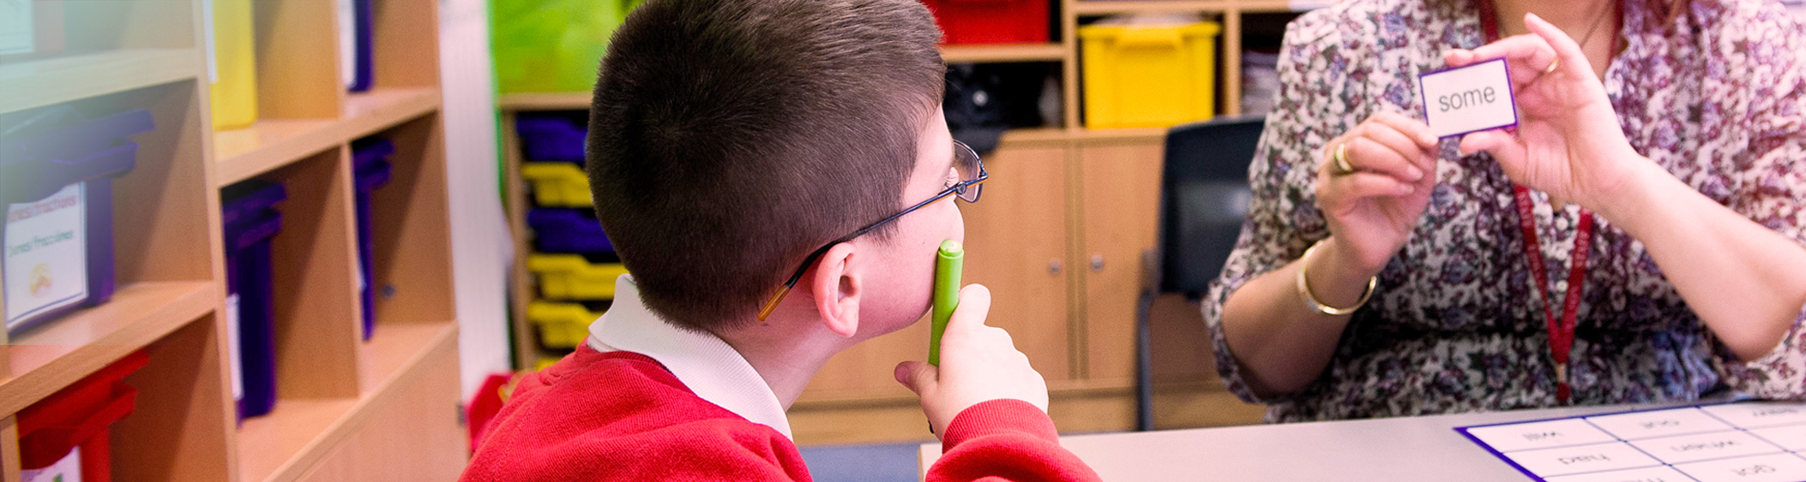

Teacher
Job Description

Introduction

The job description should be read in conjunction with the current School Teachers’ Pay and Conditions document and the provision of that document will apply to the post holder.

The performance of all the duties and responsibilities shown below will be under the reasonable direction of the Head Teacher. The Head Teacher, or other Senior Manager if appropriate, will be mindful of her/his duty to ensure that the employee has a reasonable workload and sufficient support to carry out the duties of the post.

The job description will be reviewed at least annually, and any changes will be subject to consultation. The academy’s grievance procedure will be used to resolve any disagreement arising out of the job description. Other relevant policies may be the Stress at work policy and Dignity at work policy.

Teaching and learning
- Ensure all pupils in their care within the academy receive an exciting, effective and appropriate education as outlined in their Educational Heath Care Plan (EHCP) and in accordance with the academy’s curriculum framework.
- Monitor, evaluate and report on the quality of teaching and learning and classroom management standards
- The provision of suitably differentiated work to meet the individual needs of the students
- The curriculum planning and review cycle is maintained in accordance with the school’s planning framework and policy
- On-going assessment of students’ work and abilities through comprehensive record keeping based on the academy’s agreed format
- Maintenance of good discipline in line with the academy’s Restorative Approaches policy
- Contribution, wherever appropriate, to the display, presentation and celebration of students’ work
- Safeguarding and promoting the welfare of all students

Wider responsibilities relating to whole academy issues and procedures

- Work for the positive development of the academy, in line with the Raising Achievement Plan
- Attend staff meetings, curriculum forums or any other relevant meetings within the stipulated 1265 directed hours
- Take a share of supervisory duties as part of the weekly routine as necessary
- Take appropriate responsibility for one’s own health, safety and welfare and the health and safety of pupils, visitor and colleagues in accordance with the requirements and locally adopted policies: including taking responsibility for raising concerns with a manager
Specific responsibilities agreed between the Head Teacher and the above teacher
In addition to the duties outline in the School Teachers Pay and Conditions document currently in operation, or any subsequent legislation, you will be responsible for the following:

Teaching

Teaching across a range of subject areas in line with the school curriculum

Staff development and support

Taking part in and/or delivering INSET training throughout the academy, as appropriate

Links with parents, Local Authority and the wider community

- Encourage full parental participation in the work, life and development of the school and make sure they are fully informed of their child’s progress. To be available to deal with parental concerns and provide support where possible or refer to other professionals or agencies.
- Work co-operatively with the Governing Body and Trustees
Liaise and co-ordinate with external agencies and other professionals

Selection Criteria
Teacher

 | Essential | Desirable
Professional Qualifications | Qualified to work and teach in the UK  Qualified Teacher Status (QTS)
Experience | Successful teaching experience  Planning for and teaching pupils with SEN  Effective involvement in school improvement planning and monitoring  Evidence of strategies developed for target setting and monitoring performance in order to raise pupil achievement  Experience of interactive teaching methods  Evidence of differentiation of the curriculum
Professional Knowledge & Skills | Awareness of current initiatives, issues and legislation  Knowledge and experience of developing a purposeful learning environment and using a range of strategies to promote good behaviour  Respect for pupils’ social, cultural, linguistic, religious and ethnic backgrounds with an understanding of how these may affect their learning  Understanding the role of teaching assistants in maximising pupils’ learning  Knowledge and experience of applying a framework of curriculum planning which: includes long and short term plans; requires learning objectives to be identified for classes, group and individuals; enables monitoring, assessment and recording of pupils’ progress
Personal Skills and Qualities | Strong commitment to raising standards  High expectations of self and others  Ability to establish and maintain positive relationships, including with parents  Ability to remain positive and enthusiastic, including when under pressure  Good communication skills  Effective computing skills

