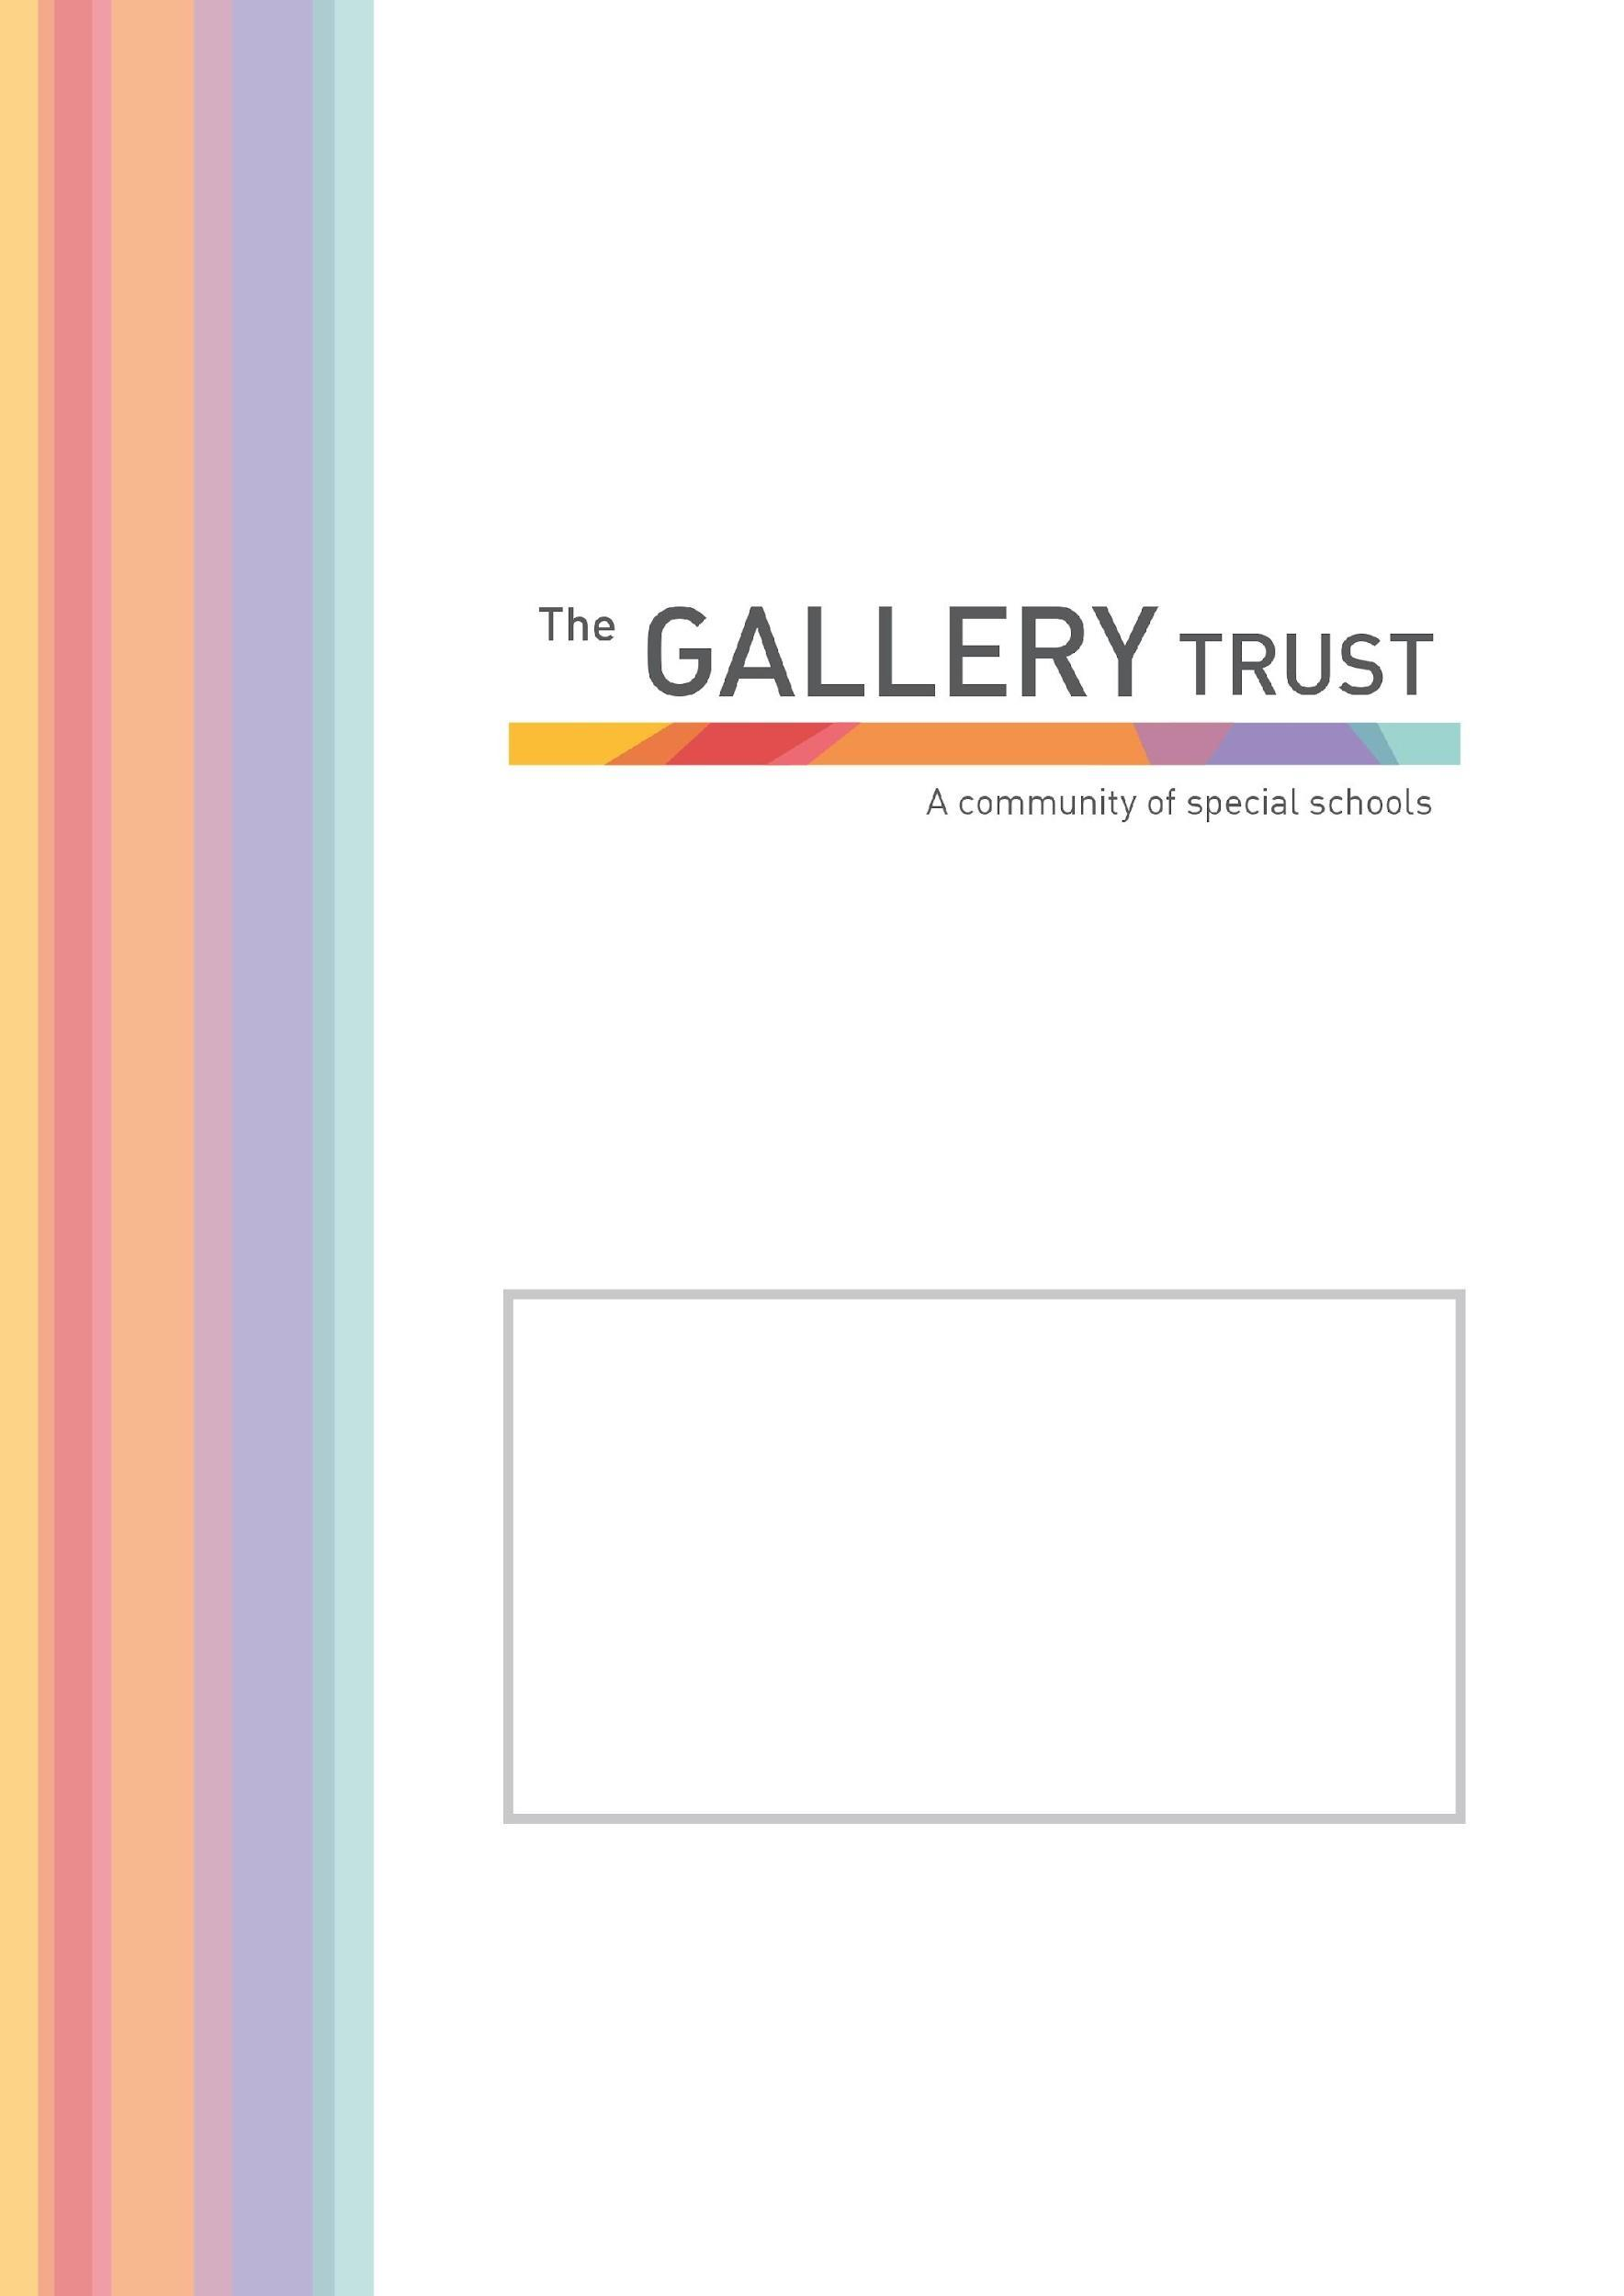

[Grab your reader’s attention with a great quote from the document or use this space to emphasize a key point. To place this text box anywhere on the page, just drag it.]

Teaching Assistant
Candidate Information Pack
2022

Thank you for your interest in the post of Teaching Assistant at Mabel Prichard School.

We are a community special school for children and young people with complex needs from the ages of 2 to 19.
At Mabel Prichard School, we believe in enabling every student to discover who they are and to realise their full potential. Our curriculum offers a broad range of opportunities to face challenge; develop independence; prepare for adulthood; discover the world around them; be safe and develop the skills and knowledge to lead a happy, positive and fulfilled life.
Through our strong caring ethos, we support students to respect their whole community, regardless of background, race, gender, faith and disability and to celebrate diversity, so they are able to develop skills of empathy and tolerance in their life ahead.
We believe education plays a pivotal role in developing as individuals, alongside the vital input from families and other professionals whom we enjoy working closely with. The purpose of the school is to create opportunities through education for each student to value themselves and each other; develop confidence; communicate their thoughts and ideas and to enjoy discovering their strengths to take forward in their life ahead.
Mabel Prichard School is a member of The Gallery Trust, an expanding Special Needs Multi Academy Trust which is dedicated to improving outcomes for SEND learners in Oxfordshire. The Trust has a national reputation for excellence and is influential in the development of SEND strategy in the county. With six academies currently in the Trust, our aim is to build a community of eight to ten special schools over the next five years.

Please visit our website to find out more about the school. If you would like to visit the school to find out more about this exceptional opportunity before you submit your application, you will be most welcome. Our staff and students will be delighted to meet you.

Thank you again for your interest and we look forward to hearing from you.

Lucy Wawrzyniak
Executive Headteacher

Teaching Assistant
Grade 6
Actual Salary £14081.60 - £15547.70 per annum
(FTE Salary £20,852 - £23023 per annum)
30 hours per week, 38 weeks per year, term time only
To start as soon as possible

A Teaching Assistant role at Mabel Prichard School is rewarding, exciting and challenging.

We have high aspirations and expectations for all of our pupils and in turn this leads to high expectations of our staff. Teaching Assistants at Mabel Prichard School aid the delivery of creative learning that motivates our pupils and supports them to achieve.

All aspects of the role and responsibilities are focused on having an impact on the children and young adults at our school. This involves setting appropriate boundaries for children, supporting with their education and care and liaising with families to get the best possible outcomes.

Some examples of our expectations include:
- Supporting Teachers to deliver highly personalised inclusive lessons
- Having, or willingness to develop, a good understanding of our school curriculum
- Working closely with other professionals and families
- Supporting the creation of a climate for success for pupils with special educational needs and disabilities to learn and develop
- Promoting high standards in your class team
- A resilient and instinctive approach in meeting our pupils’ needs

If you share our passion for making a real difference to the lives of children and young people with special needs this could be a great role for you. Previous special school experience is not necessary, but it is essential you fully share our values, which can be found on our website.

Application Process

To apply for this post, please email recruitment@mabelprichard.org. You can also download an application form and job pack from our website https://mabelprichard.org or from The Gallery Trust website www.thegallerytrust.co.uk

Please submit your application form by Thursday 19th May at 12 noon to recruitment@mabelprichard.org or by post. Please ensure you detail any gaps in employment and use the selection criteria which is contained in the job pack when you prepare your application, as shortlisting for interview will be based on how closely you demonstrate your ability to fulfil the essential criteria.

We do not accept CVs. If you are shortlisted, we will take up written references before your interview so please provide permission for this and provide accurate phone and email contact details for your referees. One of your referees must be your current or last employer, and if you are employed in a school, must include your current Head Teacher.

The Gallery Trust is committed to safeguarding and promoting the welfare of all children and expects all staff to share this commitment. Any offer of employment with The Gallery Trust is subject to verification of ID and qualifications, satisfactory evidence of the right to work in the UK, health clearance, NCTL and Enhanced Disclosure and Barring Check. The Gallery Trust is an equal opportunities employer, and we welcome applications from candidates from all ethnic and community backgrounds.

The Gallery Trust is a Multi Academy Trust which is dedicated to improving outcomes for SEND learners in Oxfordshire. The aim of the Trust is to provide outstanding education and support for young people with special needs and disabilities, enabled through:

- Commitment to special education – striving to provide the best specialist learning experience for all students
- Opportunities for all to learn – ensuring that students and staff have access to learning pathways which enhance their lives
- Genuine respect and value – creating relationships which promote trust, confidence and respect within environments which are safe and secure

The Trust is on a continuing journey of expansion, growing from a Multi Academy Trust based on a single academy in 2013, to its position as the largest Special Trust in Oxfordshire.

The schools in the Trust are:

- Bardwell School, Bicester
- Bloxham Grove Academy, Bloxham, to open in 2022
- A Free Special School in South Oxfordshire, opening date to be confirmed
- Iffley Academy, Oxford
- Mabel Prichard School, Oxford
- Northern House Academy, Oxford
- Orion Academy, Oxford
- Springfield School, Witney
- The Grove (satellite provision of Orion Academy)

The Trust’s vision is to continue to expand over the next five years, supporting a community of converter academies, free schools and sponsored academies. All member academies have the opportunity to share SEND expertise and to work with peers who share common aims and goals.

The Trust is committed to investment in learning, developing system leadership, working in partnership and through a shared vision, enabling all students to reach their full potential.

At Mabel Prichard School students work in class groups where teachers differentiate learning for all students, ensuring lessons are inclusive for all.

The school has developed a comprehensive and broad skills-based curriculum, which can be found on the school’s website. This curriculum, which is underpinned by detailed assessment processes, guides the learning for all students. The school has excellent links with community partners and its strong focus on pathways to adulthood supports students onto further education and into employment.

The committed team at Mabel Prichard School includes class teachers, teaching assistants, lunchtime supervisors, care assistants, school business manager and admin team, caretaker and cleaning team and safeguarding leads.

The school recognises its success is based on successful partnerships. Most importantly, the school works closely with parents and understands that they know their child best. The wider multi-professional team at Mabel Prichard includes a Special School Nurse, Speech and Language Therapist, Occupational Therapist and Physiotherapist. The school also hosts health clinics through the special school nurse provision.

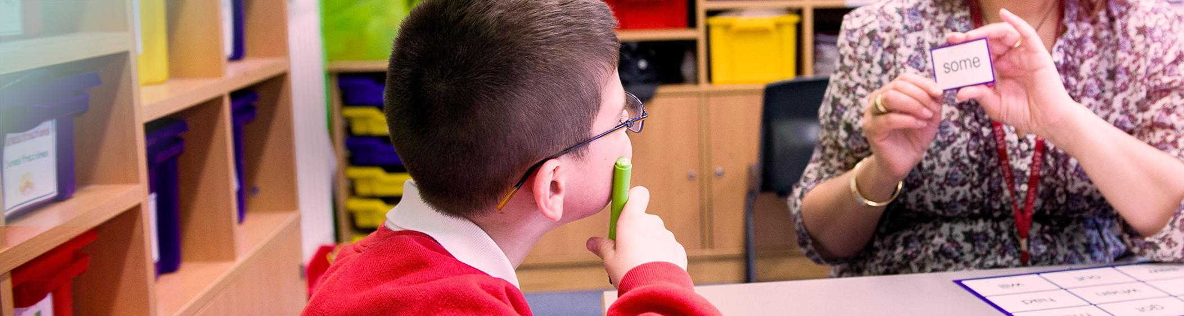

Teaching Assistant
Job Description

Introduction

This job description describes in general terms the normal duties which the postholder will be expected to undertake. However, the job or duties described may vary or be amended from time to time without changing the level of responsibility associated with the post.

The performance of all the duties and responsibilities shown below will be under the reasonable direction of the Head Teacher. The Head Teacher, or other Senior Manager if appropriate, will be mindful of her/his duty to ensure that the employee has a reasonable workload and sufficient support to carry out the duties of the post.

The job description will be reviewed at least annually, and any changes will be subject to consultation. The academy’s grievance procedure will be used to resolve any disagreement arising out of the job description. Other relevant policies may be the Stress at work policy and Dignity at work policy.

Job Purpose

To assist and support the Head Teacher and teaching staff in providing high standards of teaching and learning across the curriculum and to promote the academy’s vision and ethos.

Key Responsibilities:

Aim: To support the class teacher in teaching and learning.

The successful candidate will be expected to:

- Provide the student with the necessary help and support required to:
  - access the curriculum
  - manage learning and behaviour
  - to participate in classroom and school activities
- Provide pastoral, social and personal care for the child, including intimate care and medical care with training
- Provide supervision and care during break times, including lunch
- Support the integration of the child to a mainstream school where relevant
- Meet, plan and prepare activities for students with teachers and other agencies
- Attend training to develop an understanding of the needs of the child and your role in relation to these
- Attend a weekly class team meeting and any required inset days
- Provide feedback to the teacher on an individual or small group’s progress
- Adhere to the school’s policies including the equal opportunities policy, staff absence policy, safeguarding and child protection policy, staff code of conduct and health and safety policy
- Commit to on-going professional development in order to achieve the best outcomes for our learners
- To be a role-model to our pupils
- Commit to safeguarding children in line with the Oxfordshire County Council Child Protection and Safeguarding Children policy
- To be aware of and comply with Health and Safety legislation and policies of the school
- Adhere to the staff code of conduct at all times
In addition:

- Assist classroom teachers as directed/necessary, including taking small groups of children out of class for help with their work, or helping children in the classroom alongside the teacher
- In line with the school’s Educational Visits policy, support with off-site learning including swimming, sporting events, shopping, the allotment and Forest School.
- Help the teacher with simple practical and administrative tasks

The above list of job duties is not exclusive or exhaustive and the post holder will be required to undertake such tasks as may reasonably be expected within the scope and grading of the post.

Selection Criteria
Teaching Assistant, Mabel Prichard School

 | Essential | Desirable
Professional Qualifications | Level 2 (GCSE or equivalent) in Maths and English or suitable equivalent experience | NVQ 2 for Teaching Assistants or equivalent  A Levels  A degree  A qualification in education
Experience |  | Previous experience working in a school environment  Previous experience working with SEN, ASD, SLD and PMLD.
Professional Knowledge & Skills | Understanding of child development and learning  Ability to self-evaluate learning needs and actively seek learning opportunities  Training in relevant learning strategies e.g. literacy, numeracy, communication approaches etc or willingness to learn  Specialist skills/training in curriculum or learning area e.g. sign language, PECs or a willingness to learn  Ability to work flexibly, throughout the whole school, meeting the needs of pupils in a range of contexts  Willingness and ability to undertake physical management of pupils, following appropriate training  Willingness to undertake First Aid training and to attend to the medical, first aid and personal needs of pupils.  Ability to take an active role in the support of PE lessons  Effective use of ICT to support learning  Good understanding of child development and learning processes  Desire to constantly improve own practice/knowledge through self-evaluation and learning from others  Ability to relate well to children and adults  Work constructively as part of a team, understanding classroom roles and responsibilities and your own position within these  A commitment to safeguarding and health and safety legislation  A commitment to following all school policies  A commitment to upholding the school’s vision and values  Ability to turn up for work regularly and on time. | Experience of working with or caring for children of relevant age  Team Teach trained  Understanding of relevant policies/codes of practice and awareness of relevant legislation  General understanding of National Curriculum  First aid trained
Personal Skills and Qualities | An understanding of or willingness to learn about the barriers to learning faced by students with complex needs | Full driving license  Able to drive a minibus or willingness to learn

