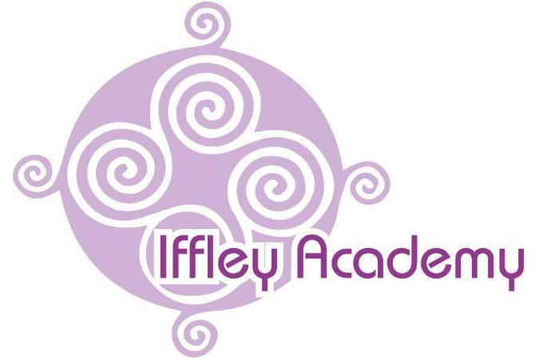

Iffley Academy

Science Policy

Written | May 2025
Review Date | May 2026
SLT Lead | Debbie Nicholas
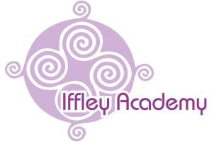

Aims

Science Policy

A high-quality science education provides the foundation for understanding the world around us. Science teaches an understanding of and develops a sense of excitement and curiosity about natural phenomena. It aims to stimulate students to find out why things happen in the way they do and encourages them to understand how science can be used to explain what is occurring, predict how things behave and analyse causes. It teaches our students to work scientifically to stimulate creative thought and understand the nature, processes and methods of science. Students learn to ask scientific questions and begin to appreciate the way in which science will affect the future on personal, national and global level.

Objectives

The objectives of teaching science are to enable our students to:

- Work scientifically to develop an understanding of the nature, processes and methods of science, through different types of scientific enquiry that help them to ask and answer scientific questions about the world around them

- Develop scientific knowledge and conceptual understanding in the following areas: ○ Biology: including plants, animals, habitats, evolution and inheritance
○ Chemistry: including everyday materials and their uses, rocks, states of matter and the properties and changes of materials

○ Physics: including seasonal changes, light, forces, magnets, sound, electricity and earth and space
- Understand the uses and implications of science, today and for the future

Curriculum Planning

Our values and aims are embedded into the four pillars of our curriculum:

- Community
- Employment
- Personal Development and Communication
- Education for Life

These pillars build from Behaviours for Life and are centred on developing independence. The schemes of work for science are aligned with the curriculum for life pillar, leading to independence, within the education for life pillar.

The Iffley Academy uses the National Curriculum programmes of study for Key Stages 1 and 2 science as the basis of its curriculum planning. Where possible, we include a local context, e.g. trips to Oxford National History and Science museums and connections to the GLAM project to ensure a deeper understanding and experience for our students.

The Iffley Academy Trust Company Ltd is
The Iffley Academy delivers science by using a variety of teaching and learning styles to meet the needs of all our learners and their specific SEN. Medium and short term plans demonstrate the range of different approaches, e.g. whole class teaching and enquiry-based research activities. Where students participate in activities outside the classroom, risk assessments are carried out prior to the activity to ensure that the activity is safe and appropriate for all pupils.

Differentiation

At The Iffley Academy all our learners are grouped according to their stage rather than age, but we recognise that within all classes’ students have a wide range of scientific ability and we ensure that we provide suitable learning opportunities for everyone by matching the challenge of the task to the SEN ability and learning style of the student.

This is achieved in a variety of ways:

- Setting tasks which are open-ended and can have a variety of responses

- Setting tasks which can be completed in a variety of different ways, e.g. verbal, pictorial, written response

- Providing resources of different complexity or presented in different ways to match the
ability and learning style of the students
- Grouping students flexibly within the classroom and setting different tasks for each group

- Setting tasks of increasing difficulty
- Using support staff to support and extend the work of individual students or groups of
learners
- Use of detailed questioning designed to test knowledge and develop scientific and considered thinking.

Assessment and Accreditation

Assessment is built into lesson planning, with a strong focus on assessment for learning that involves students in self and peer assessment, an essential part of formative feedback.

- Formative: the information gained affects the next learning experience

- Diagnostic: finding out what attitudes, knowledge, understanding or skills need to be developed
- Evaluative: analysing the impact of planning, teaching and the curriculum on students’ outcomes
- Summative: the systematic recording of information which leads towards a summary

Spoken Language

The Iffley Academy recognises the need to develop students’ language across the whole curriculum – cognitively, socially and linguistically. We recognise that students will need support to build up and extend any specialist scientific vocabulary and be assisted in making their thinking clear both to themselves and others.

Mathematics

Science contributes to the teaching of mathematics in a number of ways. When working scientifically, the students learn to use and apply number, measurements and statistics. They also develop maths skills such as estimating, predicting, spotting and explaining patterns and develop accuracy in their observation and recording of events. Many answers and conclusions include numbers and measurement.

ICT

Science is greatly enhanced by the use of ICT, providing students the scope to explore a wide range of scientific fields, including data logging, data handling, modeling and the use of the internet to research information and satisfy students’ scientific curiosity. Students are given the opportunity to explore scientific concepts using modern ICT equipment, such as computer science resources and VR headsets.

Personal, Social and Health Education (PSHE) and Citizenship

Science makes a significant contribution to the teaching of PSHE and Citizenship:

- Citizenship and social welfare,e.g.the way people recycle material and how environments are changed for better or worse

- Discussions and debates, e.g. issues of local, national and global concerns
- Scientific study of animals and understanding of humans,e.g.lifecyclesandhealthy living link directly to areas within the personal and health sections of RSE programmes of study, including SRE.
- Exploration of different jobs and employment within the science sector.

Health and Safety

All practical activities in science must comply with the requirements of the Health and Safety at Work Act 1974. Teachers must carry out risk assessments of any hazards to meet the demands of COSHH regulations. Teachers use risk assessments for science activities normally carried out in schools from CLEAP

Some activities may need additional risk assessment to take account of the individual needs of the students. When working with tools, equipment and materials, in practical activities and in different environments, including those that are unfamiliar, students should be taught:

- About hazards, risks and risk control

- To recognise hazards, assess consequent risks and take steps to control the risk to themselves and others
- To use information to assess the immediate and cumulative risks
- To manage their environment to ensure the health and safety of themselves and others
- To explain the steps they take to control risks

- Risk in science cannot be eliminated completely, but through the management of risks in the classroom students can be helped to develop their own personal sense of safety and learn how to work safely and manage risks in their everyday lives.

Resources

All chemicals and potentially hazardous equipment are stored in a locked room under suitable conditions to minimise risk, and are managed by the Site Manager.

The Iffley Academy Trust Company Ltd is a Registered Charity Company Registration No. 8334718 Registered in England & Wales

