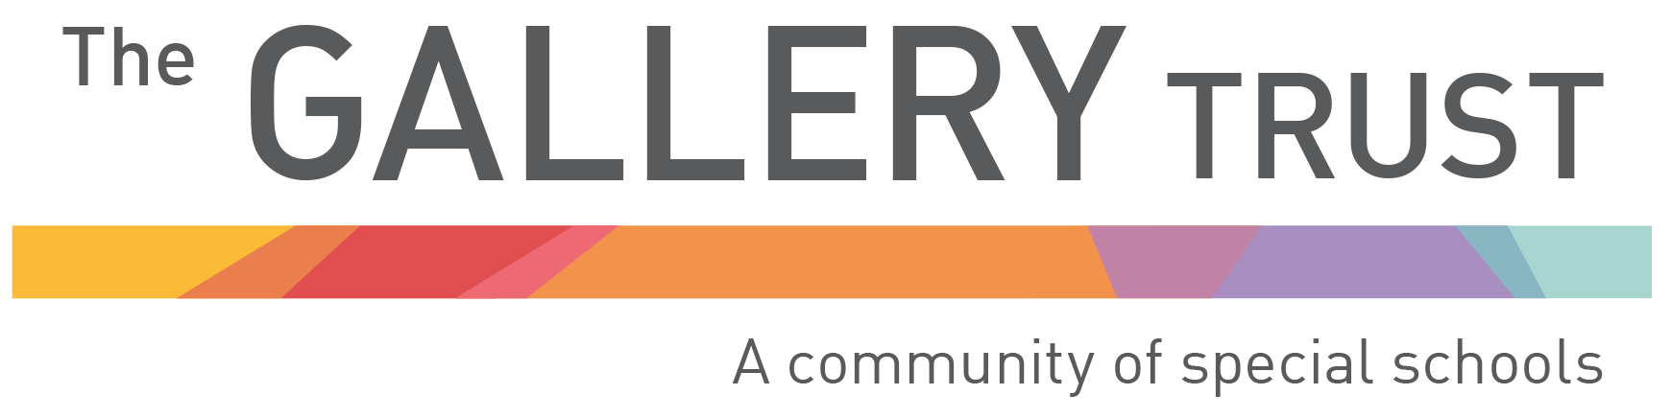
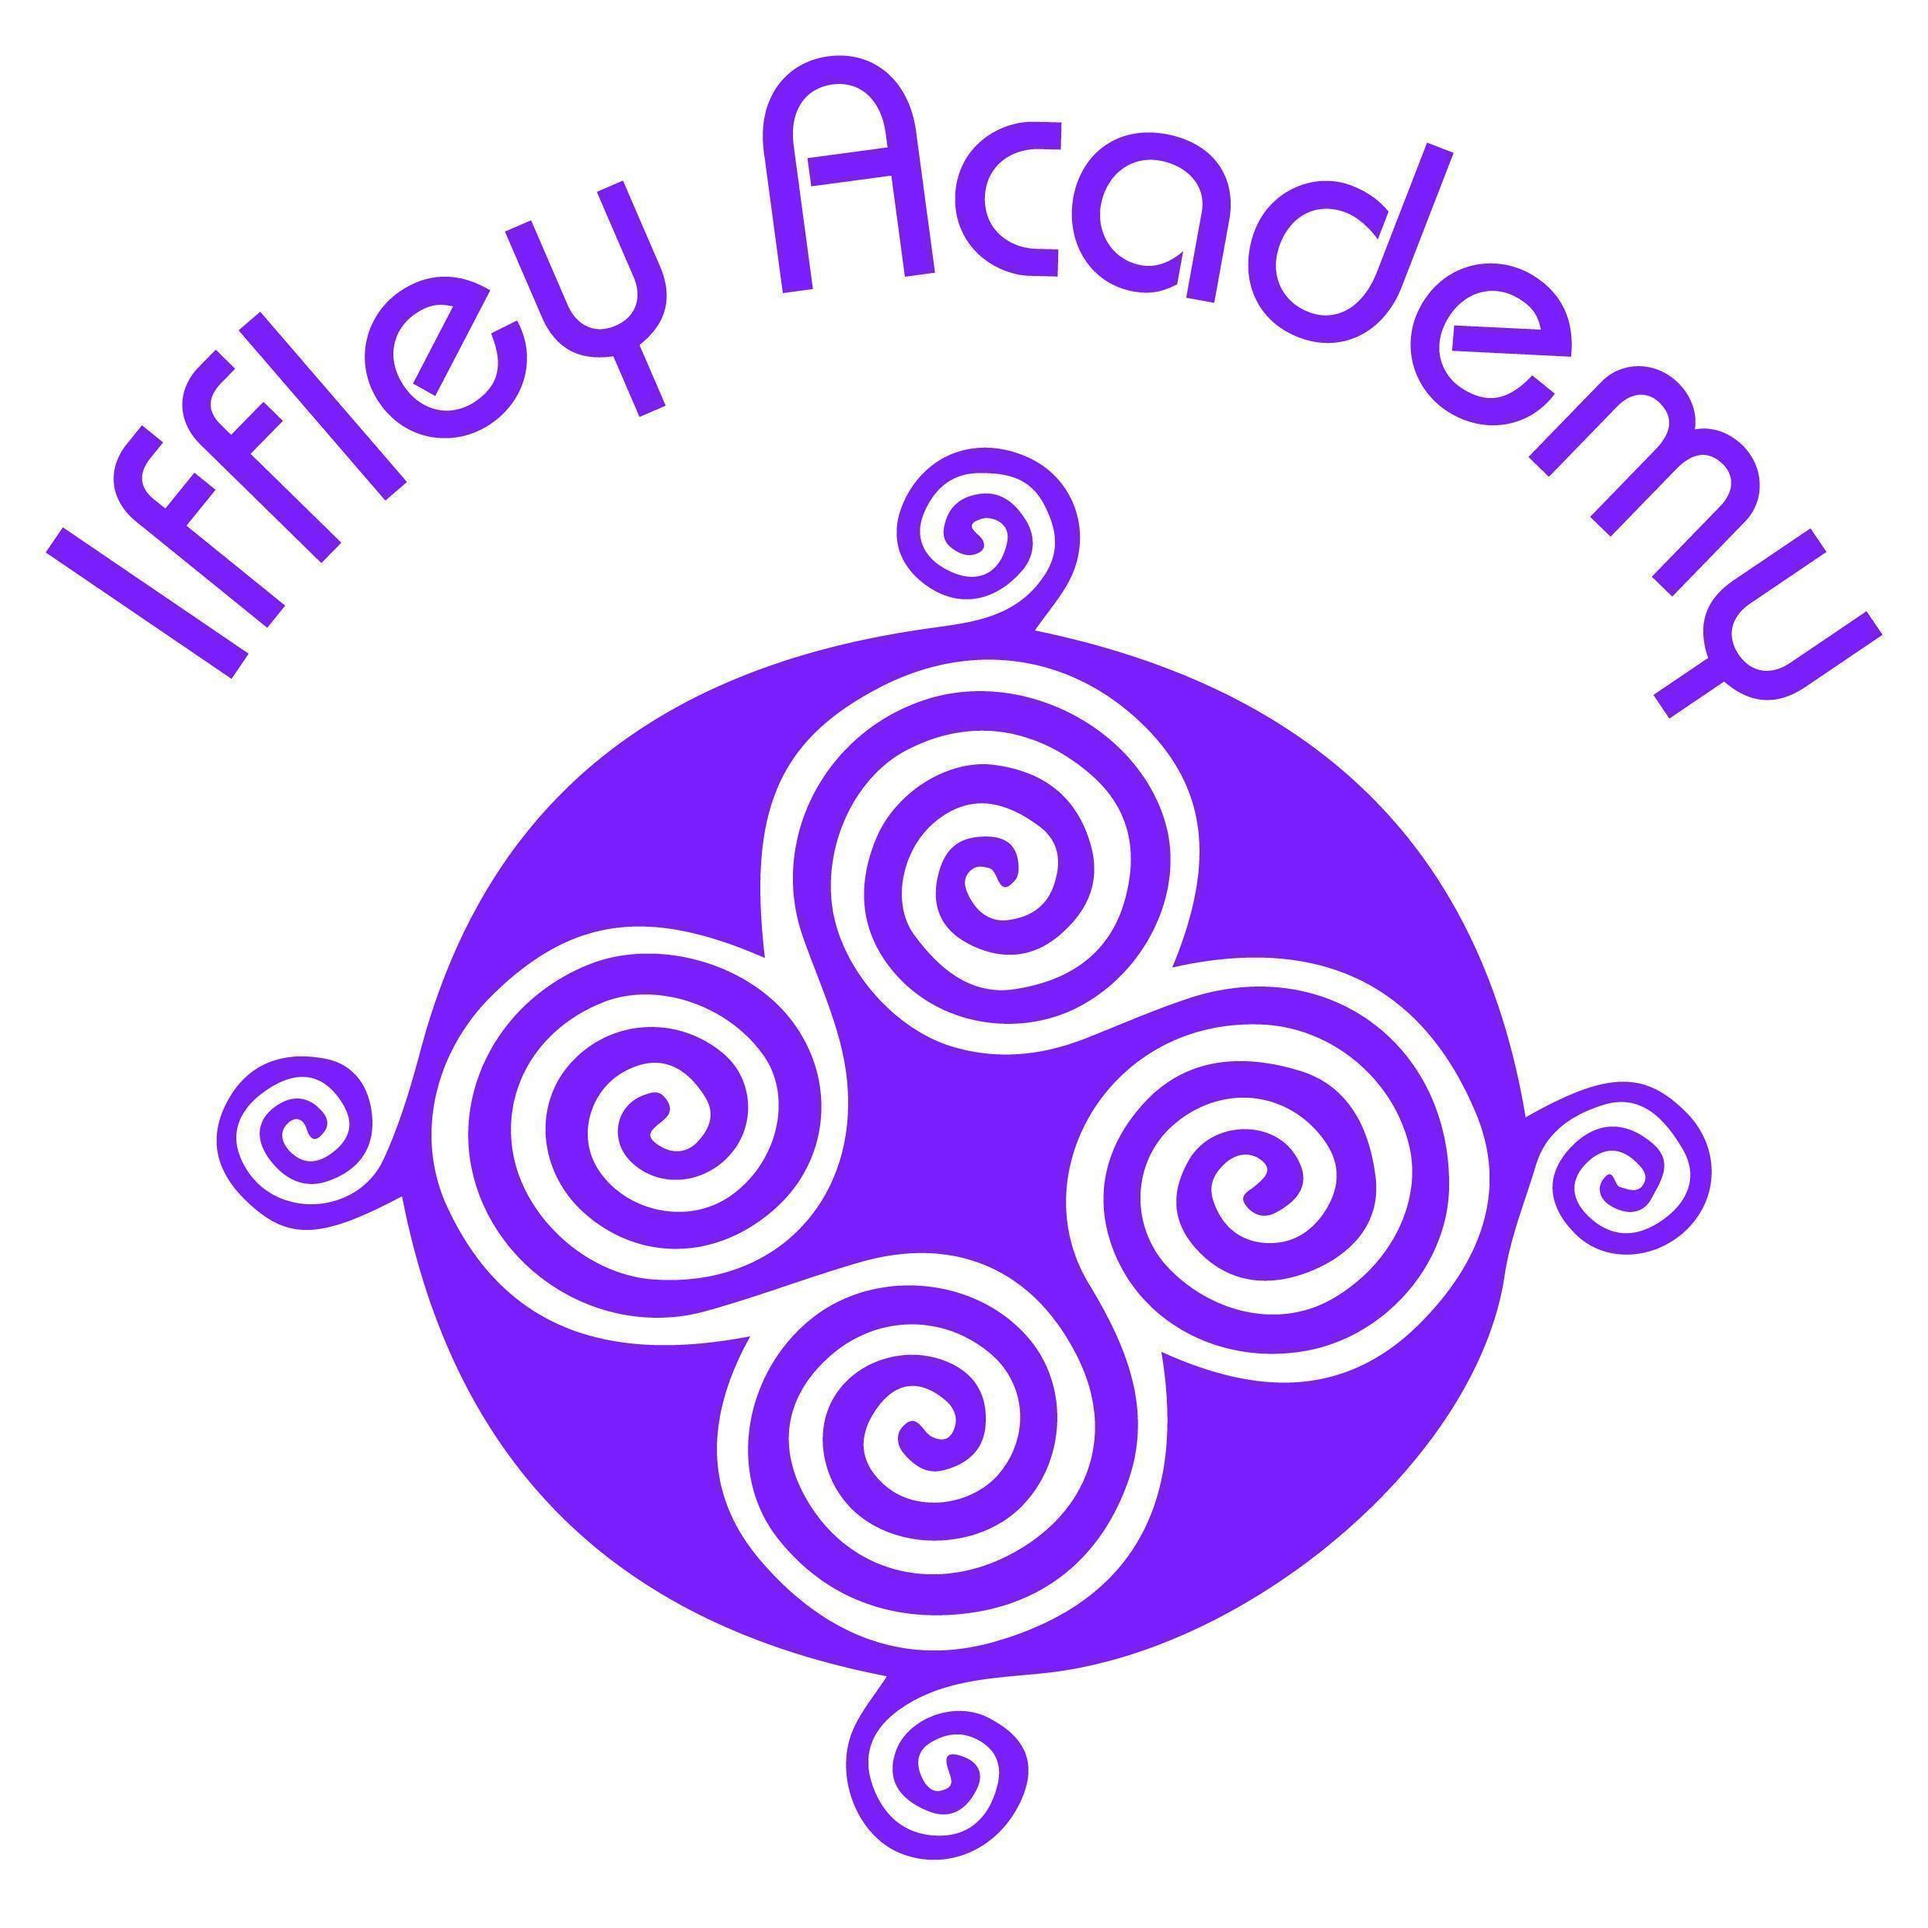

Published Results for 2024 - 2025

The Iffley Academy is a special academy for students with complex needs in years 7 – 13. Students have a primary Cognition and Learning, Communication and Interaction or SEMH. All students are working below the current floor standards due to their cognition and learning needs.

Staff go the extra mile to ensure that pupils make excellent progress academically, socially and emotionally. This includes the high proportion of disadvantaged pupils. There is an inherent culture of high expectations. Consequently, pupils achieve highly from their individual starting points.’ OFSTED report, 2024

Year 11 Learners Examination Outcomes
Numbers in brackets indicate the size of the cohort

Mathematics

Year | Whole Cohort | No result | E1 | E2 | E3 | Level 1 | Level 2
2021/22 | 27 | 0% (0) | 26% (7) | 52% (14) | 22% (6) | 0% (0) | 0% (0)
2022/23 | 27 | 0% (0) | 33% (9) | 37% (10) | 26% (7) | 4% (1) | 0% (0)
2023/24 | 24 | 12.5% (3) | 25% (6) | 29.2% (7) | 20.8% (5) | 12.5% (3) | 0% (0)
2024/25 | 32 | 6% (2) | 28% (9) | 21% (7) | 38% (12) | 6% (2) | 0% (0)

English

Year | Whole Cohort | No result | E1 | E2 | E3 | Level 1
2021/22 | 27 | 0% (0) | 56% (15) | 37% (10) | 7% (2) | 0% (0)
2022/23 | 27 | 0% (0) | 33% (9) | 37% (10) | 30% (8) | 0% (0)

Due to the increasingly complex SEN of our learners, English outcomes will be reported by strand, rather than an aggregated score. This enables an accurate assessment and publication of their abilities and successes, whilst mitigating new exam guidance published by exam boards.

Reading | Whole Cohort | No result | E1 | E2 | E3 | Level 1
2023/24 | 24 | 16% (4) | 16% (4) | 30% (7) | 16% (4) | 21% (5)
2024/25 | 32 | 12% (4) | 12% (4) | 35% (11) | 32% (10) | 9% (3)

Writing | Whole Cohort | No result | E1 | E2 | E3 | Level 1
2023/24 | 24 | 16% (4) | 21% (5) | 25% (6) | 16% (4) | 21% (5)
2024/25 | 32 | 12% (4) | 32% (10) | 22% (7) | 28% (9) | 6% (2)

Spoken | Whole Cohort | No result | E1 | E2 | E3 | Level 1
2023/24 | 24 | 20% (5) | 12% (3) | 29% (7) | 37% (9) | 0% (0)
2024/25 | 32 | 9% (3) | 28% (9) | 25% (8) | 31% (10) | 6% (2)

Progress 8
All students at the academy have Cognition and Learning disabilities. Progress 8 measures are not applicable. Students mainly work on qualifications in functional English and Maths from Entry Level 1 to Level 1. Vocational accreditation outcomes are linked to the development of personal, social and employability skills which do not contribute to the published school and college qualifications tables.

The academy does not set KS4 Progress 8 or Attainment 8 measures.

Sixth Form
Students at the academy do not follow the Achievement Continuum. Accreditation targets are set each year for individual students and are linked to the outcomes in each student’s Education Health and Care Plan. Students in the sixth form are set short term targets, Termly Outcome Plans (TOPs).

Year 13 Exam Outcomes 2023 - 2024

Functional Skills

Reading
Year | No assessment | Entry Level 1 | Entry Level 2 | Entry Level 3 | Level 1 | Level 2
2021 - 2022 | 0% (0) | 13% (2) | 18% (3) | 31% (5) | 38% (6) | 0% (0)
2022 - 2023 | 0% (0) | 22% (4) | 39% (7) | 17% (3) | 22% (4) | 0% (0)
2023 - 2024 | 5% (1) | 15% (3) | 20% (4) | 55% (11) | 5% (1) | 0% (0)
2024 - 2025 | 0% (0) | 6% (1) | 39% (7) | 44% (7) | 11% (2) | 0% (0)

Writing
Year | No assessment | Entry Level 1 | Entry Level 2 | Entry Level 3 | Level 1 | Level 2
2021 - 2022 | 0% (0) | 19% (3) | 19% (3) | 43% (7) | 19% (3) | 0% (0)
2022 - 2023 | 0% (0) | 28% (5) | 44% (8) | 11% (2) | 17% (3) | 0% (0)
2023 - 2024 | 5% (1) | 15% (3) | 25% (5) | 55% (11) | 0% (0) | 0% (0)
2024 - 2025 | 0% (0) | 22% (4) | 22% (4) | 56% (10) | 0% (0) | 0% (0)

Spoken Word
Year | No assessment | Entry Level 1 | Entry Level 2 | Entry Level 3 | Level 1
2021 - 2022 | 0% (0) | 13% (2) | 25% (4) | 31% (5) | 31% (5)
2022 - 2023 | 0% (0) | 28% (5) | 44% (8) | 11% (2) | 17% (3)
2023 - 2024 | 5% (1) | 10% (2) | 40% (8) | 35% (7) | 10% (2)
2024 - 2025 | 0% (0) | 22% (4) | 35% (7) | 35% (7) | 0% (0)

Mathematics
Year | No assessment | Entry Level 1 | Entry Level 2 | Entry Level 3 | Level 1
2021 - 2022 | 0% (0) | 12% (2) | 19% (3) | 63% (10) | 6% (1)
2022 - 2023 | 0% (0) | 11% (2) | 50% (9) | 39% (7) | 0% (0)
2023 - 2024 | 5% (1) | 15% (3) | 30% (6) | 50% (10) | 0% (0)
2024 - 2025 | 0% (0) | 33% (6) | 28% (5) | 39% (7) | 0% (0)

BTEC Vocational
Year | No assessment | Entry Level 3 Award | Entry Level 3 Certificate | Level 1 Award | Level 1 Certificate | Level 1 Diploma
2022 - 2023 | 0% (0) | 0% (0) | 0% (0) | 0% (0) | 16% (1) | 84% (5)
2023 - 2024 | 0% (0) | 0% (0) | 0% (0) | 0% (0) | 0% (0) | 100% (6)
2024 - 2025 | 0% (0) | 0% (0) | 0% (0) | 0% (0) | 0% (0) | 100% (7)

ICT
Year | No assessment | Entry Level 1 Award | Entry Level 2 Award | Entry Level 3 Award | Level 1 Certificate
2021 - 2022 | 0% (0) | 19% (3) | 37% (6) | 44% (7) | 0% (0)
2022 - 2023 | 0% (0) | 11% (2) | 61% (11) | 28% (5) | 0% (0)
2023 - 2024 | 5% (1) | 10% (2) | 75% (15) | 10% (2) | 0% (0)
2024 - 2025 | 6% (1) | 17% (3) | 67% (12) | 12% (2) | 0% (0)

NOCN Awards

Construction
Year | No assessment | Construction: Award | Construction: Certificate
2021-2022 | 0% (0) | 100% (6) | 0% (0)
2022-2023 | 0% (0) | 50% (3) | 50% (3)
2023 - 2024 | 0% (0) | 100% (1) | 0% (0)
2024 - 2025 | 0% (0) | 33% (1) | 66% (2)

Employability Skills
Year | No assessment | EL2 Award | Entry 2 Certificate
2023 - 2024 | 0% (0) | 75% (15) | 65% (13)
2024 - 2025 | - | 100% (11) | -

Independent Living: Living in the Community
Year | No assessment | EL2 Award | Entry 2 Certificate
2023 - 2024 | 0% (0) | 0% (0) | 55% (11)
2024 - 2025 | - | 100% (11) | -

Independent Living: Looking After Yourself and Your Home
Year | No assessment | EL2 Award | Entry 2 Certificate
2023 - 2024 | 0% (0) | 0% (0) | 75% (15)
2024 - 2025 | - | 100% (11) | -

Level 1 Award: Vocational Studies

Year | Level 1 Award
2024 - 2025 | 100% (7)

Sixth Form student retention

Destination of leavers
Year | Iffley sixth form | Oxford City College | Banbury and Bicester College | Abingdon and Witney College | Apprenticeship | Other
2021/22 | 36% (15) | 33% (14) | 5% (2) | 24% (10) | 0% (0) | 2% (1)*
2022/23 | 40% (18) | 32% (14) | 2% (1) | 13% (6) | 2% (1) | 11% (5)**
2023/24 | 23% (10) | 27% (16) | 5% (2) | 16% (7) | 0% (0) | 19% (8)***
2024/25 | 37%(15) | 12% (5) | 19% (8) | 22% (9) | (0) | 10% (4)

*1x SOFEA
** 1x residential, 1x EMBS collage, 1x remaining (Year 14), 1x employment, 1x ACE Sports Academy
*** Berkshire college of agriculture, Derwen College, MAP provision, EMBS, Synolos, Henley College.
**** 1x SOFEA, 1x Green Mile Training, 1xMAP, 1x gap year

