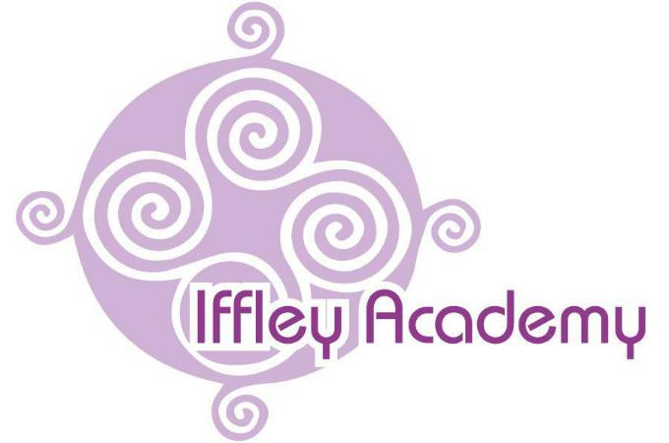

Iffley Academy
Teaching and Learning Policy

Written | April 2025
Review Date | April 2027
SLT Lead | Debbie Nicholas

Teaching and Learning Policy
- Introduction
This policy sets out our approach to teaching and learning, ensuring alignment with our school’s core purpose, aims, and values. It provides a framework for delivering high-quality education that reflects our curriculum intent and strategic objectives.
- Purpose, Aims, and Values
Our teaching and learning approach is underpinned by our school’s core purpose, which is to foster a learning environment where students are inspired, challenged, and supported to achieve their full potential. We are committed to:
- Providing a broad, balanced, and ambitious curriculum that meets the needs of all learners.
  - Ensuring all subjects are taught with depth and rigor, enabling students to develop expertise across a range of disciplines.
  - Embedding cross-curricular links to enhance understanding and application of knowledge.
  - Offering opportunities for enrichment activities, including residentials, trips, and guest speakers, to broaden students’ horizons.
- Ensuring a positive, inclusive, and supportive learning environment.
  - Cultivating a culture of respect, kindness, and collaboration among students and staff.
  - Implementing clear behaviour expectations and supportive interventions to ensure all students feel safe and valued, in line with our restorative approaches.
  - Providing pastoral support and resources to help students overcome barriers to learning.
- Developing students’ critical thinking, creativity, and independence.
  - Encouraging students to ask questions, explore new ideas, and think independently.
  - Incorporating project-based learning and inquiry-driven activities to promote creativity and innovation.
  - Fostering resilience and problem-solving skills to prepare students for future challenges.
- Promoting values of respect, responsibility, and resilience in all aspects of learning.
  - Embedding character education throughout the curriculum and extracurricular activities.
  - Encouraging students to take ownership of their learning and demonstrate responsibility in their studies.
  - Providing opportunities for reflection and self-improvement to build resilience and adaptability.

- Curriculum Intent
Our curriculum is designed to:
- Equip students with the knowledge, skills, and attributes they need for future success.
  - Aligning learning with real-world applications to enhance relevance and engagement.
  - Integrating life skills, career education, and financial literacy to prepare students for adulthood (Employment curriculum).
- Be ambitious, engaging, and accessible for all learners.
  - Implementing differentiated instruction to support diverse learning needs and abilities.
  - Using innovative teaching methods, including collaborative learning and gamification, to maintain engagement.
- Support the development of English, mathematics, and digital competency across subjects.
  - Embedding reading, writing, and mathematical skills within all areas of learning.
  - Implementing the Maths for Life programme to develop real-world numeracy skills and problem-solving abilities. (More information available at: Maths for Life)
  - Providing digital literacy training to ensure students are confident users of technology in academic and professional settings.
  - To provide regular Fresh Start phonic lesson to ensure pupils leave school with functional literacy skills.
- Provide opportunities for deep learning, critical analysis, and application of knowledge.
  - Encouraging students to analyse, evaluate, and synthesize information from various sources.
  - Utilising real-world case studies and problem-solving tasks to enhance learning experiences.
- Ensure that students experience a rich, diverse, and relevant education that prepares them for life beyond school.
  - Incorporating global and cultural perspectives to develop students’ awareness and understanding of the wider world.
  - Offering a variety of learning pathways, including vocational and academic options, to suit individual aspirations.
- Effective Teaching and Learning Strategies To achieve our curriculum intent, we implement evidence-based teaching practices, including:
- High Expectations: All teachers set ambitious targets and create a culture of excellence.
  - Setting challenging yet achievable goals that inspire students to reach their full potential.
  - Encouraging students to take pride in their work and strive for continuous improvement.
- Adaptive Teaching: Lessons are tailored to meet the needs of all students, ensuring accessibility and challenge.
  - Using a variety of instructional strategies to accommodate different learning styles.
  - Providing scaffolding and targeted support to help students progress at their own pace.
- Engagement and Participation: A range of interactive and student-led learning activities encourage active participation.
  - Incorporating hands-on learning experiences, discussions, and collaborative projects.
  - Encouraging student voice and choice in learning activities to foster ownership and motivation.
- Assessment for Learning: Regular, formative assessments inform teaching and provide feedback to support progress.
  - Using quizzes, peer assessments, and teacher feedback to guide student improvement.
  - Implementing data-driven instruction to tailor lessons to individual needs.
- Collaboration and Inquiry-Based Learning: Students are encouraged to work collaboratively and engage in problem-solving activities.
  - Promoting teamwork through group projects, debates, and peer review exercises.
  - Encouraging inquiry-based approaches where students explore and investigate topics deeply.
- Use of Technology: Digital tools and resources are integrated to enhance learning experiences and accessibility.
  - Utilizing e-learning platforms (Seesaw, Goggle Classroom, Fresh Start, Lesson Up), multimedia resources, and virtual simulations to enrich instruction.
  - Teaching responsible and ethical use of technology to prepare students for digital citizenship (Jigsaw).
- Role of Teachers and Staff Teachers are expected to:
- Plan and deliver engaging lessons that align with curriculum intent and school values.
  - Ensuring lesson objectives are clear, structured, and purposeful.
  - Using diverse instructional strategies to cater to different learning preferences.
- Use data and assessments to inform instruction and support individual learning needs.
  - Regularly reviewing student performance data to identify strengths and areas for development.
  - Adjusting teaching methods based on assessment outcomes to maximise student progress.
- Foster a positive classroom environment where all students feel valued and motivated.
  - Creating an inclusive atmosphere that celebrates diversity and encourages participation.
  - Implementing positive reinforcement and constructive feedback to build confidence and resilience.
- Provide timely and constructive feedback to students.
  - Offering specific, actionable feedback that helps students improve their understanding and skills.
  - Encouraging students to reflect on feedback and take steps toward self-improvement
6.An autistic-friendly classroom
Many classes in the school contain a high level of ASC students. To support these students classrooms are carefully considered and adapted to meet their needs. Our ASC friendly classrooms include:

- The use of pastel colours, as this is calming for our students.

- Minimal visual distractions, such as bright displays and classroom resources.

- Quiet learning spaces, including the use of workstations where appropriate.

- High levels of visuals to support pupils in understanding the structure of the school day (visual timetables etc).
- Clear structures and routines through all aspects of lessons, in particular during transition times.
- Clear concise use of language, which is familiar to our students.
- Role of Students
Students are expected to:
- Engage actively in their learning and take responsibility for their progress.
- Demonstrate resilience, respect, and responsibility in their studies.
- Seek feedback and use it to improve their work.
9. Monitoring and Evaluation Teaching and learning practices will be regularly reviewed to ensure alignment with school priorities and educational excellence.
10. Conclusion By fostering a culture of high expectations, inclusivity, and continuous improvement, we aim to equip students with the skills and knowledge they need to thrive.
Policies which support the Teaching and Learning Policy:

- Anti-bullying policy

- Behaviour policy

- Classroom criteria

- Collective worship policy

- Communication policy

- Computing policy

- Creative Arts policy

- Curriculum policy

- English policy

- Marking policy

- Mathematics policy

- PSHE policy

- RE policy

- RSE policy

- Science policy

- SEN policy

- Spiritual, Moral, Social and Cultural policy

