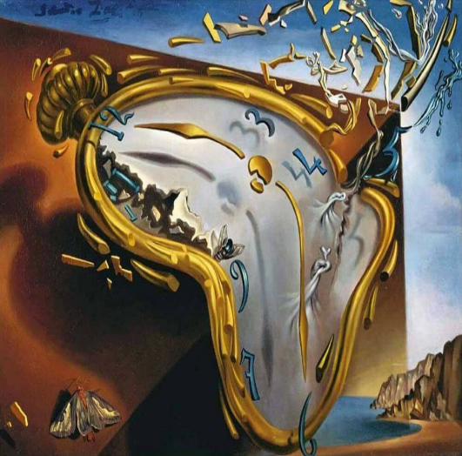
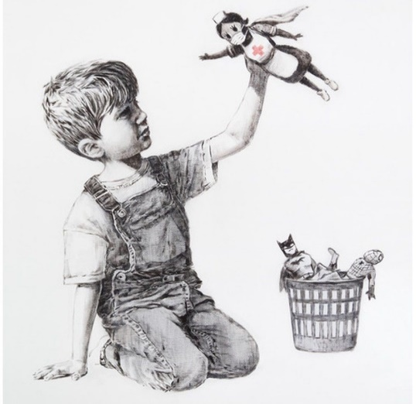

Lesson Plan 18/11/2020
Good morning Dali and Banksy class,
We are almost at the end of our isolation. Please see below todays lessons for you to complete. Please take lots of photos of all the wonderful work you do and send them to Miss. Kingston if you are in Dali class or Miss. Davies if you are in Banksy class.
We look forward to welcoming you back to school very soon, but until then please remember to stay safe.
All the best,
Miss. Kingston and Miss. Davies
Maths: Counting to 20
Link to lesson:
https://classroom.thenational.academy/lessons/exploring-one-more-and-one-less-cgt64t
Learning Objective:
I can find one more and one less than a number to 20
Equipment:
- 20 cubes or objects for counting
- Number line t0 20
- Number cards to 20
- Two pence coin
(Please don’t worry if you do not have a printer at home. All of the material can be written on a piece of paper )

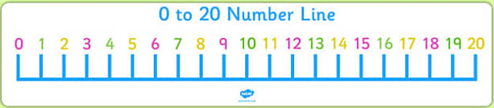

Lesson overview for parents:
- Introduction and welcome with Reggie
- Playing game: name the object
- Get your equipment ready – 20 objects for counting, number line to 20, number cards to 20 and a 2 pence coin.
- Play game – choose a number card, (e.g. 5) card and count the right number of objects associated with that number. Flip your 2p coin. If it lands on heads count 1 more object. If it lands on tails take way one object and count how many you have.

__________________________________________________________________________________
Literacy: Little Red Hen
Link to lesson 7:
https://classroom.thenational.academy/lessons/to-join-in-with-a-telling-of-a-recycled-story-6xjk6t
Learning Objective:
I am able to explore different ways of telling our new story
Equipment:
- None
Lesson overview for Parents:
- Introduction with Adam and Panda
- Looking at our agenda
- Warm up: playing a word game thinking about animals. Panda and Adam will give you clues and you need to guess the animal
- Listen to Adams recycled story
- Discuss with a family member which were your favourite moments in the story
- Learn to sing the story

__________________________________________________________________________________
Phonics:
These are the sounds we have previously covered in class –
Set 1: s, a, t, p
Set 2: i, n, m, d
Set 3: g, o, c, k
Set 4: ck, e, u

Please note your child may not be able to recall all these sounds and that's okay, the best thing for them is to consolidate them through the sets. (for example, if they are confident with s, a, t focus on practicing ‘p’ and there so on).
For todays lesson please click on the following link and watch Alphablocks ‘c’ video:
https://www.youtube.com/watch?v=aCAkSEPEBr4
Alphablocks is a great way to practice phonics and home. It is important that the children join in with the clip and practice repeating the sounds discussed. It would be great to pause the clip along the way and question your child on the sounds that are displayed on screen.
And
Phonics play:
Username: nhouse
Password: phonics
- Log into phonics play
- Click resources
- Click on Flash cards time challenge
- Click on start
- Click phase 2
- Choose 1 or 2 minute challenge
Children also enjoy the interactive sound games in phase one. You could try Sound Starters or Welcome to the Zoo. These games are great fun and help develop listening skills, ability to describe sounds and talking about the difference between the sounds they hear and widens their vocabulary, so please give them a go.
Additional:
Books for your children will be uploaded onto Active Learn for them to work through. Teachers will send out login details for your child.
Please listen to your child read the books and help them break words into smaller sounds where they struggle. Please ask your child regular questions about what is happening throughout the book for example:
- What do you think is going to happen next? Why?
- How do you think the character is feeling at that moment? Why?
- Can they recall events throughout the story and tell you what has happened in the book – encourage them to use full sentences.

CHRISTMAS COMPETITION

Please see below information regarding the Christmas Card competition.

