Lesson Plan 10/11/2020

Maths: Counting objects to 20
Link to lesson 1
https://classroom.thenational.academy/lessons/counting-objects-up-to-20-6rrkgc
Learning Objective:
I can count to 20
Equipment:
- 20 objects for counting -i.e. pencils, buttons, bottle caps etc
- Counting container
- Number line to 20
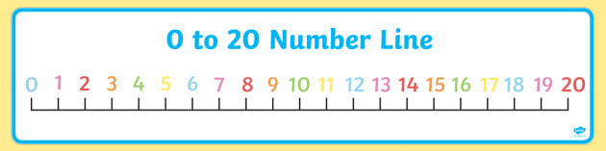

Lesson overview for parents:
- Introduction and learning counting song
- Playing dominos game – children to count how many dots they can see on the dominos
- Get your objects ready
- Looking at star words/ key vocabulary
- Counting pictures that appear on screen using careful counting finger
- Using selected objects, practice counting to 20
- Use number line and objects to help answer question on screen
- Close: practice counting objects around the house
__________________________________________________________________________________
Literacy: Little Red Hen
Link to lesson 1:
https://classroom.thenational.academy/lessons/to-listen-and-join-in-with-a-story-c5h36t
Learning Objective:
To listen and join in the with the story.
Equipment:
- Paper and pencils to draw with.
Lesson overview for Parents:
- Introducing characters for the story (red hen, cow, dog and mouse)
- Learn to sing Mamma Rosa had a farm
- Introduction to story and the sounds the animals will make
- Listen to the story
- Discuss and draw your favourite moment from the story
- Discuss with adult what lesson (moral) we can learn from the story
__________________________________________________________________________________

PSHCE:
Link to lesson 1:
https://classroom.thenational.academy/lessons/healthy-hugs-c5h3ge
Learning Objective:
How to keep ourselves and people around us safe when we go back to school,
Equipment:
- A favourite teddy
Lesson overview for Parents:
- Introducing our friends
- Talk about Rosie’s problem: she can’t give hugs, what else can she do?
- Learning signs: how else can we show friends we care about them
- Closing: Teach your family how to give healthy hugs.
__________________________________________________________________________________

Phonics games:
Equipment:
- Pudsey’s Phonics Fun Game Coins
- Pudsey’s Phonics Fun Game Boards
- Pudsey’s Collection Bucket Sign
- Bucket, jar or tub
- Small bag or box
Preparation:
- Print, and cut the Game Coins and the Game Boards.
- Print the Pudsey’s Collection Bucket Sign and attach it to the front of a bucket,
- tub or jar.
How to play:
- Place the picture coins face down on the table and place the word coins in a small bag or box.
- Place Pudsey’s coin bucket within reach of all the participants in the game and hand each participant a game board.
- Ask the children to take five picture coins each and place these, facing upwards, on to their game board.
- Tell the children that these are their coins. The aim of the game is to get all of your coins into Pudsey’s bucket.
- Take a word coin from the bag or box and use oral segmenting to say the sounds in the word, for example, ‘c-u-p’.
- The children can look at their coins and see if they can pick out the correct picture coin.
- If a child finds the correct picture coin, they can drop it into Pudsey’s bucket.

Additional:
Pudsey story: https://www.youtube.com/watch?v=LCIOC0OxZnY

