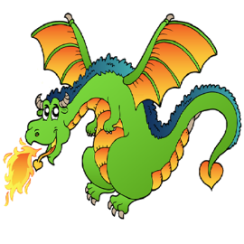
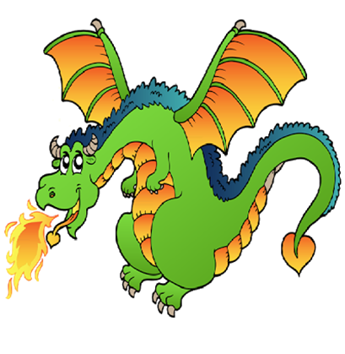
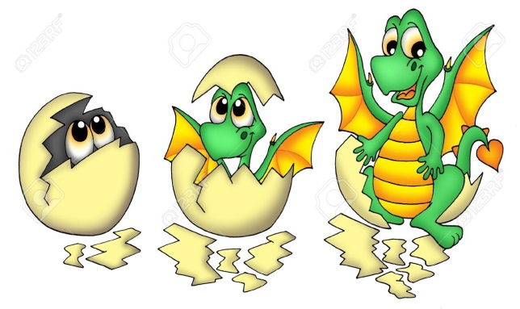
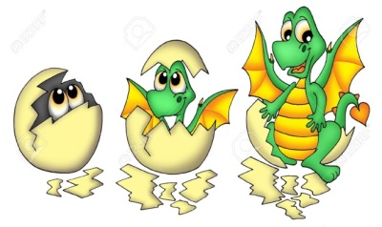
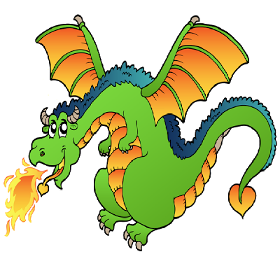

exciting
apprehensively
slowly
evil
popped
hatched
colossal
dragon
frown
head
slumped
shiver
bigger than a…
floppy
rescue
glossy
scales
nervous
heavy
skin
looks
feels
flying
flared
caring
eyes
worried
T
anxious
hunched
bigger
nostrils
quivering
Adventure Word Mat

