PICASSO
Click on the picture to go to an amazing Poppy activity pack.

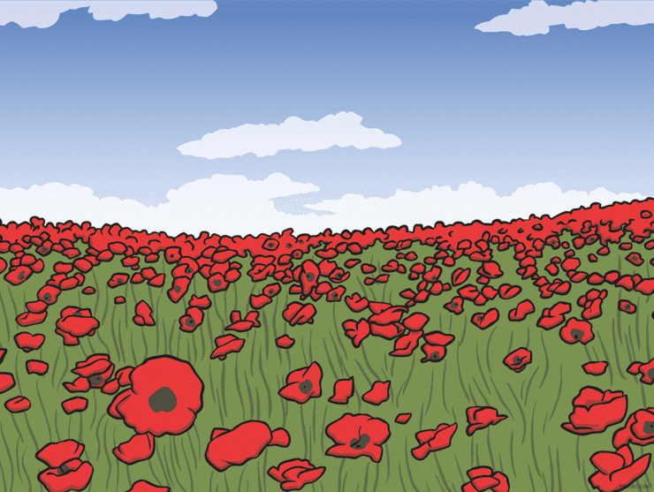

11TH NOVEMBER 2020
ART

