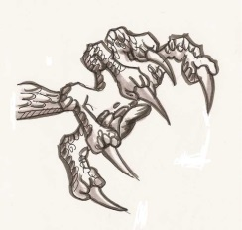  claws | 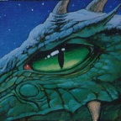  eyes  ears | 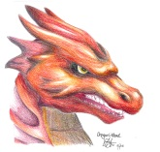  head  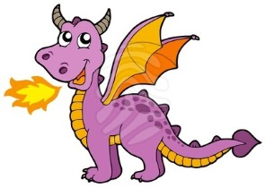  horns | legs | scales  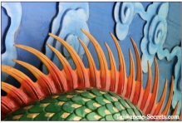  spikes |   teeth  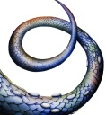  tail | 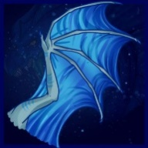  wings
cutting  callous  clear  clumsy  creepy  crooked  cruel | emerald  eager  eerie  electrifying  enormous  evil  excellent  exotic  excited | hard  hooked  hairy  horrendous  horrible  horrid  handsome  harsh  harmful  huge  hazardous  heavy  hollow | leathery  large  limping  loathsome  long  lumpy  lazy | savage  scary  scratchy  silver  sinister  smooth  sleek  slim  slender  sparkling  spooky  stiff  strange | terrible  tremendous  terrifying  terrific  titanic  tough  toxic | wicked  wonderful  warlike  wavy  weary  weighty  weird  white  wide  wild  wonderful  wondrous

