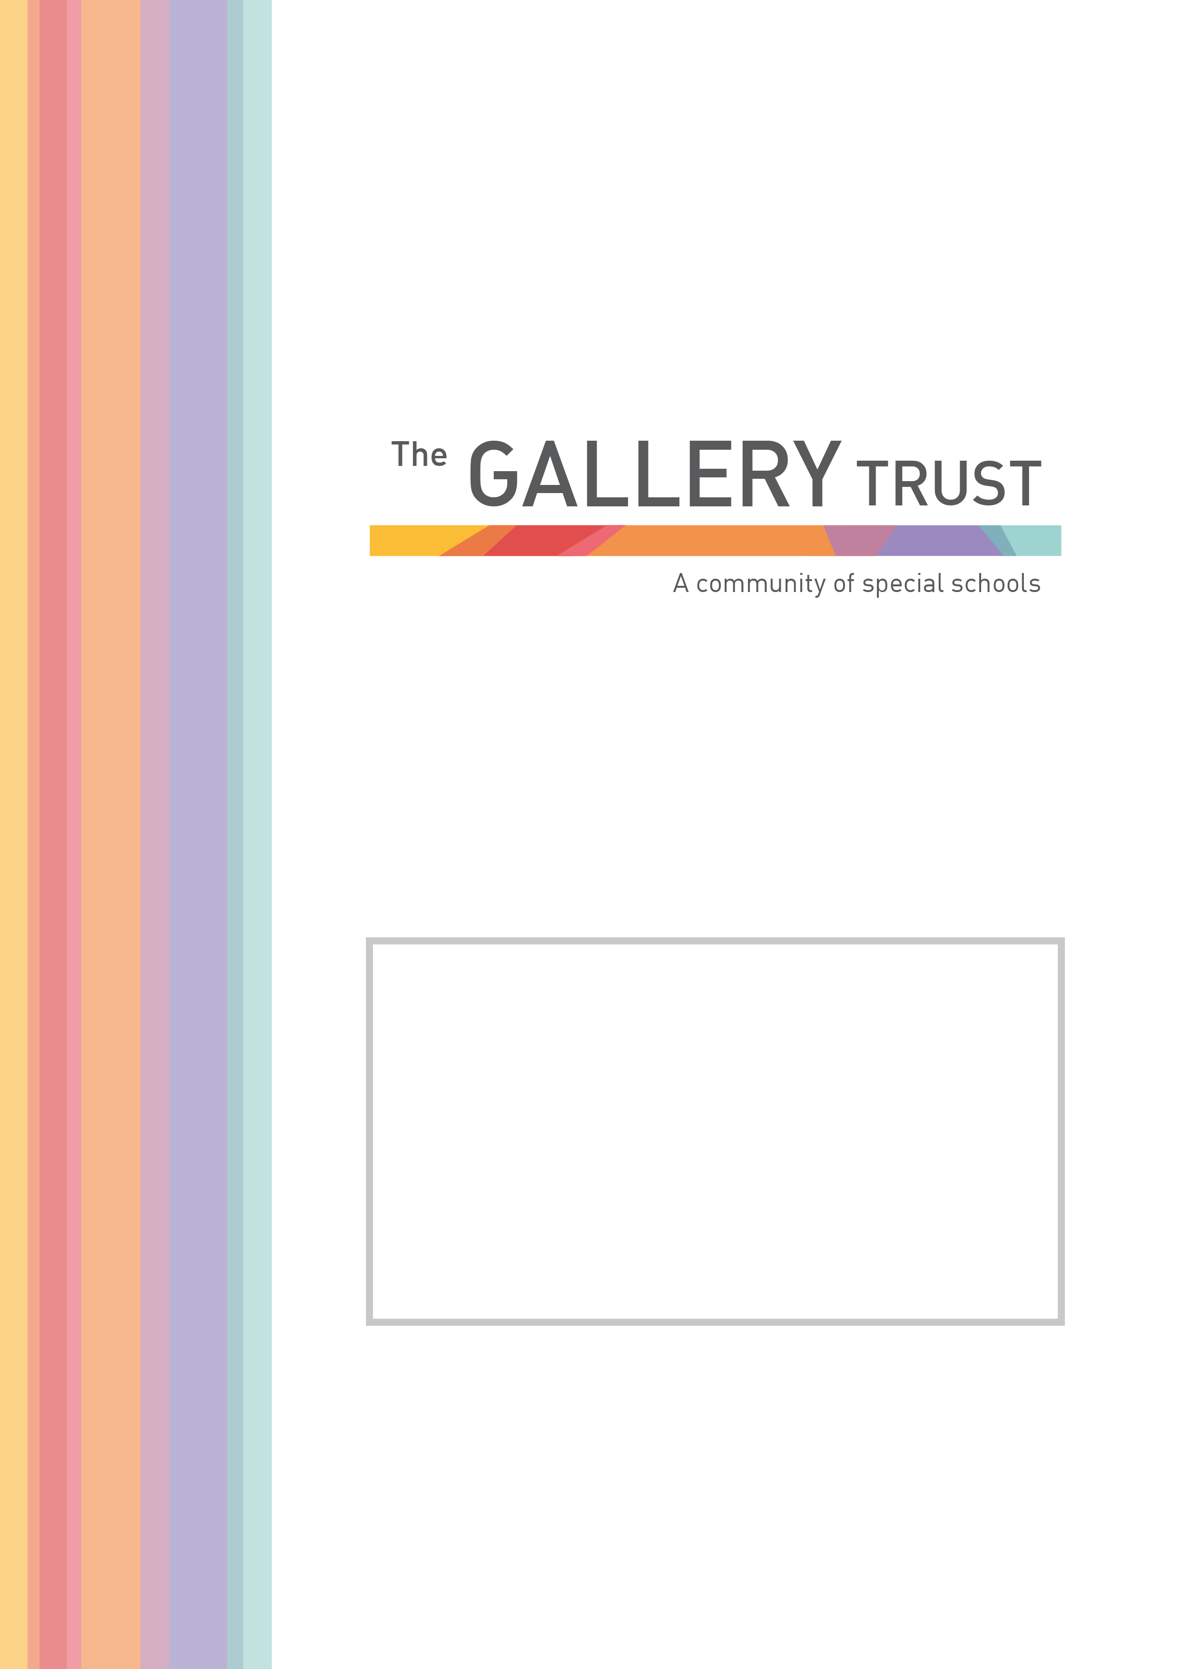

Teaching Assistant
Grade 6
Bardwell School

Candidate Information Pack
April 2022


Thank you for your interest in the post of Teaching Assistant at Bardwell School.

Bardwell School is a community special school for children aged 2 – 19 years with severe learning difficulties and profound and multiple learning difficulties. The school has 103 pupils on roll, following recent expansion of the school buildings.

We are passionate about students at Bardwell having their abilities recognised and celebrated, whilst receiving an excellent education. The staff team is committed to very high standards in relation to every aspect of our pupils’ education. The school is values led, with every decision underpinned by its principles and values. These values include a positive reinforcement approach to behaviour management and a non-label led individualised approach to planning and delivering learning for all students.

Bardwell School is a member of The Gallery Trust, an expanding Special Needs Multi Academy Trust which is dedicated to improving outcomes for SEND learners in Oxfordshire. The Trust has a national reputation for excellence, and is influential in the development of SEND strategy in the county. With six academies currently in the Trust, our aim is to build a community of eight to ten special schools over the next five years.

Thank you again for your interest and we look forward to hearing from you.


Matthew Selsdon
Interim Head Teacher

JOB DESCRIPTION
Teaching Assistant

Grade 6: Actual Salary £14,531 - £16,044 per annum
(FTE Salary £20,493 - £22,627 per annum)
31.5 hours per week, 38 weeks per year, term time only

To start June 2022 (or as soon as possible)

Bardwell School is the community special school in Bicester, we serve the Bicester and Kidlington areas, but also have children from across Oxfordshire. We are seeking enthusiastic and motivated staff to join our thriving and vibrant community at an exciting time in our development.

Judged as Good by Ofsted in July 2018, we recognise ourselves as a very strong school, that is on a continuous journey of school improvement. We make respectful relationships with our students through our understanding of their special educational needs, thorough assessment of their skills and abilities and carefully planning next steps for them. We are a warm and caring community, dedicated to equipping pupils with the skills and knowledge they need to succeed.

The role of the Teaching Assistant involves setting appropriate boundaries for children, supporting with their education and care and liaising with families to get the best possible outcomes. You will have the attributes to work across the whole school, including supporting children with complex health and medical needs and students who may demonstrate physically challenging behaviour. You will have, or be willing to quickly develop, a good understanding of our school curriculum, how to create a climate for success and how to support pupils with special educational needs and disabilities to learn and develop. You will also demonstrate a resilient and instinctive approach in meeting our pupils’ needs.

If you share our passion for making a real difference to the lives of children and young people with special needs, this could be the opportunity you are looking for. In return for your contribution to our team, you will work in an environment, which is innovative and in a role which is rewarding and fulfilling. We will provide you with induction and training, and the opportunity to join the Local Government Pension Scheme, one of the largest public sector pension schemes in the UK. This is an exciting time to join our team, having recently joined The Gallery Trust, we are further developing our curriculum and assessments and will soon be having a new hall and classrooms built to support further expansion.

Application Process

To apply for this post, please email jobs@bardwell.oxon.sch.uk or telephone 01869 242182 to request an application form and a job pack. You can also download an application form and job pack from our website: www.bardwell.oxon.sch.uk

Due to the Spring Break closure period for the school, the closing date for applications is a little longer than usual.

Please submit your application form by 5pm on Monday 2nd May 2022 to jobs@bardwell.oxon.sch.uk or by post. Please ensure you detail any gaps in employment and use the selection criteria which is contained in the job pack when you prepare your application, as shortlisting for interview will be based on how closely you demonstrate your ability to fulfil the essential criteria. We do not accept CVs. If you are shortlisted, we will take up written references before your interview so please provide permission for this and provide accurate phone and email contact details for your referees. One of your referees must be your current or last employer, and if you are employed in a school, must include your current Head Teacher.

If you have any questions prior to the closing date please speak to Matthew Selsdon, Interim Headteacher or email head.7029@bardwell.oxon.sch.uk
Bardwell School is committed to safeguarding and promoting the welfare of all children and expects all staff to share this commitment. The successful candidate will be subject to an Enhanced DBS check, Occupational Health check. The Gallery Trust is an equal opportunities employer and we welcome applications from a range of ethnic backgrounds to represent diversity in line with our school community.




The Gallery Trust is a Multi Academy Trust which is dedicated to improving outcomes for SEND learners in Oxfordshire. The aim of the Trust is to provide outstanding education and support for young people with special needs and disabilities, enabled through:

- Commitment to special education – striving to provide the best specialist learning experience for all students
- Opportunities for all to learn – ensuring that students and staff have access to learning pathways which enhance their lives
- Genuine respect and value – creating relationships which promote trust, confidence and respect within environments which are safe and secure

The Trust is on a continuing journey of expansion, growing from a Multi Academy Trust based on a single academy in 2013, to its position as the largest Specialist Trust in Oxfordshire.

The schools in the Trust are:

- Bardwell School, Bicester
- Bloxham Grove Academy, Bloxham, to open in 2024
- A Free Special School in South Oxfordshire, opening date to be confirmed
- Iffley Academy, Oxford
- Mabel Prichard School, Oxford
- Northern House Academy, Oxford
- Orion Academy, Oxford
- Springfield School, Witney
- The Grove (satellite provision of Orion Academy)

The Trust’s vision is to continue to consolidate our recent growth by securing effective systems that deliver school improvement through all academies whilst continuing to expand over the next five years, supporting a community of converter academies, free schools and sponsored academies. All member academies have the opportunity to share SEND expertise and to work with peers who share common aims and goals.

The Trust is committed to investment in learning, developing system leadership, working in partnership and through a shared vision, enabling all students to reach their full potential.

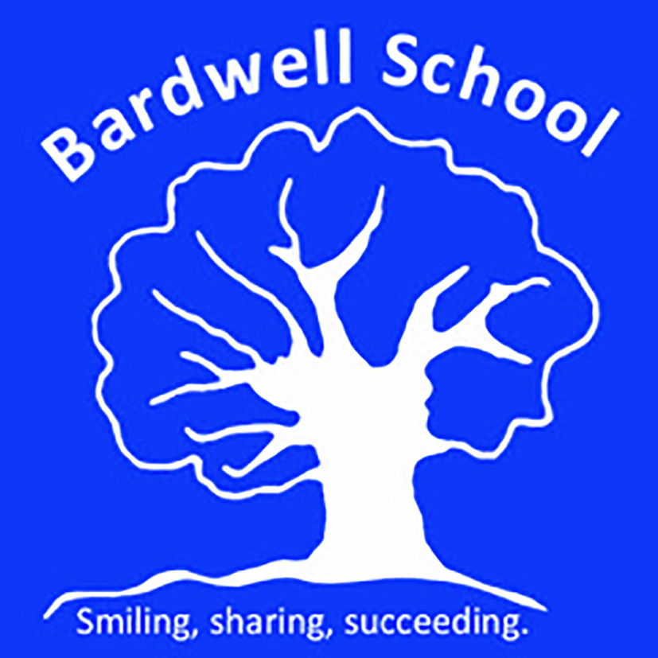

Bardwell School is a community special school that caters for children aged 2 – 19 years.

Students work in class groups where teachers differentiate learning for all students ensuring lessons are inclusive for all.

The school has developed a comprehensive and broad skills-based curriculum, which can be found on the school’s website. This curriculum, which is underpinned by detailed assessment processes, guides the learning for all students. The school has excellent links with community partners and its strong focus on pathways to adulthood supports students onto further education and into employment.

Bardwell School benefits from a hydrotherapy pool that has recently been refurbished. All pupils access the pool for weekly swimming lessons, and pupils with physically disabilities and/or physiotherapy programmes attend additional weekly sessions as required.

The committed team at Bardwell School includes class teachers, teaching assistants, lunchtime supervisors, reception, finance and human resources staff, site manager and cleaning team, a pool manager and pool assistant, an ICT technician and pastoral and Safeguarding manager.

The school is also commissioned to deliver a Short Break service, Branch-Out. This provision is highly regarded by parents and professionals and lead by the Short Breaks Lead and Short Breaks Deputy and has a team of play workers. Branch-Out provide after school clubs, youth clubs and holiday provision.

The school recognises its success is based on successful partnerships. Most importantly, the school works closely with parents and understands that they know their child best. The wider multi-professional team at Bardwell includes a Special School Nurse, Speech and Language Therapist, Occupational Therapist and Physiotherapist. The school also hosts health clinics through the special school nurse provision.

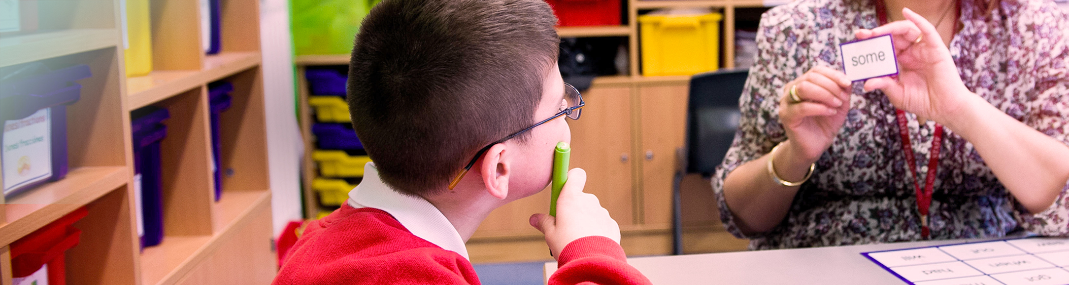

Teaching Assistant
Job Description

Introduction:

This job description describes in general terms the normal duties which the postholder will be expected to undertake. However, the job or duties described may vary or be amended from time to time without changing the level of responsibility associated with the post.
The performance of all the duties and responsibilities shown below will be under the reasonable direction of the Head Teacher. The Head Teacher, or other Senior Manager if appropriate, will be mindful of her/his duty to ensure that the employee has a reasonable workload and sufficient support to carry out the duties of the post.
The job description will be reviewed at least annually, and any changes will be subject to consultation. The academy’s grievance procedure will be used to resolve any disagreement arising out of the job description. Other relevant policies may be the Stress at work policy and Dignity at work policy.

Job Purpose:

To assist and support the Head Teacher and teaching staff in providing high standards of teaching and learning across the curriculum and to promote the academy’s vision and ethos.

Teaching and learning:
- To understand our school vision, aims and ethos and promote these at all times
- To work under the direction of the class teacher to support teaching and learning in our classes as timetabled (this will include small group and one-to-one sessions)
- To produce/reproduce materials and resources to support teaching and learning
- To positively support pupils in informal sessions such as break-times and lunch-times
- To support pupils with personal care needs
- To support with a child’s individual needs, following specific training and advice (for example movement and positioning programmes, managing epilepsy, managing challenging behaviour, supporting with eating and swallowing skills)
- To be a role-model for our pupils
- To work within our ethos to positively manage behaviour, recognising that praise and reward are the most effective behaviour management tools
- To support with the physical management of challenging behaviour. This role will involve the restrictive physical interventions, including with young adults.
- To support pupils in inclusion sessions as required
- To participate in off-site learning activities
- To support pupils with swimming and hydrotherapy
- To feedback back pupil progress to the class teacher and contribute ideas for targets and planning

Administrative duties:
- To attend weekly team meetings
- To attend whole staff meetings once a month
- Support class teachers in photocopying, proof reading and other administrative tasks in order to support teaching
- Undertake other duties from time to time as the Head Teacher requires
- To be committed to your own professional develop and participate in professional development systems and activities as required

Standards and quality assurance:
- Support the aims and ethos of the academy
- Set a good example in terms of dress, punctuality and attendance
- Attend team and staff meetings
- Be proactive in matters relating to health and safety
- Participate positively in training and professional development
- Taking a share of supervisory duties as part of the weekly routine and as necessary
- Take part in Performance Management and appraisal
- Meet deadlines
- To follow school and county guidelines for safe working practice to safeguard pupils and staff in schools, maintaining confidentiality and attending training as required. Including:
- Reading and understanding Keeping Children Safe in Education (Part 1)
- Following our Code of Conduct (see staff handbook)
- Knowing and following our Child Protection/ Safeguarding Policy and
procedures
- Following procedures within our Whistleblowing Policy as appropriate.
- To be aware of and comply with Health and Safety legislation and policies of the school including;
- Sign out and in at reception (when leaving the site)
- Cooperate with health and safety requirements.
- Report all defects on the maintenance forms and return them to the office.
- Complete and action risk assessments for all potentially hazardous on/off site activities.
- Use, but not misuse things provided for your health, safety and welfare.
- Assess the risk - do not undertake unsafe acts.
- Inform Head of Establishment of any “Near-Misses”.
- Be familiar with the emergency action plans for fire, first aid, bomb,
security and off site issues.
- Raise health, and safety and environmental issues with pupils.

General responsibilities:
- To promote the school and our pupils
- Any other class duties as directed by Headteacher, Assistant Headteachers or class teacher

Selection Criteria
Teaching Assistant, Bardwell School
 | Essential | Desirable
Professional Qualifications | Grade 4 at GCSE in Maths and English (C on old scaling) or equivalent  in mathematics and English, or suitable equivalent experience | NVQ 2 for Teaching Assistants or equivalent
Experience |  | Previous experience working in a school environment  Previous experience working with SEN  Experience of working with or caring for children of relevant age
Professional Knowledge & Skills | Understanding of child development and learning  Ability to self-evaluate learning needs and actively seek learning opportunities  Ability to work flexibly, throughout the whole school, meeting the needs of pupils in a range of contexts  Willingness and ability to undertake physical management of pupils, following appropriate training  Willingness to undertake First Aid training and to attend to the medical, first aid and personal needs of pupils.  Ability to take an active role in the support of PE lessons  Effective use of ICT to support learning | Team Teach trained  Understanding of relevant policies/codes of practice and awareness of relevant legislation  General understanding of National Curriculum  First aid trained
Personal Skills and Qualities | Ability to establish and maintain positive relationships with pupils, colleagues and parents  Good organisational skills Good communication skills  Ability to remain positive and enthusiastic, including when under pressure  Strong commitment to raising standards | Full driving license

