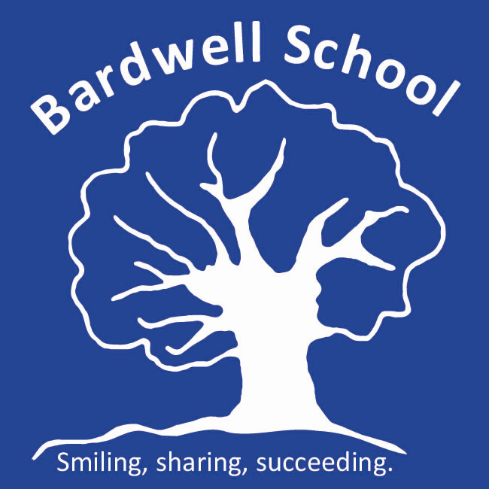

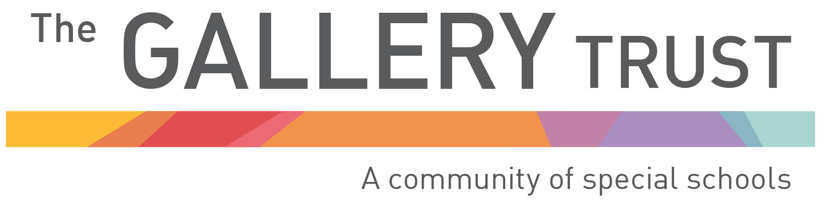

Sex and Relationship Education Policy

Written: November 2021
Updated: September 2022
Date of review: September 2023
Bardwell Lead: Matthew Selsdon (Deputy Headteacher)
Signed LAB:
Signed TGT:

Bardwell School is committed to providing high quality Sex and Relationship Education (SRE) and guidance as an integral part of the Personal, Social and Health Education curriculum for all students. It will seek to ensure that the provision is appropriate to the age, ability, and the special educational need of the individual student and is underpinned by equality of opportunity and latest researched recommendations.
SRE is part of the curriculum for modern life and should provide young people with both the knowledge and skills to manage their lives, have healthy and positive relationships, stay safe, make informed decisions and thrive as individuals and members of society. The SRE provision and programme of study at Bardwell School will aim to provide young people with opportunities to develop skills and qualities such as resilience, communication and empathy. We know that these are key skills which our students require to lead successful, safe and healthy lives.
We will provide high quality PSHE and age appropriate SRE teaching across the school as we recognise that this is essential in keeping our students safe and healthy, inside and outside of school. Young people today face unprecedented pressures posed by modern technology so our quality PSHE and SRE programme will provide them with the information they need to stay safe and build resilience against the risks of exploitation. We know that good PSHE supports young people to make informed choices and decisions.
We embrace many different cultures, religions and social backgrounds and all needs will be acknowledged and understood in the delivery of this subject. Sex and Relationship Education and guidance is the responsibility of all staff within the school. We aim to help our students enhance their self-esteem and awareness so that they can make appropriate choices and transitions, which maximise their potential and enable them to gain satisfaction from their adult lives.
We fully support and embrace the recommendations that SRE is approached in partnership with families and understand that for our students to make the most of understanding this aspect of their lives and society, that communication and sharing of knowledge between school and families is key. It is important to aid families in being able to support their child through puberty and understanding of SRE. To support this commitment, workshops to develop parents understanding of the SRE program of study, to identify their wishes and concerns for their child and to share good practice are held on a regular basis.
Our policy ensures:
- It is everyone’s right to have relevant knowledge of their sexuality regardless of whether or not they have special educational needs.
- To confront the many myths and misconceptions passed on regarding the sexuality (or supposed lack of it) of people with a learning disability.
- Sex education will be co-ordinated by each student’s class teacher who will normally be assisted by classroom support staff and/or the specialist staff. Arrangements are flexible so that this area of the curriculum can be delivered sensitively and in accordance with the wishes of the students e.g. mixed groups; male staff teaching boys; female staff teaching girls; group dynamics etc. However, it is to be noted that through the research work completed with students during the academic year 2016-2017, students were clear that they wanted boys and girls to be taught together not separately as they needed to know about the needs of the other sex.
- We do not feel it is appropriate to artificially divide our sex education syllabus into the primary and secondary stage of the school. Students will have access to the curriculum at the level appropriate to their age, maturity and understanding.
- If parents feel they might wish to withdraw their child from this area of teaching they are encouraged to first discuss this with their child’s class teacher or then the PSHE Subject Leader.
We must accept that for some students with very limited cognitive skills it may only be possible to teach sex education on a behavioural level, discouraging unacceptable sexual behaviour without detailed explanation of why this is being discouraged. However, even in these extreme cases, it is hoped that as a pupil’s cognitive awareness develops, it may be possible to introduce him or her to the early stages of the SRE Program and provide more detailed sex education. Apart from explicit teaching of sex education, we fully recognise that implicit teaching through cross curricular links, the ethos of the school and the behaviour and attitudes of the adults within it will also be very important. In conjunction with this belief, it has been identified that within both Language and Communication and ICT lessons each year, there will be specific links to the PSHE Curriculum, which relate to the relationships aspect of SRE.
Some of our students may require individual support and teaching in SRE and in these cases this work will be directly linked to their learning objectives and success criteria which will be informed by their Education, Health and Care Plans.
The Bardwell Curriculum
The Bardwell Curriculum informs the planning of teaching and learning of SRE. The curriculum covers:
- The Body
- Public and Private (body parts and places)
- Relationships
- Sex Education
- Where babies come from
- To know what sex is
- To know what safe sex is
- To understand choices and the right to say ‘no’
- To know where to get advice from
- To understand the importance of personal hygiene
Delivery and Implementation
The implementation of this policy is the responsibility of the PSHE Subject Leader along with all teaching staff, together with outside agencies and partners.
The Sex and Relationship Curriculum will be delivered in a variety of ways, including sessions delivered by specialist professionals, lessons delivered by the class team, 1:1 sessions with pastoral support staff, small group discussions, off site visits and the use of on-line resources and interactive resources. A variety of teaching methods and materials will be used. All class teachers will be involved in providing guidance for their students on SRE and will ensure that the delivery and content of the programme is suitable and appropriate for their needs. All staff at the school have a responsibility to make appropriate contributions to the wider PSHE curriculum through their roles as tutors, subject specialists and specialist support staff to fulfil the aims of the whole school policy.
A letter will be sent out to parents before the SRE program begins and it will provide core information about what will be covered each week, to support parents in re- enforcing specific learning at home and to help prepare for questions they may be asked.
The programme is designed to support and compliment the role of parents who have the prime responsibility in this sensitive area. Parents have the right to withdraw their child from all or part of the Sex and Relationship programme that is not included in the programme of study for the Science national curriculum. This should only happen after careful consideration and discussions with the PSHE Subject Leader and should be confirmed in writing by parents.
Equal Opportunities
Sex and Relationship Education will be delivered to both genders normally in mixed classes. There are however certain subjects that might be delivered in single sex groups, if there is a need for this. Staff will present all information without bias and will present information about relationships as gender neutral. Staff will provide a range of information to students and present ideas from different religions and cultures.
Evaluation and Consultation
The effectiveness of Sex and Relationship guidance will be evaluated at least every two years. During this process parents/carers and students will be consulted (please see Appendix 1 for latest parent/carer consultation). Coverage of core themes and the curriculum will be overseen by the Subject Leader for PSHE.
Links
When writing this policy, the following advice and guidance has been considered:
- Sex and Relationship Education Guidance: DfEE 0116/2000
- www.pshe-association.org.uk
- Special educational needs and disability code of practice: 0 to 25 years
- Does sex and relationships education work? (Sex Education Forum)
- Not yet good enough: personal, social health and economic education in school (Ofsted 2012)
- Sex and relationships education for the 21st Century (DfEE Guidance)
- Family Planning Association Guidance and training
- Sexuality, Puberty and Relationships in Autism Seminar. (Dr Sally Powis, Consultant Clinical Psychologist)

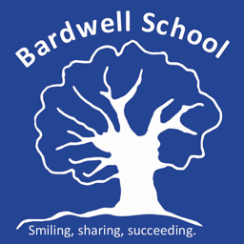

Appendix 1 - Consultation on Bardwell Schools Sex and Relationship Policy (July 2022)
The data below is in response to the review of our Sex and Relationship Education policy, in consultation with parents and carers.
Total number of responses: 47/103
Are you in agreement with our Sex and Relationship Education Policy?
 | Total | %
Yes | 41 | 88%
No | 2 | 4%
In part | 4 | 8%
88% of parents who responded to this consultation were in agreement with the policy. It has therefore been adopted without further changes.
There were a number of further comments to support and consider when implementing our RSE Policy. These related to:
- The importance of parents being aware of what is being taught, and resources, visuals being used so that they can support their child at home.
- The importance of focusing on and revisiting the concept of consent.
- The balance of delivering RSE in a developmentally appropriate way as well as an age appropriate way
- The importance of privacy when students are going through personal changes (for example when girls begin the menstrual cycle)
There were some personal/individual views that we will work closely with individual parents on.

